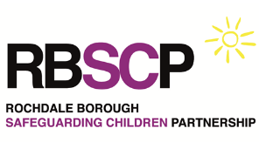
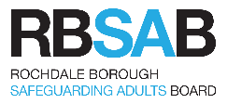
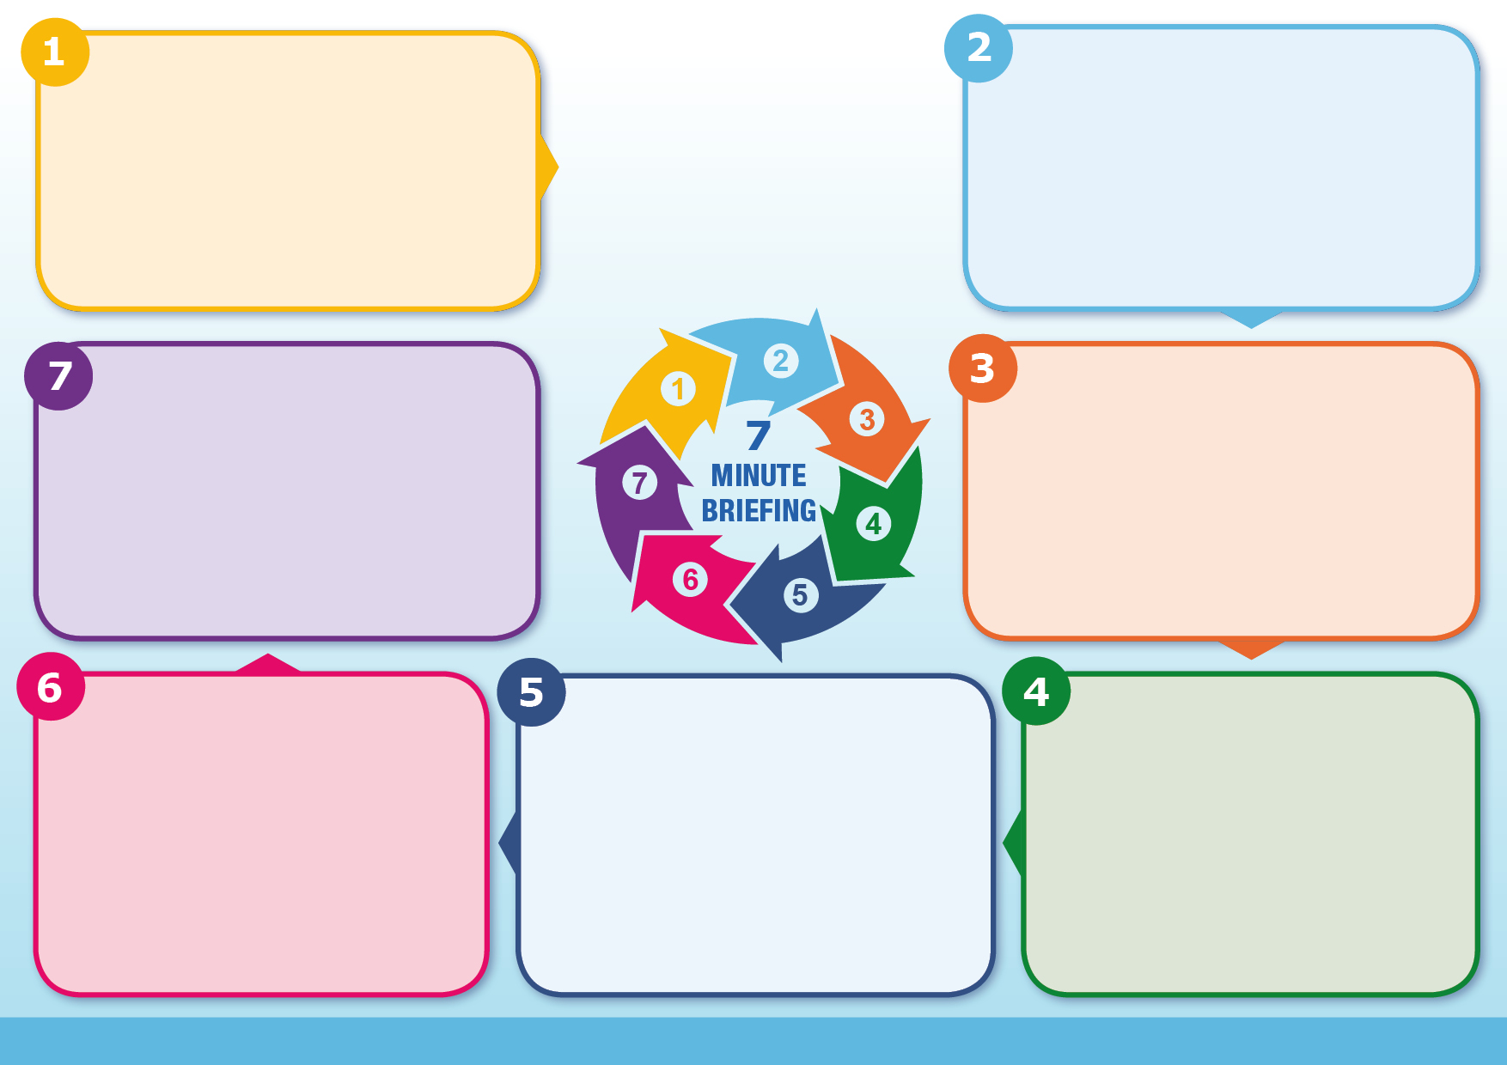
Practitioners must feel able, and committed, to challenging each other about aspects of plans that they feel are not SMART or trauma informed.
Has the child’s view been sought and child been involved in creating the plan?
Have the parents co-produced the plan?
What if the parents disagree, either overtly or covertly?
Does the plan say how and when progress will be evaluated?
Does the plan clearly show who is responsible for each part?
Agreed
Plans are most likely to succeed, and actions achieved when agreed by and co-produced by children, parents or carers & practitioners; making people feel that
they are part of and take ownership of the plan.
Realistic
Plans should be realistic and based upon our knowledge and understanding of the family, parental capacity to change and the specific developmental needs of the child or young person. For example, it would not be realistic (or indeed safe) to expect a parent with long term alcohol misuse issues to
suddenly stop drinking
Timely
All aspects of plans should contain realistic timescales with some being broken down into stages to make them more achievable. This will enable everyone to be clear what is expected of them and by when, as well as allowing progress to be monitored.

Information
Specific
All aspects of the plan should be as specific as possible – for example, if a service is identified to meet the need, the plan should state: when the service will be provided, how frequently, what exactly will be provided, and what the goals of providing the service are. All aspects of the plan should be as specific as possible. If a service is identified to meet a need, the plan must state: who will provide the service or make the referral, when it will start, how often it will occur, what exactly will be delivered, and the goals of the service.
Measurable
All aspects of the plan should be measurable – this enables both families and practitioners to be clear about progress made and quickly identify when a plan is not working
Information
Objectives that are SMART are more likely to be achieved, which helps to avoid
drift in cases. When objectives are SMART, they become clear expectations, where it is obvious who is meant to do what. They are also easier to
understand for families and children. They can be a very helpful check to the question ‘is the plan working to make life better for the child?’
In order to answer this question, the child should be included in creating the plan (where age appropriate)
The most common errors that are made in SMART plans are that the statements are:
• Vague
• Action, not outcome based
• Unrealistic/unachievable
SMART stands for Specific, Measurable, Achievable, Realistic, and Timely and the model has been used make sure that goals are achieved which make a difference to children’s lives. SMART principles help families and practitioners develop clear effective and trauma informed plans.
Evidence from serious case reviews suggests that where serious issues have been known to services the accompanying plans have often been vague, non-measurable and have lacked direction, making them difficult to apply or measure and leaving professionals unsure of the expectations of them.
Using a SMART approach to planning, the focus must remain on what needs to change for the child/young person, as well as how quickly that change needs to happen
Questions
Does the plan address the concern of harm and the needs of the child?
Is the plan clear about what change is needed?
Is the plan clear about the required outcome for the child?
Are the expectations in the plan appropriate and realistic in regard to the needs of the child or young person?
Are the expectations in the plan appropriate and realistic, taking into account historical information and based on assessment of
parenting capacity?
Why it matters
Background
What to do?
Questions
SMART Planning

