
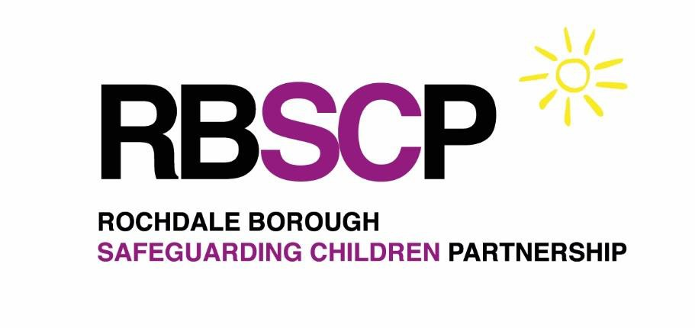

Rochdale Borough
Safeguarding
Children Partnership
Multi-Agency
Safeguarding
Arrangements

February 2026

Review date: April 2027
1

Table of Contents Page

Preface 3
Legal Context 3
Understanding the Borough 4
Introduction 5
Lead Safeguarding Partners 6
Designated Safeguarding Partners 6
Vision and Values 7
Leadership 8
Rochdale Borough Safeguarding Children Partnership 9
Transparency and Scrutiny 10
A Responsive Partnership 11
Learning from Good Practice and Reviews 12
Child Death Overview Panel 12
A Well-informed Multi-Agency Workforce 13
Understanding our Strengths and Areas for Development 14
Working with Education Partners 16
Identifying our Vulnerable Children and Emerging Threats 17
Partnership, Regional and National Links 18
Arrangements 18
Professional Challenge and Effective Resolution 19
Whistleblowing 20
Appendices 21

Appendices Table

Appendix 1 | Rochdale LSP Organisational Charts and Scheme of Delegation
Appendix 2 | Rochdale Safeguarding Children Partnership
Appendix 3 | RBSCP Relevant Agencies.
Appendix 4 | Rochdale Borough Safeguarding Children Partnership Summary
Appendix 5 | Local Child Safeguarding Practice Review Process
Appendix 6 | RBSCP Member Pledge Board

Preface
There are many agencies in Rochdale supporting children and young people and their families. Working Together 2023 sets out how these agencies should work together to keep children and young people safe from harm. This document sets out how the Rochdale Borough Safeguarding Children Partnership meets the requirements and statutory duties for joint and equal responsibility for the multi-agency safeguarding of Rochdale’s Children:

- Keeping children and young people safe in Rochdale,
- Partnership Working to continuously improve our safeguarding effectiveness,
- Placing learning and improvement at the centre of our shared work,
- Evidencing impact and outcomes for local children and young people.

As safeguarding partners, we recognise the importance for safeguarding arrangements and how they relate to other partnerships and the wider governance frameworks. This document describes these relationships, together with independent scrutiny arrangements, signed by the Lead Safeguarding Partners (LSPs).

Legal Context
Working Together to Safeguard Children 2023 defines the three safeguarding partners in relation to
a local authority area. They are defined under the Children Act 2004 (as amended by the Children and Social Work Act 2017) as:

  - The Local Authority (Rochdale Borough Council)
  - The GM NHS Integrated Commissioning Board (NHS GM ICB)
  - Greater Manchester Police (GMP – Rochdale district)

To fulfil this role, the three safeguarding partners must set out how they will work together and with any relevant agencies. Relevant agencies are those organisations and agencies whose involvement the safeguarding partners consider may be required to safeguard and promote the welfare of children regarding local need.

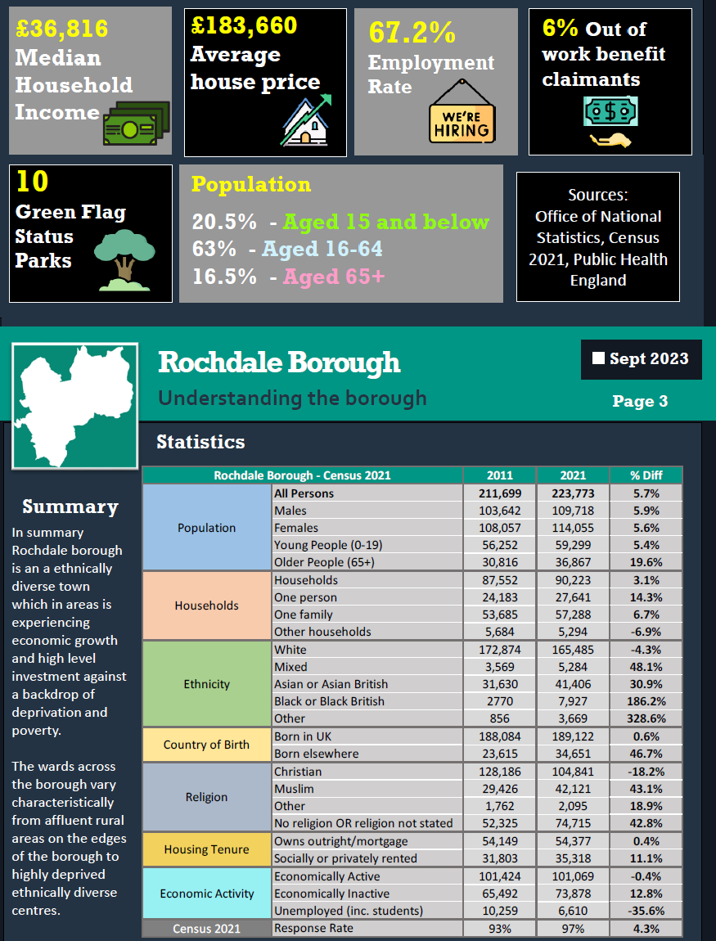
Understanding the Borough Reference: JNSA 2023

4

Introduction
The Rochdale Borough Safeguarding Children Partnership (RBSCP) has been developed to support the Children and Social Work Act 2017 and Working Together to Safeguard Children 2023. RBSCP provides the framework for the safeguarding arrangements under which the safeguarding partners and relevant agencies work together to identify and respond to the needs of children, commission and publish local child safeguarding practice reviews and provide scrutiny to ensure the effectiveness of the arrangements.

Our framework fosters a culture of continuous learning and improvement across the partnership. As part of our core arrangement, we have a robust local child safeguarding practice review (LCSPR) process, effective multi- agency audits, analysis of performance data and a comprehensive multi-agency training programme. Our governance structure has a clear line of sight to front line practice for leaders to understand the effectiveness of arrangements to safeguard and promote the welfare of vulnerable children.

The involvement of relevant partners has been fundamental to the effective safeguarding of children in Rochdale borough and our new structure enables continued meaningful engagement through membership of groups and a multi-agency meeting forum. The commitment of our partners is highly valued and the success of the new arrangements relies on the continuation of these positive relationships.


Lead Safeguarding Partners s
Rochdale Lead Safeguarding Partners (LSPs) have equal and joint responsibility for local safeguarding arrangements and have agreed on the model of oversight, single- and multi-agency governance, accountability and service delivery, supported by independent scrutiny. The Rochdale Lead Safeguarding Partners (LSPs) are:
  - The Chief Executive of Rochdale Borough Council
  - The Chief Executive of the Greater Manchester NHS Integrated Care Board
  - The Chief Constable of Greater Manchester Police.

Local Safeguarding Partners (LSPs) coordinate safeguarding services across their areas and meet three times a year through the Greater Manchester Safeguarding Alliance, which provides strategic leadership and oversees implementation of learning at all levels. In Rochdale, LSPs delegate certain functions but remain accountable for decisions made on behalf of the Rochdale Safeguarding Children Partnership. Designated Safeguarding Partners (DSPs) represent their agencies with authority, make decisions, commit to policy and resources, and ensure effective implementation of safeguarding arrangements.

Designated Safeguarding Partners
In Rochdale the delegated officers from each statutory agency act as Designated Safeguarding Partners (DSPs), and they are:
  - Director of Children’s Services (Rochdale Borough Council)
  - District Commander (Greater Manchester Police)
  - Medical Director (Greater Manchester NHS Integrated Care Board)

The Designated Safeguarding Partners, working together, have equal authority & shared responsibility for leading the multi-agency safeguarding arrangements to ensure they are effective in bringing together relevant partner agencies. Joint functions of delegated safeguarding partners include:

- Delivery and monitoring of multi-agency safeguarding priorities and procedures.
- Partnership working with education allows better identification of and response to harm.
- Implementation of effective information sharing arrangements between agencies.
- High-quality, timely Rapid Reviews and Local Child Safeguarding Practice Reviews, evidencing impact of learning and independent scrutiny clearly in yearly reports.
- Provision of appropriate multi-agency workforce development and training.
- Seeking and responding to feedback from children and families, co-designing services, ensuring children from different communities access the help and protection they need.

The organisation charts, in Appendix 1, highlight safeguarding responsibility distribution within each statutory partner.

RBSCP Vision & Values s

In Rochdale Borough our shared vision is:
Children and young people in Rochdale Borough will be safe and feel safe within their homes, schools and communities.

Fundamental to achieving our vision is a framework which engages all partners, embracing a transparent and reflective approach to safeguarding, designing services informed by the views and experiences of children and practitioners, knowing our strengths, continuously learning from practice and delivering focused training to address areas requiring development for the benefit of our children, young people and families.

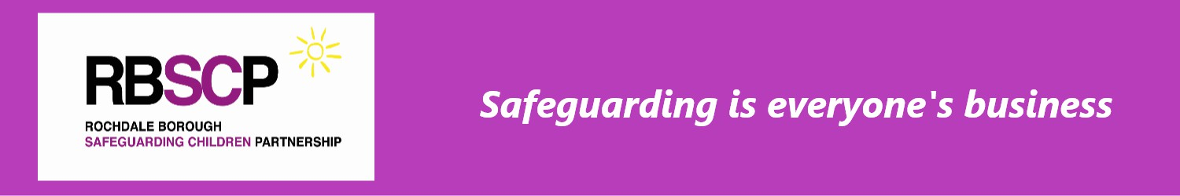
Rochdale’s central value is that:

For services to be effective, each practitioner and organisation acts to achieve sustainable impact supporting the whole family, regardless of their level of need, where:

- Children are safeguarded and their welfare promoted.
- Partner organisations and agencies collaborate, share and co-own the vision for how to achieve improved outcomes for vulnerable children.
- Partners challenge appropriately and hold one another to account effectively.
- There are early identification and analysis of emerging safeguarding issues & threats.
- Learning is promoted and embedded in a way that local services for children and families can become more reflective and implement changes to practice.
- Information is shared effectively to facilitate accurate and timely decision making.
- Local data from all agencies is developed to strategically identify and respond to the underlying conditions and factors that lead to the need for help & protection.

Effective safeguarding partners collaborate to create processes that:

- Drive action beyond organisational boundaries.
- Build trust with children and families, forming the basis for meaningful help and protection.

To be effective, these arrangements link to wider strategic partnerships including the Children & Young People Partnership (CYPP), LCO Boards, Rochdale Borough Adult Safeguarding Boards (RBSAB), Rochdale Youth Justice Board, Rochdale Safer Communities Partnership, Families First Partnership Programme, the Local Family Justice Board and Multi-Agency Public Protection Arrangements etc.

Leadership

RBSCP structure and affiliations to wider structures can be found in Appendix 2. A full list of RBSCP ‘relevant’ agencies, who RBSCP consider have a requirement to safeguard and promote the welfare of local children as defined by Working Together to Safeguard Children 2023, are published on the RBSCP website, and access link is in Appendix 3.

Rochdale Borough Safeguarding Children Partnership Executive
RBSCP Executive meet bi-monthly and oversees the wider RBSCP Partnership. Membership consists of the three Designated Safeguarding Partners, their deputies and the Assistant Director of Schools and Inclusion, in recognition of their important safeguarding role. The Assistant Director of Children’s Social Care also represents Youth Justice and Children’s residential homes. The Designated Nurse for Safeguarding Children (HMR), GMP Detective Superintendent and Head of Safeguarding and Quality act as professional advisors on RBSCP Executive.

One Designated Safeguarding Partner (DSP) Chairs the RBSCP multi-agency arrangements,
with an appointed Deputy Chair. The DSP Chair role may rotate if agreed by LSPs. The Chair facilitates discussions, ensures continuity, and acts as the main contact for the Full Partnership and Executive, but does not replace complaints procedures or provide independent scrutiny.
The DSPs must focus on driving safeguarding practice improvements to deliver RBSCP Priorities, ensuring Police, Health and Children Service professional practice is effective to help and protect children. Like the LSPs, DSPs must act as an equal and joint collaborative. In Rochdale senior leaders have direct sight of practice to respond quickly to the needs of children.

The effectiveness of the partnership to safeguard and promote the welfare of children and young people is supported via multi-agency safeguarding subgroups. The RBSCP subgroups are Child Safeguarding Practice Review Group, Safeguarding Performance & Quality Assurance Subgroup, Early Years, Education & Safeguarding Group, EHASH Strategic Group and the Learning & Development Group, a summary of their functions can be found in Appendix 4.

Strategic direction and progress of the RBSCP Priorities is informed by reports to RBSCP Executive from Subgroup Chairs, RBSCP Business Manager, Independent Scrutineer and other assurance reports, as required using the RBSCP reporting proforma. RBSCP Executive may also co-opt partners to report on safeguarding matters or Annual Reports related to safeguarding local children. RBSCP Executive also aligns RBSCP Priorities to wider boards and partnerships.

All safeguarding partners must raise awareness of emerging safeguarding themes and issues within the borough, and these can be reported to and discussed at the RBSCP Partnership or Executive meetings as an agenda item. Relevant Safeguarding partners can also request or be requested to attend a Safeguarding Partnership Executive meeting to discuss a specific issue or emerging theme to ensure multi-agency safeguarding awareness and responses, where needed.

The RBSCP Executive compiles and agrees the Yearly Report from RBSCP Partnership, Executive, Subgroup or affiliated group activity and outcomes. The Annual Report also contains statements from the RBSCP Chair and the Independent Scrutineer on progress.

Rochdale Borough Safeguarding Children Partnership

RBSCP is obliged to set out which organisations and agencies are required to work together as part of the safeguarding arrangements to promote the welfare of local children. These are referred to as ‘relevant agencies’ who should act in accordance with the arrangements and:

- Fully engage with the RBSCP functions as set out within this document.
- Provide information which enables and assists the safeguarding partners to perform their functions to safeguard and promote the welfare of children in their area, including those related to local and national child safeguarding practice reviews.
- Ensure that their organisation works in accordance with the interagency safeguarding procedures approved by the RBSCP.
- Have appropriate robust safeguarding policies and procedures in place specifically relevant to their organisation.
- Provide evidence of the above to the relevant subgroups, including the RBSCP Performance and Quality Assurance Subgroup (PQA).

As recommended by Working Together to Safeguard Children 2018, and emphasised in the revised 2023 guidance, all schools (including independent schools, academies and free schools), colleges and other educational providers are named as relevant agencies.
RBSCP will work with all relevant agencies and ensure they are fully involved in RBSCP activity. The RBSCP Forum includes wider partnership members, with responsibility for services that support children and families in the local area. All the RBSCP ‘relevant agencies’ are represented on RBSCP subgroups and task & finish groups. These groups assist and inform the RBSCP Executive in carrying out essential safeguarding work and development.

The RBSCP is chaired by the appointed DSP member and meets 3 times a year. One of these meetings maybe a joint meeting or conference with the Adults Board in the form of a borough wide Safeguarding conference. Importantly, RBSCP oversees the findings from Local Child Safeguarding Practice Reviews, facilitates challenge around safeguarding practice, considers solutions and disseminates learning across the partnership and community.



Transparency and Scrutiny
Working Together to Safeguard Children 2023 states that independent scrutiny is required to drive continuous improvement and provide assurance that safeguarding arrangements are effective. It should also consider learning from local child safeguarding practice reviews, national reviews and thematic reports. Scrutiny should be evidence-based, and feedback should be considered and acted upon by safeguarding partners but will also contribute to the wider system of accountability which includes the independent inspectorates and regulation of relevant single agency inspections.
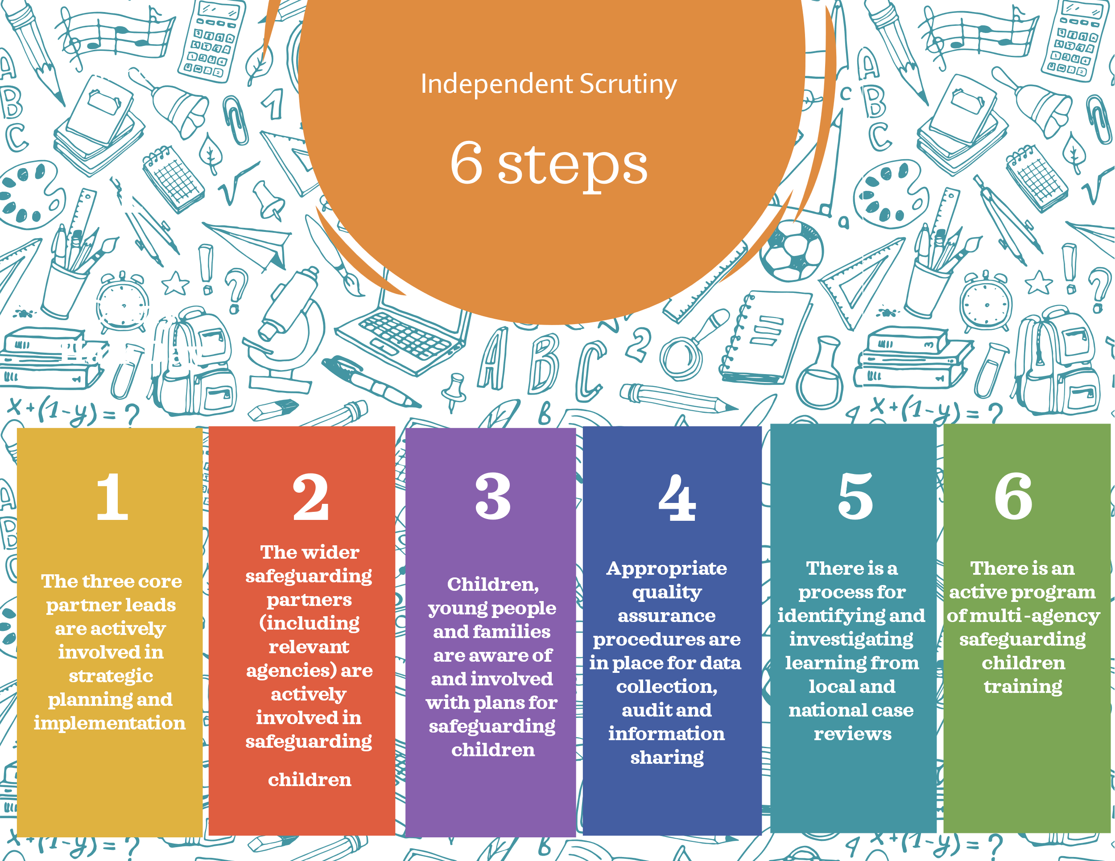

The ‘Six Steps for Independent Scrutiny: Safeguarding Children Arrangements’ by Pearce, J (2019); Institute of Applied Social Research; University of Bedfordshire.

The Independent Scrutineer, appointed by the RBSCP, delivers the six steps of scrutiny through analysis of activity and impact. Scrutiny of the RBSCP Executive is realised through assessment of the effectiveness and evidenced impact of the safeguarding arrangements. The Independent Scrutineer workplan is centered around local safeguarding practice and the effectiveness of achieving the RBSCP Priorities. Scrutiny will also include:
- Reviews the work of Safeguarding Performance & Quality Assurance Subgroup on a quarterly basis including an analysis of the data set and the progress of multi-agency case file audits (MACFA) action plans.
- Reviews S11 and S157/175 completion, reports and action plan progress
- Reviews progress and impact of Local Safeguarding Child Practice Review action plans and oversight by Safeguarding Practice Review Subgroup
- Provides a report to the Safeguarding Partnership Executive quarterly detailing progress and highlighting areas for improvement and attends as requested.
- Provides a Lead Safeguarding Partners report and meets with them, as requested.

The impact of Independent Scrutiny provides an objective, constructive and reflective examination of current practices to drive improvement within a systemic learning culture.

A Responsive Partnership

Children and Young People Shaping the Future of our Services
The RBSCP is committed to improving services and outcomes for children and young people through engagement and consultation. Assurance of safeguarding arrangements and impact of practice is achieved through understanding the experiences of those accessing services. RBSCP aim to strengthen and embed baby, child, young person and family voices within governance, decision making and strategic planning.

RBSCP has Strategic Participation Champions who help co-ordinate all the partnership participation and engagement work, sharing good practice and identifying areas to develop.

Work is underway to co-produce a Partnership Participation and Voice Strategy, to improve multi-agency collaboration & increase opportunities to ensure that baby, child, young person, and family voices are actively listened to, valued, and meaningfully acted upon.

Ongoing improvement work aims to align participation work, strengthen voice opportunities
in Partnership activities and be assured of sincere and significant participation, engagement and
co-production with children and families.

Learning from our Practitioners
The RBSCP will engage with practitioners through practitioner forums, reflective events and learning circles. Learning or thematic topics for discussion are identified by the RBSCP or Subgroups, and practitioner feedback or findings are reported to the RBSCP Executive.

Specific Practitioner Events are also held as part of all Local Child Safeguarding Practice Reviews. These provide practitioners close to the child/ren involved in serious incidents with the opportunity to come together with the Independent Author/Reviewer to share practice experience, explore findings, foster learning and drive improvement in the systems related to direct safeguarding practice.

Members of the RBSCP Executive will also undertake visits of services, view frontline practice and speak to practitioners as part of quality assurance arrangements. These visits will be agreed by the RBSCP Executive to understand the quality of service. Feedback from visits will be collated with other quality assurance activity and fed back to the RBSCP Executive via Safeguarding Performance & Quality Assurance Subgroup.

Learning from Good Practice and Reviews

Local Child Safeguarding Practice Reviews (LCSPR) are completed by the Safeguarding Practice Review Group as required by Working Together 2023. Following a significant incident to a child, a Greater Manchester Serious Child Safeguarding Case Notification form is submitted and an initial SIN meeting takes place to consider the criteria for SIN. If the DSP representatives agree threshold is met, the serious incident will progress to a Rapid Review. Children’s Services formally notify the National Child Safeguarding Panel.

The full process can be found in Appendix 5, but in summary, a LCSPR Panel will undertake a rapid review of the circumstances surrounding the serious incident, making recommendations to the DSPs regarding criteria for a LCSPR. Where a LSCPR is required, RBSCP commission an independent author, and the LCSPR Panel manage the process to completion, approving final report and developing achievable local actions in line with findings and recommendations. The Safeguarding Practice Review Subgroup oversees action plan progress and practice improvement, and the Learning and Development Group provides and disseminates learning.

Publication of Child Safeguarding Practice Reviews or information about the improvements will be via RBSCP website within six months, unless circumstances exist such as ongoing criminal investigations, inquests or future prosecution. Any delay to the completion or publication of a review is approved by RBSCP Executive and the National Child Safeguarding Practice Review Panel is updated. NSPCC also maintains a national case review repository where case reviews remain available for five years.

Where RBSCP Executive considers it inappropriate to publish a review report, arrangements will be made to publish information about the improvements made following the review. The RBSCP Executive will set out rationale for non-publication of the report to the National Panel.

Child Death Overview Panel
When a child dies, in any circumstances, the responsibility for ensuring child death reviews are conducted is held with the Local Authority and the local Integrated Care Board via a Child Death Overview Panel (CDOP). LSPs are required to respond to any safeguarding issues that are identified by the Bury, Rochdale and Oldham Child Death Overview Panel (CDOP) which reviews the deaths of all children in Rochdale. They are required to respond to notifications that a child has died, and abuse or neglect is known or suspected, to determine whether the case meets the criteria for a local child safeguarding practice review. The CDOP Annual Report is presented to RBSCP to ensure good practice and learning are shared and developed.
LSPs are also required to respond to notifications from the coroner that a child has died and they have decided to investigate the death or commission a postmortem (as per Working Together 2023). In circumstances where abuse or neglect is known or suspected, safeguarding partners will again determine whether the case meets the criteria for a local child safeguarding practice review.

A Well-Informed Multi-Agency Workforce

Partnership workforce development is facilitated by RBSCP Learning and Development Group who devise RBSCP Training Strategy and coordinate partnership safeguarding learning events. The group supports the Performance & Quality Assurance Subgroup and Practice Review Group through the RBSCP Business Manager. The multi-agency safeguarding training offer is informed by training needs analysis and learning from practice reviews and audit, to improve safeguarding practice and improve outcomes for local children and young people. RBSCP is committed to providing a comprehensive multiagency training programme which includes the following elements:

- Core safeguarding training courses, providing a foundation for good multiagency safeguarding practice, with refresher events to keep knowledge up to date. Courses are offered regularly throughout the year to maximise access, including train the trainer offer.
- Subject specific training events, and seminars, provide safeguarding training in greater depth. Topics vary, depending on local and national safeguarding themes and the offer adapts to meet partnership workforce needs, so that demand is responded to effectively.
- E learning - a suite of safeguarding children courses, provide numerous topics for practitioners to access, including neglect, sexual abuse, physical abuse and emotional abuse, and wider safeguarding practice matters.
- Development of innovative learning materials, including 7 Minute Briefings, 5 Minute Takeaway, Workbooks, videos, spider grams or infographics.

Evaluating the impact of learning

To ensure that local and national learning impacts positively on practice and that changes are embedded, sustainable over time and have the desired effect, monitoring is undertaken to:
- Ensure training courses reflect statutory safeguarding standards and principles.
- Monitor training effectiveness, attendance and impact on practice.
- Quality assure training programmes using Learning Framework and QA Process.
- Actively involve practitioners to obtain meaningful feedback and evaluation.
- Ensure the voice of children, young people and families is evident in training.
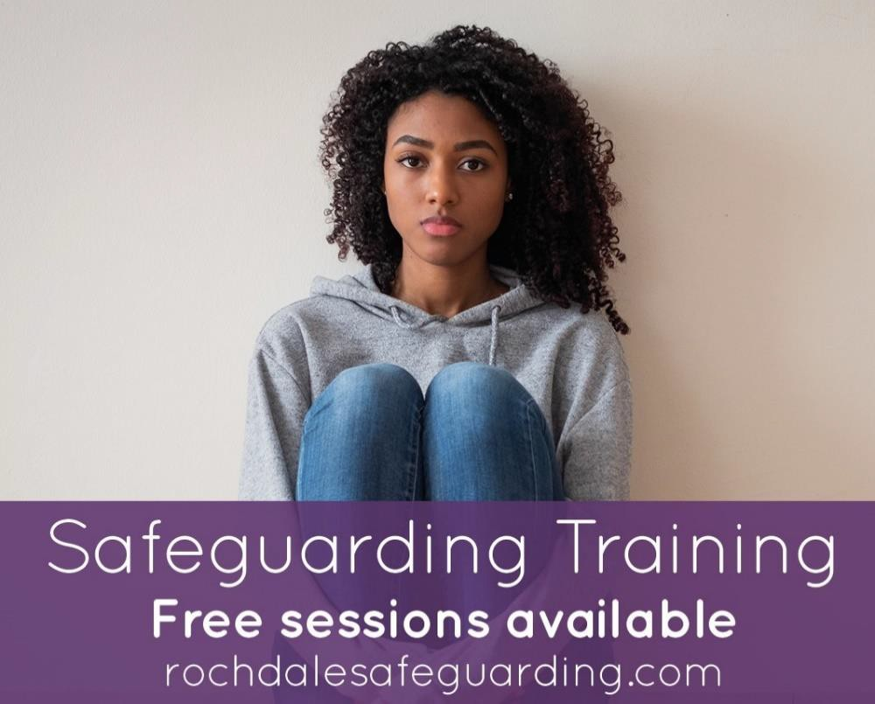

Understanding Strengths and Areas for Development

Analysis of the effectiveness of the RBSCP in safeguarding children is provided by the Safeguarding Performance & Quality Assurance Subgroup through data analysis and multi-agency audit. The group works closely with Children’s Social Care Quality Assurance and Safeguarding Lead The group oversees multi-agency audits and reviews single agency audits, leading an audit cycle which is responsive to areas of concern and includes a programme of re-audit/ dip sampling to evidence effective safeguarding practice improvement.

The QA Framework is published on the RBSCP website and provides the strategic principles of RBSCP quality assurance including audit, performance and evidence of practice improvement impacting positively on children and families in Rochdale. Quality Assurance Framework
The audit cycle reflects the RBSCP Priorities and is also informed by:

• Child Safeguarding Practice Reviews
• Performance indicators and dataset information/analysis
• Repeated issues or concern, including those highlighted through previous audits.
• Feedback from practitioners, management forums or policy developments.
• Views of children, young people and their families to support qualitative analysis.
• Joint Targeted Area Review (JTAI) themes identified for improvement.
• Statutory audit requirements and findings from Section 11 and Section 157/175.

SPQA group and other subgroups use data and intelligence to explore and monitor performance in their area of responsibility, aligning to the RBSCP Priorities. This information assesses the effectiveness of partner services effectiveness in helping to protect children and families. For example, Northwest Dataset, Early Help, Early identification of Neglect, responsivity and identification of Need, outcomes for children and families, Voice, Operation Encompass etc.

SPQA Group is responsible for agreeing and updating interagency safeguarding procedures. These apply to the Greater Manchester online Procedures, which provide a clear framework under which Greater Manchester organisations work together to safeguard children. Procedures are regularly updated to take account of local or national learning, changes in legislation or statutory guidance.
The Early Help and Safeguarding Hub (EHASH) Strategic Group oversees the delivery and development of the front door to ensure children and families receive the right services at the right time.
This will be achieved via consultation and collaboration with all multi-agency stakeholders, to provide assurance that EHASH operates within the Family Safeguarding Practice Model & is linked into the Families First Partnership work.

The EHASH Group oversee the delivery and development of the EHASH model, integrating early help and safeguarding approaches to:
- Strengthen Safeguarding Outcomes.
- Promote Partnership Working.
- Drive Consistency and Quality.
- Champion Strategic Development.
- Embed the Voice of the Child.
- Ensure connectivity with other strategic boards.
- Drive delivery and improvement across the front door.
By overseeing quality assurance activity and data analysis the EHASH Group can better inform local priorities in the context of emerging themes, regional and national work.
The EHASH Group will provide monitoring and challenge when appropriate, using regular audits and data analysis, whilst seeking the views of children and families to ensure EHASH provides the care and support required for effective outcomes. EHASH data, information & intelligence assures RBSCP Executive of Early Help and Front door performance, quality and outcomes.

Working Together with Education Partners

RBSCP recognise the importance of Education as being central to the safeguarding of children and has the Assistant Director of Schools and Inclusion as a central member of the RBSCP Executive. In addition, there are designated representatives from Primary, Secondary and Special School Headteachers as members of the RBSCP Full Partnership, in recognition of their important safeguarding role and to ensure they are represented at strategic discussions.

All local education and childcare providers working with children up to the age of 18 are included in local arrangements and members form the Early Years, Education & Safeguarding Subgroup. This group is responsible for ensuring education partners are informed and involved with strategic development of safeguarding, providing assurance to Rochdale Borough Children Safeguarding Partnership (RBSCP) that all key stages are actively working towards guidance within Keeping Children Safe in Education 2025 and Working Together to Safeguard Children 2023.

The Partnership Early Years, Education and Safeguarding Subgroup will:

- Ensure strategic links between Rochdale Borough Children Safeguarding Partners, Early Years and Education. To foster greater understanding of each other’s priorities.
- Provide key assurances and updates to Rochdale Borough Safeguarding Children Partnership and a platform for the RBSCP to disseminated key messages.
- Provide opportunities to hear safeguarding experiences of Early Years and Education.
- Explore and strengthen issues regarding safeguarding process, policy and procedure.
- Ensure full compliance in Section 157 / 175 audit activity, sharing good practice and timely progress against improvements.
- Evidence quality assurance outcomes for safeguarding children and young people, in respect of improved safeguarding practice and policy development.
- Share strategic information and issues in respect of children and young people, particularly those relating to high level matters and national attention.
- Ensuring that the learning from Child Safeguarding Practice Review learning is shared and cascaded to ensure Early Years and Education practitioner access learning and development for the benefit of children and young people.
- Facilitate challenge and scrutiny from the Independent Scrutineer to assure RBSCP of the effectiveness of processes, activity and improvements.
- The Chair of sub-group will provide regular reports to the RBSCP & Executive.
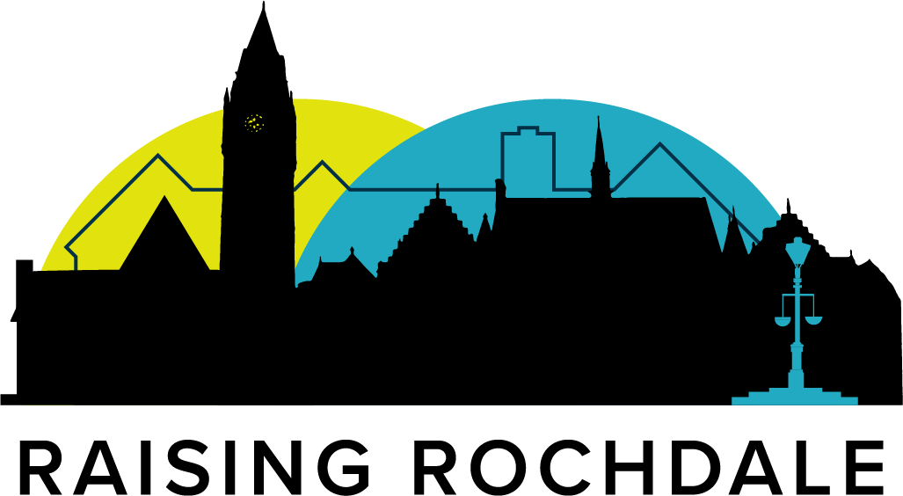

Identifying our Vulnerable Children and Emerging Threats

Working Together 2023 defines contextual safeguarding as threats to the welfare of children through vulnerability to abuse or exploitation from outside their families.

‘These extra-familial threats might arise at school and other educational establishments, from within peer groups, or more widely from within the wider community and/or online. These threats can take a variety of different forms and children can be vulnerable to multiple threats, including exploitation by criminal gangs and organised crime groups such as county lines; trafficking, online abuse; sexual exploitation and the influences of extremism leading to radicalization. Extremist groups make use of the internet to radicalise and recruit and to promote extremist materials. Any potential harmful effects to individuals identified as vulnerable to extremist ideologies or being drawn into terrorism should also be considered’

The Complex Safeguarding Board will operate under delegated authority from the RBSCP to reflect upon, identify, develop and seek assurance of membership safeguarding systems. The aim of the quality systems is to ensure RBSCP understand and are assured on the effectiveness of local multi-agency complex safeguarding activity. Our Complex Safeguarding Service offers assurance through an annual report and oversight through the Complex Safeguarding Strategic Board. The Complex Safeguarding Board’s overall aim is to protect children and young people from being exploited and ensure that victims are well supported. The Complex Safeguarding Annual Report is further submitted and overseen by RBSCP, Joint Leadership Team and Cabinet.

The Channel Panel is a voluntary, multi-agency safeguarding process under the UK’s Prevent strategy that protects children vulnerable to radicalisation. Referrals are assessed, and with parental consent, a panel of professionals—including social care, housing, education, health, and police—creates a tailored support plan. This plan addresses risks and underlying needs such as mental health, housing stability, education, and online safety, with regular reviews to ensure progress. By intervening early and collaboratively, Channel reduces risks of children being vulnerable to extremism, and / or radicalised, and supports children in a safe, holistic way. Rochdale Channel Panel is chaired by the Head of Service for Complex Safeguarding, and Youth Justice. Channel Panel is governed by the Home Office and we offer assurance through an annual assurance report that is overseen by our Prevent Board, and submitted to the Home Office.

Youth Justice Services work closely with partners such as social care, education, health, housing, and the police to help children achieve positive change. Through joint planning and tailored interventions, they promote safety and stability for children, reduce risks to others, and encourage restorative justice approaches. The service operates under robust governance arrangements through the local Youth Justice Partnership Board and the national Youth Justice Board, which report to the Ministry of Justice, ensuring transparency, accountability, and high standards of practice. Our annual Youth Justice Business Plan is submitted to our Joint Leadership Team and Cabinet.

Partnership, Regional and National Links

To be effective, RBSCP works with wider strategic partnerships including the Children & Young People Partnership (CYPP), LCO Boards, Rochdale Borough Adult Safeguarding Boards (RBSAB), Rochdale Youth Justice Board, Rochdale Safer Communities Partnership, Families First Partnership Programme, the Local Family Justice Board and Multi-Agency Public Protection Arrangements etc.

This ensures strong partnership working, information sharing, supports cross cutting priorities or emerging themes, whilst minimising duplication. The RBSCP will be represented at these boards by one of the three key partners as a minimum. The usual representation will be GM Police at the Community Safety Partnership, the Local Authority and LCO at the LCO Board. Robust links with other strategic partnerships and boards are a strength, and priorities and plans are well aligned.
Rochdale Borough Safeguarding Children’s Partnership (RBSCP) is well established. Shared priorities are communicated clearly in strategic plans and in annual reports. Local and regional governance arrangements are augmented by a culture of professional accountability and respectful challenge.

RBSCP is committed to maintaining our existing regional and national links and will continue to work with the Greater Manchester Combined Authority. The RBSB Business Manager will continue to strengthen Northwest Safeguarding collaboratives, and lead on any regional or national children’s safeguarding initiatives, where relevant.
Arrangements

Information Sharing & Data Protection.
There is a Data Sharing Agreement (DSA) between RBSCP and safeguarding partners. The Memorandum of Understanding within the DSA sets out the principles of Information Governance that all organisations who provide, access and use information have agreed to. It provides a framework for safeguarding the processing of data and information as defined by the Data Protection Act 2018 and General Data Protection Regulation (GDPR). Data sharing agreements have been signed and published on the RBSCP website and can be accessed here

There is a separate Manchester North Standard Operating Procedure to establish effective notification and information sharing procedures between: HM Coroner’s Office for Manchester North, Rochdale, Bury, and Oldham Safeguarding Adults Boards and Safeguarding Children Partnerships, Community Safety Partnerships and the Rochdale, Bury and Oldham Child Death Overview Panel: manchester_north_information_sharing_protocol_final_version.pdf

Data protection and information sharing regarding safeguarding children is prioritised and advice is shared with Partners. For example, the ICO A 10 step guide to sharing information to safeguard children was shared with all RBSCP members.
A 10 step guide to sharing information to safeguard children | ICO

Funding and Resources
All activities undertaken on behalf of the RBSCP should be funded equitably and proportionately by the statutory safeguarding partners (Working Together 2023). RBSCP Executive will have delegated authority from LSP’s to agree funding formulas.
The RBSCP employs a team of Business Unit staff as agreed by the RBSCP Executive, who are hosted by the Council. RBSCP Business Unit provides essential operational, administrative, and strategic support for the main Partnership, ensuring day-to-day functions, coordinating subgroups, managing quality assurance (like audits and data), implementing learning from reviews, overseeing communications, and helping the strategic DSPs meet their statutory duties to protect children from harm, focusing on system-wide effectiveness and continuous improvement.

The RBSCP Business Unit is responsible for overseeing and supporting all the strategic subgroups and working groups. They work closely with the Delegated Safeguarding Partners and other colleagues from across the Partners to ensure work is focused on impact and outcomes for children and young people. Key Roles & Responsibilities include:
Business Management: Handles daily running, supports and organised all RBSCP strategic meetings, and mechanisms to evidence impact all RBSCP activity.
Strategic Support: Assists RBSCP in developing and overseeing local safeguarding strategies, ensuring alignment with national guidance.
Quality Assurance & Performance: Supports and collates performance data, multi-agency audits, reviews case practice (Child Safeguarding Practice Reviews) and ensures effective delivery of services. Ensuring multi-agency safeguarding statutory audits (Section 11 and Section 157/175) and multi-agency audits feature as part of Partnership activity and learning framework
Learning & Improvement: Implements lessons from reviews to drive change and improve practice across agencies.
Communications: Manages the communication strategy to raise awareness and share information effectively, including LSCPR reports, Training and other MASA publications
Policy & Procedures: Supports safeguarding policy and procedure development and review
Coordination: Links together other and all partnerships, subgroups, and agencies to ensure cohesive working.
Baby, Child, Young Person & Family Voice: Ensures feedback from children, young people, and families informs policy and practice.

The three safeguarding partners hold a joint and equal responsibility for resourcing and funding the safeguarding arrangements. Detailed information about income and expenditure is set out annually in the RBSCP Annual Report.

Commissioning of Services.
The safeguarding partners have a role to play in commissioning successful and appropriate arrangements for children. The partners do not commission services directly but will influence commissioning intentions by having a clear understanding of the collective needs of local children. This will be informed through the Joint Strategic Needs Analysis. The safeguarding partners will use this to help them understand the prevalence and contexts of need, including specific needs relating to disabled children, those with special educational needs and those relating to abuse and neglect. This knowledge in turn will help shape services. The partners will ensure that safeguarding and promoting the welfare of children is a primary consideration in all commissioning arrangements, including bids into external funds. Commissioning decisions will continue to be informed by the voices, views, needs and wishes of children and young people.

Yearly Report
RBSCP produces a yearly report on safeguarding arrangements in Rochdale, as per DfE guidance and timescales and is available on the RBSCP website. The report will be a public document and will include:

- Evidence of the impact of work by the safeguarding partners and relevant agencies on outcomes for children and families.
- Analysis of areas with little or no evidence of progress on agreed priorities.
- A record of actions taken by the safeguarding partners in the report’s period (or planned to be taken) to implement recommendations of any LCSPRs
- Ways partners have sought and meaningfully utilised feedback from children, young people and families to inform their work and influence service provision.

The yearly report is endorsed by the RBSCP and the Independent Scrutineer prior to publication and distributed across the full RBSCP and wider affiliated Boards. The report is delivered to Safeguarding Reform & the National Review Panel by September each year, as per Working Together 2023.

Our RBSCP Members also make a pledge to children and young people in Rochdale linked to the Six Principles of Safeguarding: Empowerment, Prevention, Proportionality, Protection, Partnership & Accountability. The RBVSCP Pledge Board can be found in Appendix 6.

Multi-agency Response to Need Document
The RBSCP has published a Multi-agency Response to Need document, which underpins our vision to provide support for children, young people and families at the earliest opportunity to promote the wellbeing and safety of children and young people.

It aims to offer clear guidance and to promote a shared awareness of how we meet children, young people and family’s needs in Rochdale and step in and step out to help and protect children, young people and their parents/families to meet their needs and achieve best outcomes,
Multi Agency Response to Need Guidance

Professional Challenge and Effective Resolution

All agencies have a duty to work co-operatively to safeguard and promote the welfare of children. Effective partnership working is vital to ensure that outcomes for children and families are central to all assessment, planning and intervention. This includes the need to consider differing views and experiences which enhance the value of exchanging ideas and developing critical thinking in how best to achieve effective outcomes.

There will be times when disagreements occur and the RBSCP Professional Challenge and Effective Resolution Process can be followed by all professionals working with children and families across Rochdale, when this occurs. The process details the steps that must be taken to resolve professional differences of opinion about actions taken, or decision making, in respect of arrangements for helping or protecting children. The designated safeguarding partner who is RBSCP Chair and the Independent Scrutineer may act as arbitrator/mediator in unresolved matters at Stage 4.
Professional Challenge and Effective Resolution Process
Whistleblowing g
You’re a whistleblower if you’re a worker and you report certain types of wrongdoing. This will usually be something you’ve seen at work - though not always. Reporting a wrongdoing is also known as making a ‘whistleblowing disclosure’ or ‘protected disclosure’. Information for employees on ‘blowing the whistle’, including a definition of whistleblowing has been published by the Department for Education and is available here.

The Greater Manchester Safeguarding Whistleblowing Policy can be found here
Ofsted Policy and Guidance for Whistleblowers
This policy outlines what Ofsted will do when it receives certain concerns about children’s social care services from a whistleblower. The policy covers all children’s social care establishments, agencies, services and providers that Ofsted inspect and/or regulate.
If you believe that a child is or children are at immediate risk of harm, you should refer your concern to the children’s social care department of the local authority area where the child lives or report this to the police. This includes children living in or supported by agencies that are run independently of the local authority. Further information on the safeguarding of children can be found in ‘Working together to safeguard children ’.
If you would like to read more, please click here

NSPCC Whistleblowing Advice Line
The NSPCC has officially launched its Whistleblowing Advice Line. This has been developed to provide support to employees wishing to raise concerns over how child protection issues are being handled in their own or other organisations. For more information, please click here
The NSPCC Whistleblowing Advice Line can be reached on 0800 028 0285.

Whistleblowing Procedure for Maintained Schools
Every maintained school should have a whistleblowing procedure that protects staff members who report colleagues they believe are doing something wrong or illegal, or who are neglecting their duties. Governing bodies of maintained schools are responsible for agreeing and establishing the school’s whistleblowing procedure. All schools should base their whistleblowing procedures on the procedure of the local authority.
Read more on the guidance here

Appendix 1 - Rochdale LSP Organisational Charts and Scheme of Delegation
Rochdale Borough Council. Children’s Social Care:

Director of Children’s Services (DSP)
Chief Executive of Rochdale Borough Council
(LSP)
Head of Practice Improvement & Safeguarding
Assistant Director Children’s Social Care
Assistant Director Early Years, Early Help & Neighbourhoods
Assistant Director Schools & Inclusion

Chief Executive, NHS Greater Manchester ICB (LSP)

Medical Director NHS Greater Manchester (DSP)

Locality Associate Director Nursing,
Delegated Place DSP

Designated Nurse Safeguarding Children (HMR)
(Advisor to RBSCP)

GM NHS ICB GMP:
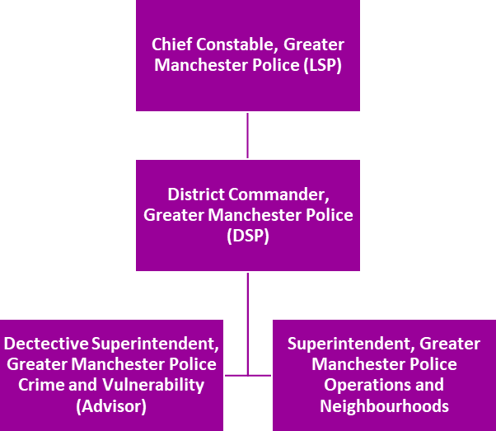

Appendix 2 - Rochdale Safeguarding Children Partnership
Independent Scrutiny
Greater Manchester Multi Agency Safeguarding Arrangements
Safeguarding Partnership Executive

North West Safeguarding Alliance
GM Groups

Rochdale Borough Safeguarding Children Partnership
GM North West Safeguarding Hub

Safeguarding Practice Review Subgroup
Early Help, Education & Safeguarding Subgroup

EHASH
Subgroup

Safeguarding Performance Quality Assurance Subgroup

Learning and Development Sub Group

AFFILIATED GROUPS AND BOARDS:
Children & Young People Partnership (CYPP), LCO Boards, Rochdale Borough Adult Safeguarding Boards (RBSAB), Rochdale Youth Justice Board, Rochdale Safer Communities Partnership, Families First Partnership Programme, the Local Family Justice Board and Multi-Agency Public Protection Arrangements

Appendix 3 - RBSCP Relevant Agencies.
Rochdale Safeguarding Partnership - About the Safeguarding Children’s Partnership (RBSCP)
Appendix 4 - Rochdale Borough Safeguarding Children Partnership Summary
RBSCP Executive Group
The RBSCP Executive provides the statutory ‘holding to account’ function and is responsible for ensuring safeguarding practice improvements and impact is evidenced. The Executive has oversight of the effectiveness of multi-agency arrangements and is responsible for overseeing the RBSCP business, learning from practice reviews and effectiveness of safeguarding productivity and impact. Membership is drawn from the DSPs & deputies.
RBSCP Full Partnership
RBSCP contains a wider membership of relevant agencies and provides a layer of coordination and scrutiny between the RBSCP Executive (where the statutory responsibility sits) and the RBSCP’s subgroups. The RBSCP Full Partnership provides broad collaborative challenge and assurance from across the Rochdale landscape.
Safeguarding Performance & Quality Assurance Group
The SPQA subgroup performs two key tasks for RBSCP. It is the primary audit group and oversees all RBSCP multi-agency audit activity—including that undertaken via other groups. SPQA oversees the multiagency Section 11 and Section 175 /175 safeguarding audit processes. The subgroup is responsible for the analysis and scrutiny of the data and narrative performance reports from partners and provides a forum for partners to hold each other to account in respect of performance and quality assurance of safeguarding practice and improvement. The group oversees the RBSCP Quality Assurance Framework and multi-agency policy design and delivery.
Child Safeguarding Practice Review Group
This group oversees serious incident notifications involving children, facilitates Rapid Reviews, makes recommendations to the RBSCP Executive regarding Multi-Agency or Local Child Safeguarding Practice Reviews. The group liaises with National Panel and facilitates partnership learning from LCSPRs and National reviews to implement and evidence effectiveness of learning from reviews, safeguarding practice improvement and positive impact for children and families.
EHASH Strategic Group

EHASH Strategic Group focuses on the effectiveness and development of EHASH service. to ensure children and families receive the right services at the right time. This will be achieved via consultation with all multi-agency stakeholders and the views of children and families. The EHASH Group examines EHASH performance and audit activity to ensure EHASH provides the care and support required for effective outcomes.
Early Years, Education & Safeguarding Group
Early Years, Education & Safeguarding Subgroup is responsible for ensuring education partners are informed and involved with strategic development of safeguarding, providing assurance to Rochdale Borough Children Safeguarding Partnership (RBSCP) that all key stages are actively working towards guidance contained within Keeping Children Safe in Education 2025 and Working Together to Safeguard Children 2023.
Learning & Development Group
The Learning & Development Group is responsible for high quality, up to date, effective and child focused multi-agency safeguarding training across the partnership to ensure skilled and effective workforces. The group supports all RBSCP subgroups and is supported by a multi-agency training pool to ensure that a comprehensive, relevant and effective multi-agency and single agency training offer is in place. The Learning & Development Group oversees the needs analysis, monitors the quality and effectiveness of safeguarding training, and translates learning from LCSPRs into briefings and trainings options to strengthen safeguarding practice and outcomes.

Appendix 5 – Local Child Safeguarding Practice Review Process
SIN/RR/LCSPR Criteria
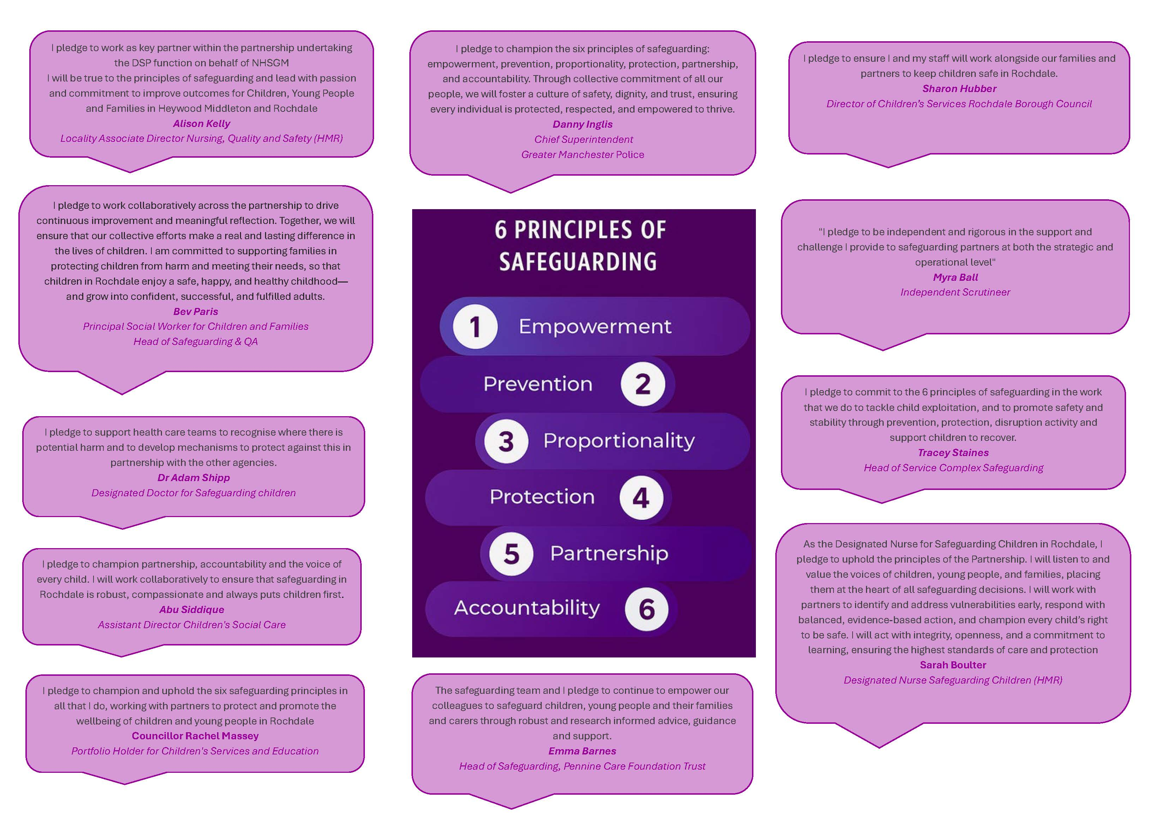
Appendix 6 - RBSCP Member Pledge Board

