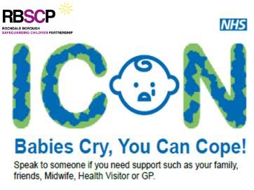
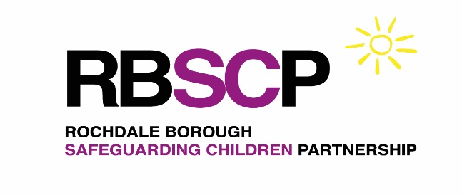

Rochdale
Coping with Infant Crying
Multi-Agency Guidance

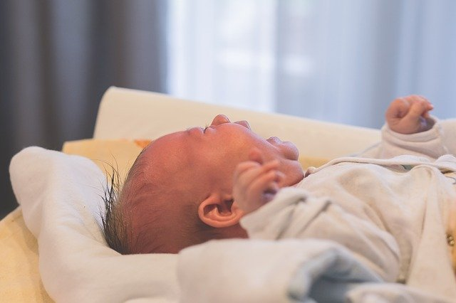

July 2021

Contents page

- Introduction………………………………………………………………… Page 3
- Local picture………………………………………………………………. Page 3
- Aim…………………………………………………………………………. Page 3
- Local progress……………………………………………………………. Page 4
- ICON………………………………………………………………………. Page 4-7
- Resources for professionals……………………………………………. Page 7
- ICON resources…………………………………………………………. Page 7-10
- Next steps…………………………………………………………………. Page 11
- Training / resources and support available for the workforce……….. Page 11
- References………………………………………………………………… Page 11

Introduction

All babies cry, some cry more than others. Crying is the baby’s way of communicating that they need comfort and care.

The stress of a crying baby can impact on parenting ability and can have a potentially negative impact on parental and child welfare (Smith, 2016).

Nationally, Abusive Head Trauma (AHT) affects up to 25 children per 100,000 in the UK (Kemp, 2011). A well-documented trigger is infant crying and evidence suggests male caregivers are responsible for inflicting AHT in about 70% of cases.

The highest category of fatal physical abuse is a non-accidental head injury. Many of the cases reviewed within the analysis undertaken by Brandon et al in 2016, appeared to arise ‘out of the blue’ and families were described as being open to universal services; on closer examination some families had vulnerabilities. Vulnerabilities included domestic abuse, particularly in the context of young parents, ambivalent feeling towards the child and overall social isolation.

A review by the National Safeguarding Review Panel into Non-Accidental Injuries in Babies under the age of one year is currently ongoing. Once available, findings from the review will be incorporated into this guidance document.

Local picture

Abusive Head Trauma has been a factor in one Serious Case Review (now known as Child Safeguarding Practice Reviews) and four Rapid Reviews (one of which will be progressing to a Child Safeguarding Practice Review) in the Rochdale Borough since 2017.

- Three are infants of six months of age or younger; with the remainder being two years of age or younger.
- Four of the children are female and one male.
- Historic domestic abuse was a factor in two of the cases.
- Previous safeguarding concerns in two cases (either sibling / parent in childhood).
- Alcohol / substance use was a factor in one case.

Aim

The overarching aim of this multi-agency guidance is to reduce the number of child deaths and serious injuries to infants in Rochdale resulting from Abusive Head Trauma.

It is essential that parents and care givers are provided with consistent information and advice by all professionals in relation to coping with infant crying and the life threatening, long term consequences of shaking a baby.

This will require increased awareness of professionals working across the safeguarding partnership (adult and children’s services including housing, mental health, probation, drug and alcohol services, early years and play, and general practice staff) as to the risks associated with shaking a baby and support available to parents / carers across the borough in coping with infant crying.

Local progress

‘Keep Baby Safe’ is a priority area for the Rochdale Borough Safeguarding Children Partnership. Coping with Infant crying and preventing Abusive Head Trauma is a key focus area.

A multi-agency working group was established in January 2020 and has undertaken the following work:

- Reviewed resources available and committed to the consistent use of ICON resources and message.
- Scoped out the local universal health touchpoints for delivery of ICON message to ensure this is in line with the national ICON programme.
- Promoted the ICON message across the safeguarding partnership including via social media, staffing a stall at Number One Riverside, distribution of resources including a 7-minute briefing for professionals.

ICON

ICON is a national programme underpinned by the following principles:

- Some care givers lose control when a baby’s crying becomes too much with some going on to shake a baby with devastating consequences.
- The most effective evidence-based programmes provided a simple message that support parents / care givers to cope with infant crying.
- A co-ordinated parent education programme targeting parents of all new-born infants can reduce the incidence of Abusive Head Trauma in children less than 36 months by between 47 and 75% (Smith, 2016)

The programme uses the acronym ‘I-C-O-N’, with each letter representing a key message as detailed below:
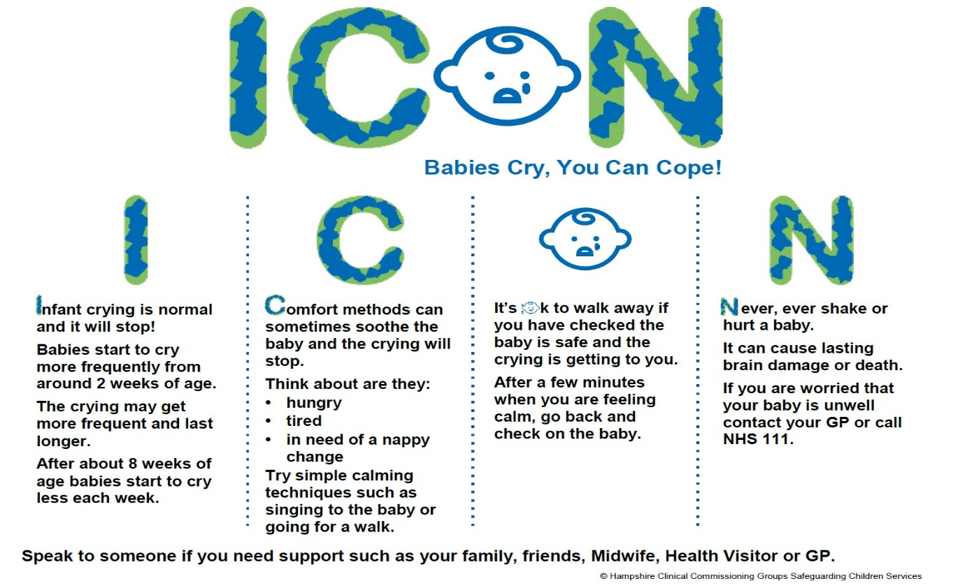
The aim is to help people who care for babies cope with crying, provide advice on comforting a crying baby, set out the devastating impact of shaking a baby (which includes brain damage and death) and signpost to sources of support using a variety of resources including discussion, video, written resources and social media.

There are six established touchpoint areas in the national ICON programme where all expectant / new parents receive the ICON message:

- Antenatally via midwife
- Following baby’s birth via midwife
- 10 day post-natal visit via midwife
- 10-14 day new birth visit via health visitor
- Six week contact via health visitor
- Six - eight week check via GP

(May be local variations; see table below for details)

Parents and families who have been affected by Abusive Head Trauma have been pivotal in supporting the design and roll out of ICON.

Touchpoint areas as set out within ICON and additional contacts which are delivered in Rochdale:

Timeline | Type of contact | ICON messages delivered and resources used
ICON messages promoted across the whole partnership | Aimed at expectant parents, parents, carers, family members and professionals | Visual resources such as film clips and posters promoted via social media platforms  Awareness raising stand at Number One Riverside at launch in 2019  Seven-minute briefing for professionals
Targeted discussions responding to identified need / requests for advice | All professionals | Resources detailed below are used  Signposted on to midwife / health visitor / GP as required
1st Established ICON touchpoint: antenatal | Delivered by midwife by 36 weeks gestation – face to face discussion | Leaflets, email and posters.  Documented in midwifery records.  Coping with Crying plan discussed, signposting to ICON website. Exploring possibility to provide printed copies of Coping with Crying plan.
Antenatal contact: between 28-32 weeks gestation | Health visitor offer contact to all universal and targeted pregnant women | In line with Internal Standard for Antenatal Contacts.  Discussion and provide copy of ICON leaflet.
28 week pack | Children’s centres | Contains ICON leaflet
Bump to Baby sessions delivered by children’s centre staff | Face to face sessions offered universally to all parents | Coping with Crying and support networks included within 3-week course
2nd Established ICON touchpoint: following baby’s birth | Delivered by midwife to mother and birthing partner  prior to discharge. If a woman has birthed at home this is done before the midwife leaves the home setting | Discussion starts with a recap of the recollection of messages given antenatally by the midwife and health visitor  Talk (using ICON Key Talking Template) and leaflet  Documented in midwifery records
3rd Established ICON touchpoint: primary community midwife visit and at discharge from midwifery services | Delivered by community midwife | Discussion starts with recap and recollection of messages given antenatally and following delivery  Talk and leaflet  Documented in midwifery records
4th Established ICON touchpoint: 10-14 day new birth visit | Health visitor | Talk in line with Internal Standard for New Birth Visits.  Coping with Crying plan discussed
Post-natal pack | Children’s centres | Contains ICON leaflet
5th Established ICON touchpoint: six week contact | Health visitor | Talk as per internal standard for six -eight week contact
6th Established ICON touchpoint six - eight week check | Six - eight week check by GP | ICON is an identified area within the six - eight week examination template for verbal discussion / link to written resource to share with parents  Royal College of GP’s National Safeguarding Toolkit (Endorses ICON)
Targeted visit three - four months | Health visitor | Talk and leaflet in line with internal standards for targeted families

Information is delivered in the parent’s first language and with reasonable adjustments such as use of pictorial ICON resources and repetition for parents with learning disabilities. To access the translation tool visit the national ICON website and click on the orange disc in the top right hand corner of your screen.

Resources for professionals

1001 Days

The 1001 days cross party manifesto (2014) sets out the evidence for the critical importance of the period between conception and age two for a child’s development and their lifelong outcomes. Such evidence is further reinforced in the Early Years Healthy Development Review Report: The Best Start for Life: A Vision for the 1,001 Critical Days (2021).

In Rochdale several agencies including health visiting, midwifery, Homestart, Healthy Young Minds, psychological therapies, locality team and children’s centres came together to develop a pathway that focused on increasing awareness and attendance at different interventions over the 1001 day period. The aim of this pathway was to ensure that as a multi-agency team we were engaging with vulnerable families earlier in pregnancy and ensuring plans were in place to support families.

ICON Resources

Rochdale borough ICON leaflet
ICON easy read leaflet
ICON premature babies leaflet

I - Infant crying is normal

All babies cry to varying degrees with different causes and reasons. Being aware of why your baby is crying can help to achieve a more appropriate response minimising stress.

Key messages:
- All babies’ cry; some more than others.
- Crying is normal and is a baby’s way of communicating and letting their parents / care givers know that they need comfort and care.
- Sometimes it’s easy to work out what the baby wants, sometimes it’s not.
- The most common reasons a baby cries is due to being hungry, having a soiled or wet nappy, being tired, wanting a cuddle, wind, being too hot or too cold, boredom and overstimulation.
- Sometimes, you may not know why a baby is crying.
- Advice and support is available from the Midwife, Health Visitor or GP.

Infant crying reaches a peak at around two months of age (see Curve of Early Infant Crying below). At this time a high crying baby may cry for five - six hours per day.
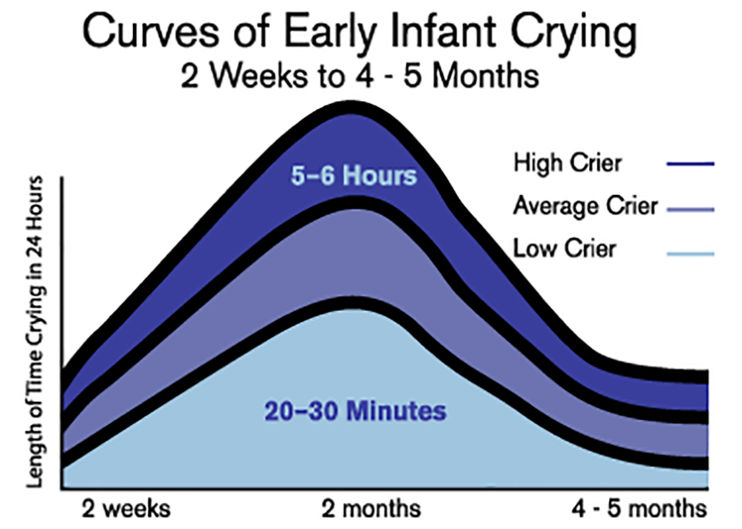m any p
Resources:

ICON Information for Parents about infant crying

‘I am Unshakeable’
Public Health England, in Partnership with ICON have developed a three minute video clip from a dad’s perspective, showing how to use the ICON resources when caring for a crying baby: Preventing Traumatic Head Injury in Babies by Public Health England in Partnership with ICON

ICON Animated Video Clips
Several short animated clips for parents are available on topics including:
- The peak of infant crying
- How to comfort your baby
- Parent relaxation techniques
- Ways to cope with crying
- Dads please talk

Dad Matters
Supports dads to be and new dads with attachment and bonding, mental health and accessing appropriate services.

C- Comforting methods can help

Try some simple comforting techniques to try and soothe your baby. Check if the baby is hungry, tired or needs a nappy change.

Simple comforting techniques such as holding the baby close, swaying, dancing, talking, singing can be used to try to soothe a baby. Also, check if the baby is hungry, tired or needs a nappy change.

Parents can be supported to develop a Coping with Crying plan, see below.

Resources / Sources of Support:

ICON Information for parents on comforting methods

NHS website - Soothing a crying baby
The NHS have information and guidance on their website which gives parents the techniques to comfort a crying baby.

Cry-Sis
Cry-Sis is a charity offering help and support to parents with babies who cry excessively or have sleeping problems. Their website provides advice, information and guidance along with a telephone helpline that parents can access for advice.

Little Lullaby
Little Lullaby has been created by young people for young people and provides advice and guidance around caring for babies and education around safer sleeping

O- OK to walk away

It's Okay to take a break from your baby's crying, as long as your baby is in a safe place. Try some relaxation techniques and return to check on your baby after a few minutes.

Parental Self-Care Tips
- Try to prepare and eat healthy meals.
- Take a break each day, and try to get outdoors near your home once a day.
- Try and get as much sleep and rest as possible.
- Take a relaxing bath or shower.
- Stay in touch with family and friends.
- Talk through emotions with family or friends
- Look after your mental health as well as your physical health –useful tips are available via:
Mental wellbeing while staying at home
Parenting through coronavirus
- Consider online fitness workouts to keep active, postnatal yoga or pilates for example. There are lots of mindfulness and mediation websites and apps that might also help.

Resources:

ICON Animated Video Clip
Short animation clip on parental relaxation techniques.

N- Never Shake a baby

A baby’s cry is designed to get your attention, it can be frustrating, but it doesn’t mean you’re doing anything wrong. If you need some support reach out to friends, family or trusted professionals

Shaking a baby during a momentary loss of control can result in death or long term brain damage.

Resources:

BBC – Shaken Inside Out
Clip from Inside Out, BBC Yorkshire focussing on the impact and physical effect of shaking a baby (10 minutes)

Ellis’ Story
Video clip presented by the mother of a child who experienced catastrophic effects due to shaking.
Some may find this video distressing. Viewer discretion is advised.

Next Steps

- To include the ICON message in Red Books given to all new parents across Greater Manchester
- Greater Manchester ICON group to consider development of an ICON commitment statement for parents. Locally, to engage with new parents to seek their views on such a statement.
- Development of local video resource, similar to one developed by Lancashire Safeguarding Children Partnership
- Further develop the Safer Sleep champions’ resource and training model to include Coping with Crying.

Training / resources and support available for the workforce

References

- Sidebotham, P., Brandon, M., Bailey, S., Belderson, P, Dodsworth, J, Garstang, J, Harrison, E., Retzer, A and Sorensen, P (2016) Pathways to harm, pathways to protection: a triennial analysis of serious case reviews 2011 to 2014: Final report. Department for Education.

- Smith, S (2016). Abusive Head Trauma: The Case for Prevention. Winston Churchill Memorial Trust. Link: Smith S 2016 WCMT

