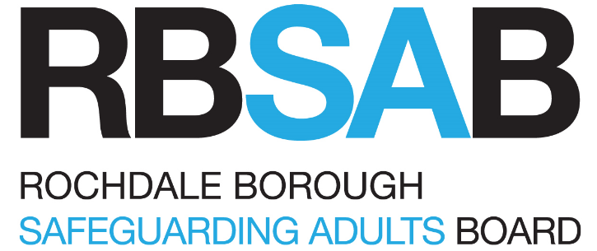

Quality Assurance and Performance Framework
2025 - 2028

Rochdale Borough Safeguarding Adults Board Quality Assurance Framework
Author | QA & Performance Subgroup | Status & version | Final
Authorised by | RBSAB | Authorised date | 10/02/2026
Circulation date | 20/02/2026 | Review date | 31/03/2028

Table of Contents

Scope 3
Governance and Leadership 4
The objectives of the framework 5
Our key principles 5
Responding to The Care Act 6
Our Quality Assurance and Performance Reporting Activity 7
Wider sharing of information 7
Confidentiality and Information Governance 7
Our evidence base: building a shared understanding 9
Evidence types 9
Sources and range of methods 9
Performance data 12
Annex A 14

Scope

The Rochdale Borough Safeguarding Adults Board (RBSAB) wants all safeguarding services for adults with care and support needs in Rochdale to be high quality, personalised and adaptive. By working together and reviewing the quality of outcomes provided by services in the borough, we can be assured that adults are kept safe from harm, abuse and neglect. RBSAB will seek assurance that we improve services based upon the views and experiences of those living in the borough.

Improving outcomes for adults and adults at risk should be central to all service provision. Organisations and partnerships should collect, share and analyse data to understand the effectiveness, and limitations, of systems and services to help protect adults from risk of harm.

It is important to RBSAB that quality assurance and performance intelligence is shared widely to ensure learning reaches all parts of the safeguarding system, and the risk of activity repetition is minimised. Our strategic quality assurance framework will enable agencies to develop and share the effectiveness of safeguarding arrangements and services across Rochdale.

Who the framework is for

This Quality Assurance (QA) framework applies to all RBSAB member individuals, organisations and providers with responsibilities for safeguarding adults under the Care Act 2014. It provides a consistent and structured approach to monitoring, evaluating, and improving safeguarding practice across the partnership. The framework ensures that all partners are accountable for delivering safe, person-centred, and proportionate responses to adults with care and support needs who may be at risk of abuse or neglect. In line with Section 43 of the Care Act, it supports the duty to prevent harm, promote wellbeing, and ensure that safeguarding arrangements are effective, transparent, and continuously improving.

Define Quality Assurance:

The RBSAB considers quality assurance (QA) to be the activity of testing the effectiveness of an action by the most appropriate method. This may be traditional case file auditing, but it may also be the use of surveys to gain qualitative information, or the use of data analysis to provide quantitative intelligence. The examples provided are not prescriptive but seek to highlight a range of QA techniques that may be undertaken to ensure intended outcomes can be evidenced.

The purpose of the QA Framework

Through shared standards, reflective practice, and robust oversight, this framework fosters a culture of learning and collaboration to protect adults and uphold their rights. The purpose of our QA activity should be to improve outcomes for adults, carers and families living in Rochdale. It is therefore important that we take account and be influenced by current safeguarding themes within the borough alongside the defined strategic priorities.

Governance and Leadership

The QA Framework is applicable to the full structure of RBSAB inclusive of Subgroups and Member organisations.

Implementation and delivery of this QA Framework will be overseen by the RBSAB QA & Performance Subgroup. Quarterly reporting on activity will be reported to the Sub-Group, and onward assurance reporting provided to the Safeguarding Adults Board.

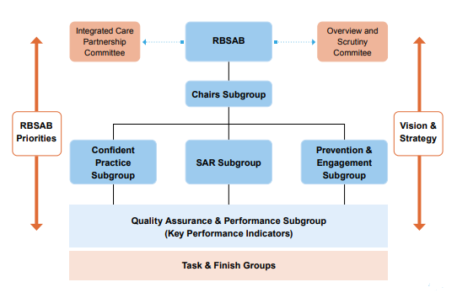
The structure states that quality assurance and performance underpin all RBSAB activity. Therefore, RBSAB has an expectation that all RBSAB subgroups will undertake QA activities, supported by the QA & Performance subgroup. This will be inclusive of:
- Safeguarding Adult Reviews recommendations will be known to be embedded and evidenced to be effectively improving system performance.
- Engagement and preventative activity will be reviewed to understand success of information delivery and how effectively voice is heard.
- Confident practice which understands how effective training delivery is, and how L&D materials are being used effectively in practice.

Prior to a Subgroup undertaking a RBSAB QA activity, formal requests from Subgroup Chairs should be provided to the QA & Performance Subgroup. Subgroup Chair (annex A) requesting the activity is approved for action. Approval of activity will occur after multi-agency scrutiny and be based on submitted proposals. Proposals outline what QA activity is going to occur, why the QA activity is important, and how the QA activity will inform the RBSAB of achieving its priorities. The purpose of this process is to ensure QA activity will add value and not duplicate similar pieces of work occurring elsewhere in the system, ensure multi-agency input, and seek agreement that the relevant resources are available to undertake activity.

The QA & Performance Subgroup will be responsible for maintaining a schedule of approved QA activity.

Also for inclusion to the RBSAB QA Framework, any single agency auditing that relates to RBSAB achieving its defined priorities should be delivered to the QA & Performance Subgroup at the earliest opportunity to allow for multi-agency information sharing. The RBSAB Data Sharing agreement is available upon request to RBSB.admin@Rochdale.Gov.UK

The QA & Performance Subgroup will be responsible for the delivery of QA information and activity to RBSAB meetings via highlight reports. The lead of individual QA activities will be responsible for ensuring the learning is shared across the multi-agency system.

The objectives of the framework

This framework is intended to help RBSAB to answer three main questions:

- how effective are we at keeping adults safe?
- how we can we evidence safeguarding performance and outcomes for adults?
- Are adults being listened too, and influencing decision making, as part of safeguarding processes?

By understanding the answers, we will help to safeguard adults at risk of harm, manage the risk inherent in this area of work, and drive improvement of outcomes for adults and their carers.

Our key principles

Our Quality Assurance Framework has been developed considering key principles. They underpin the quality assurance and scrutiny work of the RBSAB and help to keep a focus on the purpose of our activity.

- Adults and carers are the experts in their experiences. The Care Act (2014) promotes the practice of personalisation, and we want to promote this in our approach to QA. Any activity undertaken should seek the voices, views and experiences of adults and their carers.
- Safeguarding is complex in its nature. Constant scrutiny and review are required to ensure continuous improvement across the system in light of an evolving legislative framework as well as local regional and national influences.
- All members are committed to learning and improvement. Effective quality assurance comes from the nature and detail of organisational and partnership culture and leadership. We all need to be engaged, undertake QA activity, and willing to learn and improve together.
- Learning needs to be fed back into the system. The core purpose of RBSAB QA activity should be to improve outcomes for adults and their families and carers via multi-agency support. It should not focus on process compliance or a particular service area. We will be supportive in our approach to learning and development across the system. All activity and reporting should be accurate, consistent, participative and transparent.
- Quality Assurance activity is broad and adaptive. Different areas of enquiry will require a different approach, and we will need to make sure that we are measuring and scrutinising the right things. We will not adopt a ‘one size fits all’ approach but rather adapt our method of enquiry and ensure that performance indicators, system throughput and outcomes for adults are all given due consideration.
- Our activity is shared across all organisations. No one person, organisation or partnership is the owner of QA work, but we will work together and provide a constructive and supportive approach across all subgroups and agencies.

Responding to The Care Act

The key piece of legislation that is central to our framework is The Care Act (2014), which sets out 6 principles to encourage a person-centred approach when safeguarding vulnerable adults. Our QA Framework naturally sits alongside the legislation, in that we want to place the lived experience of adults at the centre of all activity.

The 6 principles of The Care Act are set out below:

1 | Empowerment | We will look at how adults’ were asked about their outcomes, and the personalisation of interventions
2 | Protection | We will explore how safeguarding procedures were followed
3 | Prevention | As well as looking at early interventions, we will explore training and development across agencies
4 | Proportionality | We will seek to understand how interventions offered were right for the individual or circumstance, and that they were treated with dignity and respect
5 | Partnership | Central to the business of the RBSAB, we will look at how individuals and agencies collaborated and worked together
6 | Accountability | We will look at factors including information sharing & referrals, as well as governance and scrutiny of safeguarding activity

The Care Act sets out the principle of Making Safeguarding Personal and states that adults should be asked about the outcomes they wish to achieve at the outset of safeguarding involvement. To ensure this approach is embedded in practice, we will monitor:
- Information and statistics on personalised outcomes through quarterly data reporting
- Adults’ voices and how they are heard as part of all audit work
- Proxy measures on adult voice (e.g. complaints) as part of thematic work

Our Quality Assurance and Performance Reporting Activity

The subject and method of our activity will vary depending upon the intended outcome. Our approach will be flexible and adaptive to suit our needs. The table on the next page outlines the breadth of different QA activity that will take place across the RBSAB, and Appendix C sets out a process flowchart for our routine QA activity.
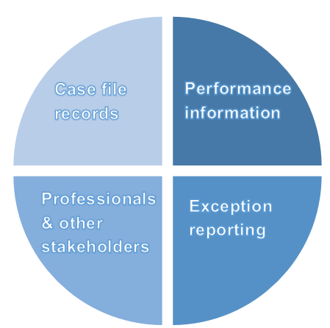
We will ensure activity takes note of a range of different evidence sources to arrive at a rounded view of quality and performance. Above all, we will ensure that adults’ voices are prominent and observed as part of any work undertaken.

We will take account of a range of evidence (dependent upon the particular audit query) as part of any QA activity. This will ensure a balance between qualitative and quantitative data is included in any analysis.

Our QA activity include three main themes as described in the Strategic Priorities.

- Confident Practice – we will explore and understand specific risk issues affecting vulnerable adults or those at risk of harm and how good practice mitigates risk
- Prevention– we will explore how to reduce the impact of harm via early help or preventative information sharing
- Engagement– we hear the thematic and current issues that can have an impact on adults’ daily lives. This will include themes arising from SARs and regulatory inspections.

Wider sharing of information
It is important to RBSAB that support transparency and accountability. Quality assurance reports produced for RBSAB will follow a clear and consistent structure. Reports will be designed to be accessible to all parts of the workforce and to the borough’s adults, enabling them to understand the purpose of the activity, the evidence gathered, examples of good practice, and any recommendations made. This structured approach ensures and supports continuous improvement across the partnership. The learning from QA will be summarised in the RBSAB annual report.

Confidentiality and Information Governance
All quality assurance and performance reporting activity across RBSAB will be undertaken in line with the Data Protection Act 2018 and any personal information will be securely stored and processed in line with each agency’s information governance policy (or equivalent).

What will we do? | What will we learn? | When will we do it?
Self-Assessment
Each agency will be asked to complete a self-assessment against key safeguarding practices based upon the principles of The Care Act. | By looking strategically across all agencies, we will be able to develop a shared understanding of our collective strengths and areas for development. | Annually  Tool 1 will be the Greater Manchester Adult Self-assessment.  Tool 2 will be a reflection of the RBSABs effectiveness to undertake duties
Multi-Agency Case File Audits
All relevant agencies will be asked to participate in audits, and a learning report and action plan will be prepared in response to the findings. | Through audit and case deconstruction, we will arrive at a shared understanding of our collective response, highlighting best practice, and what needs to improve for adults and their carers in the borough. | A minimum of 2 multi-agency audits will take place each year.
Performance outcomes monitoring
Quarterly reporting on the Safeguarding Adults Board performance outcomes framework. | Key performance indicators across all agencies will provide professionals and leaders across the system with a single overview of how safeguarding activity is being delivered, and what if any pressure points exist. | Performance reporting will be provided on a quarterly basis in arrears.
Thematic deep-dives
We will utilise learning from SARs, QA reporting, and other regional and national developments to undertake our own thematic deep dives. These will include a mix of audit, performance data, and stakeholder engagement. These enquiries could be based on individual cases or strategic areas of practice. | Learning will be gained in a similar way to case file audit activity but will be more strategic in that it incorporates performance data and stakeholder feedback. | There won’t be a set frequency for completing deep-dive enquiries, and they will be agreed by the Subgroup Chair when they are required to happen.

Our evidence base: building a shared understanding

It is important to define what our evidence base will be as part of the Quality Assurance Framework. We have acknowledged that safeguarding is complex, and we will therefore need to take account of different evidence types and sources. We will collate learning from each of these sources to triangulate findings and arrive at a comprehensive shared understanding of the effectiveness of services.

Evidence types

Within this framework there are 2 types of evidence that should be considered as equally important to understand outcomes. Full understanding and analysis will come from looking at a mix of these sources rather than just at one in isolation.
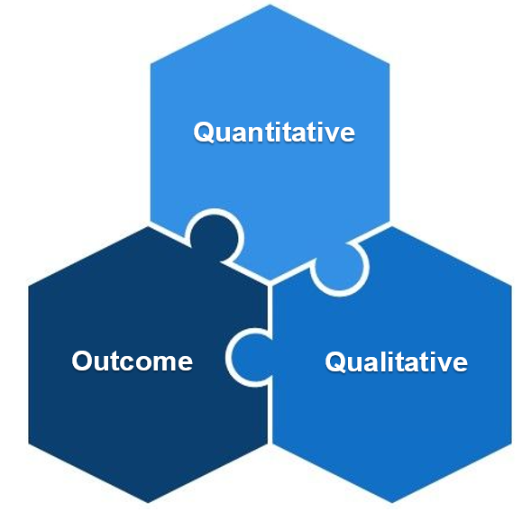
Quantitative information will look at numerical data, the how much or how many
and examples include performance data, trends and statistics.

Qualitative data will look at the quality of daily activity, the what did that look like. Examples include adults’ voices reporting, or complaints
& compliments.

Outcome reporting will look at the impact of a particular service or intervention and will answer the so what question by combining evidence of factual compliance information alongside the voice of supported adults, their carers, practitioners and leaders.

Sources and range of methods

To enable us to interrogate the above information, we will consult with 3 main evidence sources, as set out below.

- The views and experiences of adults and their carers
- Feedback from frontline professionals and managers
- Exploring and examining the findings from Subgroup QA activity

The following methods are those agreed at the QA & Performance Subgroup, however these methods are not prescriptive. The RBSAB will be flexible in the methods of QA adopted to ensure the correct evidence is being sought dependent of the action or activity being test.

Learning Circle case file audit - Full
This is the highest level audit. Cases are determined via production of a data list. Then MA evidence is collected to identify the deep dive, audit case selection. Combined statutory safeguarding partner chronologies are gathered to identifiey which RBSAB members are within the scope of activity. Audit culminates in a multi-agency, in-person practitioner day to complete the audit tool kit together and grade audit cases. A Moderation panel agree report learning content and provides leadership of sharing information and developing action plans.
Learning Circle case file audit – Lite
As above but with a focus on a singular identified case.

Digital case file audit - Practitioner
This overall method is similar to a survey but focus on a specific safeguarding theme instead of looking for demographic information. Initial case selection is data driven, data is gathered then specific audit criteria is used to reduce case selection to an appropriate number of cases to provide balanced information. Practitioners / agencies are identified from the cases. A digital form is provided to identified practitioner / service which contains questions regarding the audit topic. The returned forms are analysed for learning and a summary report is produced.

Digital Audit – General Survey
Utilising the thoughts and feelings of demographics. Audit demographic selection and method of survey is driven by the learning sought by RBSAB. This style of audit is a tool to seek quantitative data and understand how performance is perceived by the selected demographic.

Single agency perspective audit (SAPA)
This would follow the above methods but aimed at learning from a single agency perspective. The purpose of this tool is to allow a specifically identified agency within a safeguarding topic to supply assurance to RBSAB.

Evidence Source | How will we do it | What will we learn
  Adults, carers & families | - User surveys & interviews conducted either as part of audits or individual theme knowledge gathering  - Co-production networks showing how agencies engage and record streategic interations  - Complaints & compliments showing direct service user feedback | We will understand how people experience services they interact with, telling us about outcome and impact, and Making Safeguarding Personal measures. This will tell us:  - What difference interventions have made  - What did service users find useful  - What do they feel could have been different
  Frontline professionals | - Staff surveys exploring particular themes of practice  - Supervision data evaluating strengths and areas for development  - Event feedback ensuring voice is heard about the impact & quality | Those working directly with adults, carers and families will share their knowledge of the quality and impact of their own service, as well as how they navigate the system. This will tell us:  - What they feel is helpful  - How they interact with vulnerable adults and other agencies
  Case file records | - Multi-agency audit using a variety of methods to exploring how effective practice leads to positive outcomes  - Thematic auditing looking at records from a particular perspective to understand the impact of one intervention or factor | Case deconstruction following audits will show how agencies’ case records tell us:  - How adults engage with that service  - What is known about each adult (and any gaps)  - How that information contributes to a bigger picture
  Other organisational information | - Annual self-assessment  - Managament information reports to understand what is important for member organisations and how they provide effective safeguarding services  - Policy and procedure to understand how members evidence effective practice | Organisations will have a range of information in their systems which is relevant to safeguarding quality assurance. We will learn how each agency monitors and supports their staff, as well as systems and processes in place to promote effective safeguarding activity for themselves as well as across the partnership.

Performance data

As part of our Quality Assurance Framework, the systematic collection and analysis of safeguarding performance data is vital to ensuring the effectiveness of adult safeguarding practices. This data provides measurable insights into referral patterns, types of abuse encountered, outcomes of safeguarding enquiries, and the experiences of those involved. By interrogating both quantitative and qualitative data we can identify trends, assess how RBSAB Strategic Priorities are being achieved, and ensure that safeguarding is both person-centred and outcome focused. Performance metrics also support accountability across partner agencies and enable continuous improvement by highlighting areas of good practice and those requiring development. As such, and in line with the RBSAB Data Sharing agreement, the Board requires members to share data for reporting when requested.
The RBSAB has agreed four Key Performance Indicators:
- RBSAB members know their data well
- RBSAB uses SAR process effectively
- RBSAB will provide effective training
- RBSAB engage people in safeguarding well
The key indicators are designed to be S.M.A.R.T.A:
- Specific – Clearly defined and focused on the outcome of ensuring adults are safeguarded well in our Borough
- Measurable – Quantifiable with clear metrics that are agreed with members
- Relevant – Aligned with strategic goals of the RBSAB Priorities
- Actionable – Provide insights that can lead to improvements as defined in the 2024 LGA Review
- Time-bound – Tracked quarterly taking into account past years performance
- Accurate – All data is quality assured before analysis

By ensuring data checks take place in week 1, and the subsequent multi-agency discussions take place, we can be confident that intelligence reported to the RBSAB is of a high quality and has been analysed by specialists within our subgroups.
Data processing guide at the end of a reporting quarter

The QA & Performance Subgroup is responsible for the application of data process and delivery to governance held at RBSA
The set of data indicators RBSAB collects is dynamic and will be subject to change as reporting progresses. Indicators will always have a purpose to inform RBSAB of its performance as defined in our strategic plan.

Annex A
Multi-Agency Audit Proposal

Case file audit title
Safeguarding strategic priority(s) supported
Does activity relate to a safeguarding review? | Yes  ☐ | No  ☐ |  | Safeguarding review case name:
Format requested | Case file audit |  |  |  |  | ☐ | Digital Survey |  |  | ☐ | Thematic audit |  | ☐
Format requested | Other |  |  |  |  | ☐
Proposed start date |  |  |  |  |  |  | Proposed end date
Audit rationale
Expected learning outcomes
Agencies involved in MA audit
Audit database source(s) | ASC ☐ |  | CSC ☐ |  | Early Help ☐ |  |  | GMP☐ | Health ☐  Please specify: |  |  | Other ☐  Please specify:
Data request contact
(If known)
Number of case sample audits required
Moderation members suggested
Governance Board

Completed proposal sent to RBSB.Admin@Rochdale.Gov.UK

For admin use only

Governance Board
Date heard
Approved | Yes ☐ | No ☐
Rationale

https://www.legislation.gov.uk/ukpga/2014/23/contents/enacted
As outlined in Section 42 of The Care Act
https://www.legislation.gov.uk/ukpga/2018/12/contents/enacted

