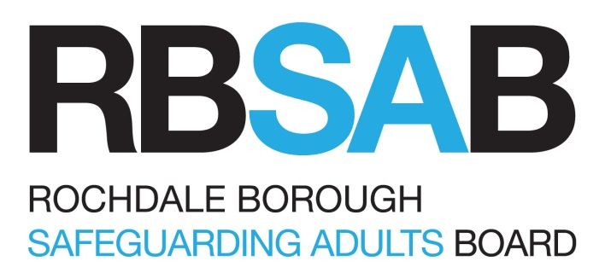

CONSTITUTION

Page
- Introduction 3
- RBSAB Objectives 3
- Core Duties and Functions 4
- The RBSAB Chair, Accountability and Resourcing 5
- Information sharing 6
- Membership. 7
- Meetings 8
- Subgroups – Membership & Remit 9

- Introduction

1.1 Rochdale Borough Safeguarding Adults Board (RBSAB) is an un-incorporated Multi-Agency Strategic Partnership, originally established to fulfil the statutory functions as set out by under section 43 schedule 2 Care Act 2014

1.2 The vision of the Board is that in Rochdale, people are able to live a life free from harm and where communities have a culture that does not tolerate abuse, work together to prevent abuse and know what to do when abuse happens.

1.3 The mission of the Board is to ensure there is strong strategic leadership to safeguard Adults at Risk in Rochdale and that preventing, detecting and reporting neglect and abuse is ‘everyone’s business’. This will be achieved by the continued development of Safeguarding policy and practice across all partner agencies and communities consistent with the Care Act 2014 and other National Policy and ‘best practice’ guidance.

1.4 Safeguarding requires collaboration between partners in order to create a framework of inter-agency arrangements. Local authorities and their relevant partners must collaborate and work together as set out in the co-operation duties in the Care Act and, in doing so, must, where appropriate, also consider the wishes and feelings of the adult on whose behalf they are working.

- RBSAB Objectives

2.1 The RBSAB has a strategic role that is greater than the sum of the operational duties of the core partners. It oversees and leads adult safeguarding across the Borough and will be interested in a range of matters that contribute to the prevention of abuse and neglect. These will include the safety of patients in its local health services, quality of local care and support services, effectiveness of prisons and approved premises in safeguarding offenders and awareness and responsiveness of further education services. It is important that RBSAB partners feel able to challenge each other and other organisations where it believes that their actions or inactions are increasing the risk of abuse or neglect. This will include commissioners, as well as providers of services.

2.2 The RBSAB will be an important source of advice and assistance, for example in helping others improve their safeguarding mechanisms. It is important that the RBSAB has effective links with other key partnerships in the locality and share relevant information and work plans. They should consciously cooperate to reduce any duplication and maximise any efficiency, particularly as objectives and membership is likely to overlap.

- Core Duties and Functions

3.1 The RBSAB has three core duties:
- To publish a strategic plan for each financial year that sets how we will meet our main objectives and what our members will do to achieve this.
- To publish an annual report detailing what the RBSAB has done during the year to achieve its main objective and implement its strategic plan, and what each member has done to implement the strategy as well as detailing the findings of any Safeguarding Adults Reviews and subsequent action.
- Conduct any Safeguarding Adults Review in accordance with Section 44 of the Care Act 2014.

3.2 The Care Act 2014 sets out the RBSAB functions as follows:

- Developing strategies for the prevention of abuse and neglect
- holding partners to account and gain assurance of the effectiveness of its arrangements;
- determining arrangements for peer review and self-audit;
- establishing mechanisms for developing policies and strategies for protecting adults which
should be formulated, not only in collaboration and consultation with all relevant agencies
but also take account of the views of adults who have needs for care and support, their
families, advocates and carer representatives;
- identifying types of circumstances giving grounds for concern and when they should be considered as a referral to the local authority as an enquiry;
- formulating guidance about the arrangements for managing adult safeguarding, and dealing
with complaints, grievances, professional and administrative malpractice in relation to
safeguarding adults;
- developing strategies to deal with the impact of issues of race, ethnicity, religion, gender and gender orientation, sexual orientation, age, disadvantage and disability on abuse and neglect;
- identifying mechanisms for monitoring and reviewing the implementation and impact of policy and training;
- evidencing how SAB members have challenged one another and held other boards to account;
- Promoting multi-agency training and to consider any specialist training that may be required.
- Considering any scope to jointly commission some training with other partnerships, such as the Community Safety Partnership.
- identifying the role, responsibility, authority and accountability with regard to the action each agency and professional group should take to ensure the protection of adults;
- establishing ways of analysing and interrogating data on safeguarding notifications that increase the Boards understanding of prevalence of abuse and neglect locally that builds up a picture
- agreeing a framework and process for any organisation under the umbrella of the Board to respond to allegations and issues of concern that are raised about a person who may have harmed or who may pose a risk to adults.

- The RBSAB Chair, Accountability and Resourcing

4.1 In order to provide effective scrutiny, the Board has to be independent. It is not subordinate to, nor subsumed within, other local structures. The Board has an independent chair who can hold all agencies to account.

4.2 It is the responsibility of the Chief Executive of the LA to appoint or remove the RBSAB chair with the agreement of Board members. The Chief Executive, drawing on other RBSAB partners and, where appropriate, the Lead Member will hold the Chair to account for the effective working of the RBSAB.
After the end of each financial year, the RBSAB will publish an annual report. The annual report will provide information about any Safeguarding Adults Reviews (SARs) that the SAB has arranged which are ongoing or have reported in the year (regardless whether they commenced in that year). The report is required to provide a rigorous and transparent assessment of the performance and effectiveness of local services, to identify areas of weakness, the causes of those weaknesses and the action being taken to address them as well as other proposals for action. The report also includes lessons from reviews undertaken within the reporting period. A copy of the report will be sent to:
- the Chief Executive and leader of the local authority;
- the Police and Crime Commissioner and the Chief Constable;
- The Chair of the Overview and Scrutiny Committee.

  - The Board is funded by:
- Rochdale Borough Council
- Greater Manchester Police
- NHS Greater Manchester Integrated Care (HMR)

The Council, Police and NHS Greater Manchester Integrated Care (HMR) are statutory members of the Board and are expected to contribute to the funding of its work. Other partners are expected to consider what assistance they can provide in supporting the Board in its work, whether financial or non-financial, for example by providing administrative help, premises for meetings or holding training sessions. It is in all partners’ interests to have an effective Board that is resourced adequately to carry out its functions.

  - Complaints Any complaints or proposed legal action in respect of SAB functions will be processed in accordance with the Local Authority Social Services and National Health Services complaints (England), Regulations 2009. Where a complaint relates to a service or function provided by a provider agency in line with their statutory obligations (i.e. how an s42 enquiry was conducted that it would for the agency to address this via there ow complaints process). Further information can be found within RBSB Policy and Procedures, which also sets out a process for resolving safeguarding disputes between partner agencies.

4.5 Legal Advice RBSAB has access to legal advice from the Local Authority. Given that RBSAB is a un-incorporated association, where legal proceedings are anticipated, the Local Authority as lead agency (s43 Care Act 2014) will assume responsibility either as the Applicant or the Respondent in any proceedings.

- Information sharing
5.1 The RBSAB may request a person to supply information to it or to another person. The person who receives the request must provide the information provided to the Board if:
- the request is made in order to enable or assist the Board to do its job;
- the request is made of a person who is likely to have relevant information and then either:
i. the information requested relates to the person to whom the request is made and
their functions or activities or;
ii. the information requested has already been supplied to another person subject to a
Board request for information.
5.2 Confidentiality RBSAB member agencies have drawn up a common agreement relating to confidentiality and setting out the principles governing the sharing of information, based on the welfare of the adult or of other potentially affected adults. The agreement is consistent with the principles set out in the Caldicott Review published 2013 and ensures that:
- information will only be shared on a ‘need to know’ basis when it is in the interests of the adult;
- confidentiality must not be confused with secrecy;
- informed consent should be obtained but, if this is not possible and other adults are at risk of abuse or neglect, it may be necessary to override the requirement; and
- it is inappropriate for agencies to give assurances of absolute confidentiality in cases where there are concerns about abuse, particularly in those situations when other adults may be at risk.

Ownership of any information provided as part of a Safeguarding Adult Review will lie with the RBSAB and this will be stated in the terms of reference.
If a request for this information is subsequently made by a third party, there should be a discussion between the agency who provided the information and the Independent Chair to agree if the information should be shared. It should be noted that the Information Commissioners Office has previously concluded (FS50368110, FS50628708) that where it is stated in a review’s terms of reference that information provided by agencies is owned by a safeguarding board, there is no requirement under the Freedom of Information Act 2000 to provide this information to the third party. This is because safeguarding boards are statutory bodies and not public bodies however; this does not mean that the request should always be refused.

5.3 Sharing information with the Coroner There is an information sharing protocol to outline expectations relating to sharing Safeguarding Adult Reviews with the HM Senior Coroner for Manchester North.

- Membership
6.1 The membership of RBSAB will comprise of senior leadership from the following key agencies:
- RBC- Adult Care, Public Health
- NHS Greater Manchester Integrated Care (HMR)
- GM Police
- Northern Care Alliance
- Pennine Care NHS Foundation Trust
- GM Fire and Rescue Service
- National Probation Service
- Health watch
- Rochdale Boroughwide Housing
- Rochdale Borough Safeguarding Children Board
- Elected Member
- Rochdale and District Mind
- Rochdale Safer Communities Partnership
- HMP Buckley Hall
- Voluntary Sector

6.2 The members/advisors of the RBSAB are people with a strategic role in relation to safeguarding their organisation. They can:
- speak for their organisation with authority;
- commit their organisation on policy and practice matters; and
- hold their own organisation to account and hold other members to account.

6.3 The RBSAB also draws on appropriate expertise and advice from frontline professionals from all the relevant sectors. This includes a designated doctor and professional and Principal Social Worker who act as advisors to the Board.

6.4 A Lay member will operate as a full member of the RBSAB, participating as appropriate on the Board itself and on relevant committees. The Lead Member for Adult Services is a participating observer of the RBSAB. In practice this means s/he routinely attends meetings as an observer and receiving all its written reports and makes a valued contribution, she/he provides an immediate and effective link with the council’s cabinet and leader.

6.5 Members/advisors should demonstrate a commitment to attend the meetings. It is essential that there is a continuity of representation at the RBSAB and nominated deputies are identified within agencies with similar authority to Board Members. If a member is unable to attend, they should submit apologies and arrange for the nominated deputy to attend. A register of attendance will be kept by the Board’s Safeguarding Business Unit and published in the RBSAB annual report.

- Meetings

7.1 The Board will meet six times a year with the schedule of meetings published in advance for a year. Meetings can be called more frequently as circumstances dictate. All members/advisors will be able to bring appropriate items to the agenda, through the Chair. The agenda will be issued to all members/advisors at least one week in advance of the Board meeting. The Chair will arrange for minutes to be taken, and a copy to be sent to each Board member and other people by agreement two weeks after the meeting.

- Subgroups – Structure and Remit

8.1 The RBSAB has a number of sub-groups, on a standing basis and commissions “task and finish groups” as required to:
• carry out specific tasks, for example: maintaining and updating procedures and protocols; screening and overseeing Safeguarding Adult Reviews; and identifying inter-agency training needs;
• provide specialist advice, for example: in respect of working with specific ethnic and cultural groups, or with disabled parents;
• bring together representatives of a sector to discuss relevant issues and to provide a contribution from that sector to RBSAB work
• focus on defined geographical areas within the RBSAB boundaries.

Some of the RBSAB subgroups function as ‘joint’ subgroups with the Rochdale Borough Safeguarding Children Partnership (RBSCP). The following tables set out the RBSAB sub group structure with joint RBSCP/RBSAB are bordered in purple
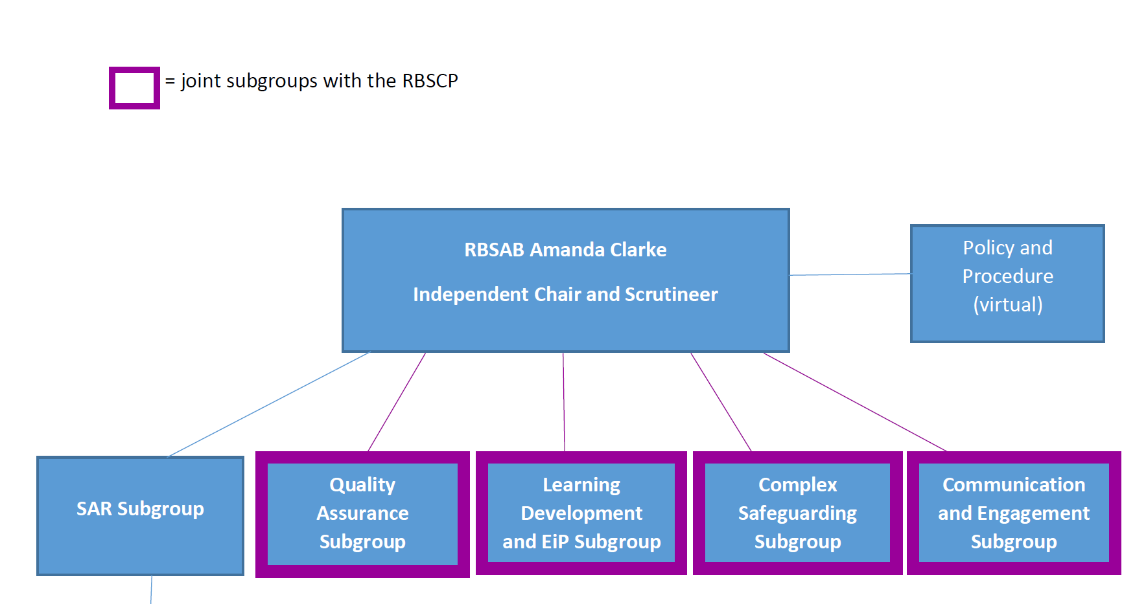
SAR screening
Policy & Procedure (Virtual)

  - Individual subgroup remits:
- Quality Assurance
- The Quality Assurance subgroup have developed a framework which is primarily for use by RBSAB member organisations. The key principles outlined in the framework can be applied by any partnership, organisation or individual with safeguarding responsibilities.
- This framework is intended to help leaders in all organisations under the RBSAB to answer two main questions:
1. How effective are we at keeping adults safe
2. How we can embed learning to prevent issues from reoccurring
- By asking these questions, and understanding the answers, we will help to safeguard those adults at risk of harm, manage the risk inherent in this area of work, and drive improvement in outcomes for adults and their carers.
- To monitor and evaluate the effectiveness of what is done by the Local Authority and Board partners both individually and collectively to safeguard and promote the welfare of adults, report this to the Board, who can then in turn provide advice on ways to improve performance and quality.

- Learning Development and Excellence in Practice
  - To ensure that safeguarding adults training is provided to all agencies providing services to adults
  - Ensure that assurance is gathered so that safeguarding training assists practitioners to deliver effective services to adults
  - To ensure that communication has a high profile across all agencies.
- The Excellence in Practice function is to enable opportunities for more collaborative approaches to be developed and to identify gaps in services. In essence, the members of the sub-group have “a foot in the camp” in respect of all relevant services and planning forums, which impinge on the provision of good services for adults at risk of harm. They come together to make sure services are appropriately “joined up” in their thinking and to give assurance to the Board that a full range of services is in place and service models reflect good practice.
- To raise awareness of Safeguarding across agencies and the public

- Communications and Engagement
- Develop and deliver an annual communication plan / multi-agency programme of local and national campaigns based on RBSAB and RBSCP priorities on behalf of the board and partnership to key stakeholders including children/young people, adults with care and support needs, families, practitioners and the general public
- Develop and deliver effective engagement with general public, third sector, local communities, faith groups and with local businesses, to increase knowledge of safeguarding children and adults with care and support needs, and safer working practices
- To provide communications advice and/or support

- Safeguarding Adult Review (SAR) Screening Panel
- The purpose of a SAR is clearly defined in the Care Act 2014. It is to promote effective learning and improvement actions to prevent future deaths or serious harm occurring again. The lessons learnt for the case should be applied to future cases to ensure continuous improvement of practice. Therefore a SAR screening takes place, its purpose is NOT to hold any individual or organisation to account. Other processes exist for that, including criminal proceedings, disciplinary procedures, employment law and systems of service and professional regulation, such as the Care Quality Commission and the Nursing and Midwifery Council, the Health and Care Professions Council, and the General Medical Council, etc.
  - To screen cases and make recommendation regarding commissioning a Safeguarding Adult Review and/or a learning lessons review following the guidance contained in the Care Act 2014

- Safeguarding Adult Review (SAR)
  - To ensure that, at a strategic level on behalf of the RBSAB, organisational lessons are learnt, and changes are instituted, from reviews of cases to prevent future incidents of serious abuse or death.
  - Oversee the referrals for Safeguarding Adult Reviews submitted to the Safeguarding Adult Board
  - Ensure that statutory requirements set out in S44 of the Care Act 2014 are fulfilled by the Safeguarding Adult Board
  - Ensure proportionality of any commissioned reviews
  - Review methodologies used in Safeguarding Adult Reviews
  - Review the Rochdale Borough Safeguarding Adult Board Safeguarding Adult Review Policy and Procedures (Chapter 13)
  - To scrutinise and monitor the quality of the Safeguarding Adult Review author reports (or any other commissioned review) to ensure that they provide a sound analysis of what happened in the case, why, and what needs to happen to reduce the risk of recurrence. Reports should be written in plain English and in a way that can be easily understood by professionals and public alike. The final overview report should be suitable for publication (except in rare circumstances) without the need to be amended or redacted.
  - Monitor and evaluate the quality and progress of both single-agency and multi-agency action plans in response to Safeguarding Adult Review or any other reviews in order to hold agencies to account and establish the impact of learning
  - To have sight of any relevant published reviews in other areas and consider if learning points are relevant for Rochdale Borough Safeguarding Adult Board and if any actions are required as a result of those reviews
  - Ensure effective links are established with the Learning, Development and Communications Sub-Group and the Quality Assurance, Excellence in Practice and Engagement Sub-Group, in order to contribute to the training programme, briefings and electronic materials to disseminate learning and recommendations from reviews
  - Regular assurance reporting to Quality Assurance Sub-Group which will include quarterly reporting on activity, action plan reviews and themes for future learning
  - To work with the Rochdale Borough Safeguarding Children Partnership when reviews have implications for children’s safeguarding
  - To work with the Rochdale Community Safety Partnership when reviews have domestic abuse elements and have sight of any published Domestic Homicide Reviews when they have implications for adult safeguarding

- Policy & Procedure
- To ensure the RBSAB fulfils the responsibilities placed on it in to have in place policies and procedures as set out in the Care Act 2014
- Documents are updated according to a fixed schedule, named “Policy and Procedure Update Schedule”
- However, documents are also updated as new initiatives or policies (both national and local) are introduced or new legislation or standards come into effect

- Complex Safeguarding
- The purpose of the subgroup is to receive thematic strategies/plans, developments (statutory/practice) and provide a challenge and support role within the context of the respective operational delivery in the following work streams and provide reassurance to both the Board and Partnership:
- Through a coordinated, holistic, multi-agency response, we are committed to playing a key role within the partnership in tackling all age Criminal/Sexual Exploitation, Modern Slavery/Trafficking/OCG and Missing. Thus ensuring there is a consistent inclusive approach of young people transitioning into adults that raises public and professional awareness, prevents/reduces harm and ultimately brings offenders to justice.
- The strategies will reflect local needs.

8.3 Subgroup working arrangements:
- Each subgroup is Chaired by a member /advisor of the Board
- Terms of Reference for each subgroup are agreed by the RBSAB
- Action plans, linked to the RBSAB strategic objectives are developed by each subgroup
- The subgroup Chairs provide bi-annual reports to the RBSAB updating the board on the implementation ,achievements and outcomes of their individual subgroup action plans

  - The Board works to a business plan. The strategic objectives in the 2022-24 business plan are;
- Prevention and Early Intervention
- Complex and Contextual Safeguarding
- Quality Assurance/ Learning lessons and shaping practice

A more comprehensive breakdown of the plan can be found here: rbsab_strategic_plan-2022.pdf (rochdalesafeguarding.com)

