

**Practical Guide to**

**Assessing Capacity and Making Best**

**Interests Decisions under the Mental Capacity Act (MCA)**

| Document properties | Version details |
| --- | --- |
| Document name | Practical Guide to Assessing Capacity and Making Best Interests Decisions under the Mental Capacity Act (MCA) |
| Document owners | Rochdale Borough Safeguarding Adults Board |
| Version | 1.1 |
| Review date | Upon review in September 2025, a change of process determined this document will be reviewed by guidance owner as/when required. Any updates will be signed off via the RBSAB Confident Practice Subgroup from this date. |

*With thanks to Oldham Safeguarding Adults Board on whose work this guidance is based.*

**Contents**

1. Overview…………………………………………………………………………………………………4
2. Making Safeguarding Personal Principles……………………………………………………………….………………………………..4
3. Identify the Decision…………………………………………………………………………………….4
4. Identify the Decision Maker………………………………….………………………………………...5
5. Consider the Decision..………………………………………………………………………………...5
6. Identify the Available Options………………………………………….………………………………5
7. Assessing Capacity……………………………………………………………………………………..6
8. Undertaking an MCA Assessment……………………………………….……………………………7
9. Best Interest Decision…………………………………………………………………………………….……….…..10
10. Recording the MCA and Best Interest Decisions…………………………………………………………………...………………….….…….10
11. Further Resources……………………………….………………………………………….………….12

Principle 1 of the MCA is the presumption of mental capacity. If you have presumed capacity, you must evidence this. Always record that Mental Capacity has been considered when no formal MCA Assessment has been undertaken and the rationale for not undertaking an MCA assessment based on evidence obtained.

If a person’s mental capacity to make decisions is in doubt, you MUST follow the MCA. This guidance provides practical steps to support professionals in following the MCA process. It is not intended to be definitive guidance. For further information, refer to the RBSAB MCA Policy and Procedure, your own organisations MCA Policy and Procedures, as well as the [MCA Code of Practice](https://www.gov.uk/government/publications/mental-capacity-act-code-of-practice)

**1**

**Overview**

The ethos of the MCA, along with all effective Human Rights based practice, is to work with people, rather than do things for people. The principles of

Making Safeguarding Personal are central to the MCA Process. The MCA is empowering legislation and supports Making Safeguarding Personal. It is important to effectively balance the principles that can sometimes be competing in complex situations. The six national principles that govern adult safeguarding are:

* **Empowerment**

People being supported and encouraged to make their own decisions

* **Accountability**

Accountability and transparency in the delivery of safeguarding.

* **Proportionality**

The least intrusive response appropriate to the risk presented

* **Prevention**

It is better to take action before harm occurs

* **Protection**

Support and representation for those in greatest need

* **Partnership**

Local solutions through services and communities working together

**2**

**Making Safeguarding Personal Principles**

**3**

**Identify the Decision**

It is helpful to phrase the decision from the viewpoint of the person, avoiding any preconceived opinion on what is in that person’s best interests. **REMEMBER – Professional/Funding Decisions and Best Interest Decisions are not the same.**

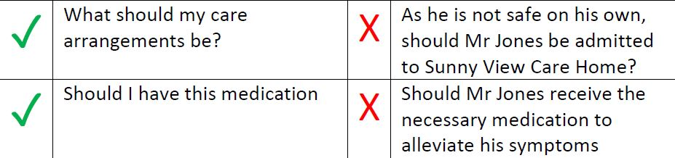

It can be useful to consider the decision on a continuum from simple to more complex decisions.

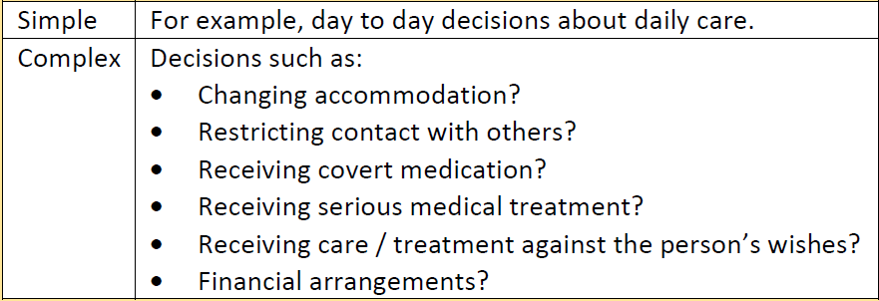

Complex decisions can often involve a potential breach of a person’s Human Rights, (such as DoLS which relate to Article 5) requiring more detailed assessment and documentation by the decision-maker.

People over 18 years old may make an advanced decision to refuse specified medical treatment (ADRT) whilst they have the mental capacity to do so. When valid and applicable, healthcare professionals are protected from liability to stop or withhold treatment (or treat a person after taking appropriate and practical steps to ascertain an ADRT is in place).

When a dispute arises between an LPA for health and wellbeing, family member and decision maker regarding best interests decisions, legal advice should be sought in consideration to approaching the Court of Protection.

**5**

**Consider the Decision**

The decision maker is usually the person who knows the individual and who is making the decision on behalf of the person.

REMEMBER – It is the person’s decision, not the professional’s decision.

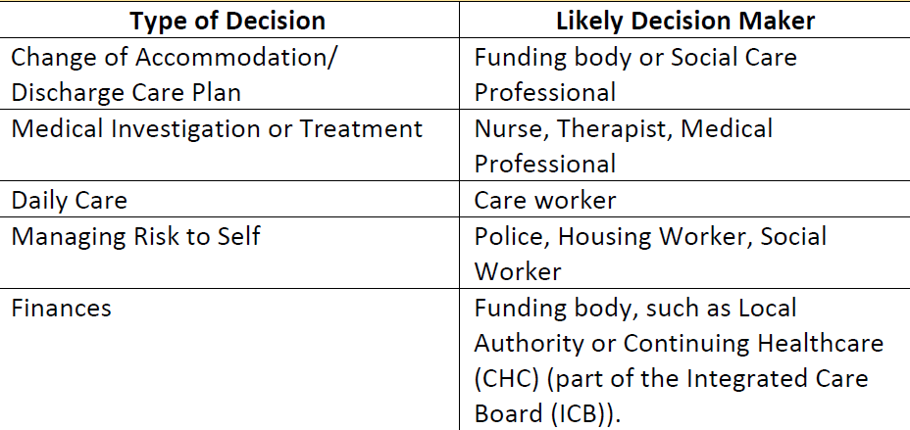

REMEMBER – If the person has a relevant Lasting Power of Attorney (LPA) or Deputyship, then the LPA or Deputy will be the likely decision maker unless they are deemed to not be acting in the person’s best interest.

**4**

**Identify the Decision Maker**

In order to assess capacity and determine best interests, you must first identify the available options. The MCA does not simply bestow a ‘wish-list’ of options for a person to choose from. Available options are often identified following professional decisions and/or funding decisions. For example, considering where the person should live the options may be 1. To remain at home with a care package; 2. Extra care housing; or 3. Care Home.

**6**

**Identify the Available Options**

The Code of Practice suggests that if we are concerned that a person does not have the capacity to make a decision because of an impairment or disturbance of the functioning of the mind or brain, then we should assess Mental Capacity. Sometimes we should consider the fact that if a person makes an unwise decision, it does not mean they lack capacity (MCA Principle 3.) However, if a person makes frequent unwise decisions, or often demonstrates differences in balancing and weighing information (communicates one thing and executes alternative) this could indicate fluctuating capacity/issues with executive functioning and should trigger a Mental Capacity Assessment. This is particularly important in adult safeguarding cases relating to self-neglect and complex and contextual safeguarding concerns such as MRM cases.

It is helpful to think of the capacity assessment as a conversation between the person and the decision maker. The decision maker needs to take all practicable steps possible when facilitating the conversation, so that the person has the best opportunity to make the decision by themselves (MCA Principle 2.) We cannot prove that someone lacks capacity to make the decision without taking all practicable steps (Do they need an interpreter? Do they have specific communication needs? Consider the time of day. Do they need an advocate? Have the available options been given to them?)

A capacity assessment is not a clinical test and is ideally completed by a decision maker who knows the person, is involved in their care and has awareness of the particular decision at hand. The conversation should commence with the decision maker outlining the important factors of the decision, and then ascertaining if the person can understand, retain, use and weigh and communicate those factors and the overall decision. If the person is unable to understand, retain, use and weigh and communicate factors related to the decision, and the reason for this is directly linked to an impairment of the brain or mind, then the person is deemed not to have mental capacity to make that decision.

The Mental Capacity Assessment is also known as a two-stage test:

• Stage 1 – Functional (Can the person understand the information relevant to the decision, retain the information, use/weigh the information as part of making a decision and can the person communicate their decision?)

• Stage 2 – Diagnostic (Is there a diagnosis to evidence an impairment or disturbance of the functioning of the mind brain?)

Consideration must be given to assessing not only decisional capacity but executive capacity. The 'articulate and demonstrate method' requires the person being assessed to both articulate their decision and demonstrate how they would carry it out. REMEMBER – The starting point of the assessment is that the person has capacity (MCA Principle 1). It is for the decision maker to prove otherwise and provide the necessary evidence.

**7**

**Assessing Capacity**

**Before Undertaking the Functional Test**

The following steps should be taken before you carry out the functional test:

• Make sure that you understand the nature of the decision to be made;

• Make sure you understand the range of options available;

• Make sure you consider and prepare the information that may be relevant to the decision;

• Establish whether there is a Lasting Power of Attorney or a Deputy appointed by the Court and arrange for them to be involved;

• Consider any need that you may have for additional support, for example a Speech and Language Therapist (based on your own skills and abilities);

• Consider any support the person may need during the assessment;

• Read any information that is available to you that could indicate the practicable steps that could support the person to make their own decision;

• Establish how the person is currently supported to make decisions and the kind of decisions they are able to make; and

• Establish if any information has already been given to the person, what this was and how it was received.

What is the Decision(s) to be made? Consider:

• What is the decision in hand? Ask the person – do they know?

• Examples of specific decisions – care and support, accommodation, medical treatment (GP, doctor needs to complete the assessment), finances, making a Will (testamentary capacity), relationships, signing a tenancy). You may need another professional to provide information to support the assessment for example, psychologist or psychiatrist.

• If the person has difficulties making decisions in several areas, separate assessment forms are needed. Decisions about care and support and accommodation are often linked so can be recorded together.

• Provide evidence of the impairment or disturbance of the functioning of the mind brain from the GP, Psychiatrist letter. However, courts have stated that people no longer need a formal diagnosis to undergo a Mental Capacity Assessment. If an impairment is suspected the assessor needs to explore what that impairment is.

• Examples of impairment – mental health diagnosis (dementia, depression /anxiety, schizophrenia), acquired brain injury, stroke, neurodiversity diagnosis (learning disability, autism, ADHD), alcohol and drug use.

Does the person understand information relevant to the decision being made? Consider:

• What is the ‘salient’ (important) information the person needs to understand in order to make the decision?

• The person’s level of understanding should not be set too high.

• Have all practicable steps been taken to support the person’s understanding? Have reasonable adjustments been considered?

• Provide realistic options, for example regarding accommodation 1. Care at home 2. Extra Care Living 3. Care home.

• Arrange for the person to visit options or show them photographs.

• Prepare in advance – what questions are you going to ask the person?

• Record the questions and answers in the person’s own words and revisit

them at the next visit. Were their answers the same or different?

**8**

**Undertaking an MCA Assessment**

Does the person have the ability to retain information relevant to the decision being made? Consider:

• Be clear about the information they need to understand in order to make the specific decision.

• Can the person make the decision at the time it needs to be made?

• For more complex decisions (accommodation changes) you will need to complete several assessment visits to test out the person’s retention of the information.

• In order to make their own decision the person needs to be able to demonstrate that they are able to retain (remember) the relevant information long enough to be able to make a decision. There is no requirement for them to be able to retain the information longer than that.

Does the person have the ability to use or weigh the information as part of making the decision? Consider:

• This can be the most complex area to assess.

• Be clear about the information the person needs to understand.

• Do they understand the options given?

• Do they understand the risks and consequences of each option provided?

• They may understand the theory but are unable to put this into practice – there is a mismatch in what they say and what they do.

• The person may present very well on assessment (they understand the information, can retain what you’ve discussed previously and can communicate the decision making) however when asked to carry out tasks/identify risks, they are unable to do so.

There may be cause for concern if someone:

• Repeatedly makes an unwise decision that puts them at serious risk of harm, abuse or exploitation; or makes a particular unwise decision that is obviously irrational or out of character.

• The person may have a known ‘script’ of what to say to all professionals.

• Issues with the ability to use or weigh information may highlight an executive impairment which can affect decision making capacity. It is often overlooked, resulting in potential exposure of a person to risk. It can be very difficult to assess the effect of executive impairment on mental capacity and repeated assessment of capacity, supported by collateral information and real-life functional assessment are recommended. If you have concerns that a person’s executive functioning may be affecting their decision-making capacity, it is probably worth seeking a specialist opinion from a psychiatrist or psychologist.

Does the person have the ability to communicate their decision by any means?

It is your responsibility to establish and take all practicable steps to:

• Communicate with the person;

• Provide relevant information to the person; and

• Support the person to communicate their decision.

**8**

**Undertaking an MCA Assessment**

When to make a determination about the person’s capacity to make a specific decision (s):

You should make a determination about the person's ability to make the decision for themselves when:

• You have provided the person with all of the information relevant to the decision and within an appropriate format;

• You have taken all practicable steps to support the person to understand, retain and use the information to make their own decision; and

• You have taken all practicable steps to support the person to communicate their decision through any means.

If you have not taken all practicable steps and subsequently decide that the person lacks capacity any Best Interests decision that you make on their behalf is not likely to be a lawful decision and you are not protected from liability.

The responsibility to make a determination:

As the assessor it is your responsibility to make the determination. However, when making a decision the following must be taken into account:

• Any views of the person about their capacity to make the decision.

• The basis for that view (ensure this is recorded verbatim from the person).

• Any views of others about the person's ability to make the decision.

• The basis for that view (ensure this is recorded verbatim from the person).

Making a determination

The outcome of the mental capacity must be that either:

• The person has capacity to make the decision; or

• The person lacks capacity to make the decision.

If it is not clear whether or not a person has capacity this determination must be made on the balance of probabilities based on evidence from various sources and recorded accurately.

The balance of probability

Mental capacity is complex, and it can sometimes be difficult to categorically say that a person is unable to make a decision. Often there may be:

• Some evidence that suggests a person is unable to make the decision; and

• Some evidence that suggests they can.

The balance of probabilities is the legal threshold by which a person's capacity must be decided when this is not clear. This is the threshold applied by the Court of Protection. Making a decision on the balance of probabilities means deciding whether it is more likely or not that a person has (or lacks) capacity based on all of the available evidence. The evidence that you have used to make the determination should be clearly recorded, and you should seek the professional opinion of others as required. If you are not sure whether the person has capacity or not, you should seek the views and support of your line manager as required and consider further steps that you may need to take to gather evidence or consider whether legal advice is required.

**8**

**Undertaking**

**an MCA**

**Assessment**

If a person does not have the mental capacity to make the decision, then a decision is made by the decision-maker in the persons best interests (MCA Principle 4). The MCA Code of Practice Best Interests checklist outlines what must be considered when making a decision in a person’s best interests.

A Best Interests decision should take into consideration the past and present views of the person, and their values and beliefs. A decision maker should also consult with individuals who are important in a person’s life, such as their family/friends/advocate. A Best Interests decision will often be a multi-agency process, with the views of a range of professionals also being consulted particularly around more complex decisions.

When making a Best Interests decision, decision makers should demonstrate consideration of a range of options and where possible should demonstrate that they have considered the least restrictive option (MCA Principle 5.) The least restrictive option is not always the option chosen; if this is the case use your best interests decision to evidence that you have considered it but explain why it is not the best interest option.

**REMEMBER – Best interests decisions about family relationships/ marriage/sexual relations are not covered by the MCA and require the jurisdiction of the appropriate court. Family members would be consulted were appropriate, however would not be involved in the decision making unless appointed as a Power of Attorney.**

**9**

**Best Interests Decision**

A formal record of the assessment and determination should be completed as soon as possible after it has been carried out.

It is your responsibility to familiarise yourself with any specific local requirements regarding the timeframe for making a formal record and the format for making a formal record.

When recording, your assessment should evidence how you have proven lack of capacity using the two-stage test. When recording a Best Interests Decision this should also be documented using the Benefits and Burdens balance sheet, to evidence that you have considered the person, consulted appropriately with others including other professionals and that you have considered a range of options including the least restrictive.

**10**

**Recording the MCA and Best Interest Decisions**

It is required practice to make reference to Capacity /Best Interests in care records even for simple care decisions, although detailed recording is not usually expected.

Formal recording should be completed if:

• It is the first time that the person's capacity has been assessed to make a decision of that kind.

• The person's capacity has changed.

• The person assessing capacity is concerned about the implications of the decision that the person has made (or not made).

Simple Decisions

More formal documentation is necessary. Recording for these decisions is required to be more in-depth and demonstrate how a particular conclusion was reached during the capacity assessment, as well as best interests considerations as outlined in the Best Interest checklist. A balance sheet approach is suitable in demonstrating your consideration of different options, where you can demonstrate the benefits and burdens of each option in showing how the decision was made.

The record must demonstrate that the statutory principles of the MCA have been applied and each element of the functional test assessed. The record should contain:

• The evidence that has been used to confirm the presence of an impairment or disturbance of the mind or brain.

• The decision(s) to be made.

• The relevant information that has been provided to the person.

• The practicable steps that have been taken to support the person to make their own decision.

• The outcome of each element of the functional test of capacity.

• The reason that the person has been deemed to have, or to lack capacity to make the decision for themselves. • Where the person has been deemed to lack capacity, the consideration that has been given to delaying the decision. The formal record of the mental capacity assessment may be used as evidence:

• During any challenge of a decision by the person (or their representative) about their capacity; or

• By the Court of Protection should an application to the Court be required.

**10**

**Recording the MCA and Best Interests Decision**

Complex Decisions

**11**

**Further Resources**

**General Resources**

• [39 Essex Chambers Website](https://www.39essex.com/)

• [Mental Capacity Law and Policy Website](https://www.mentalcapacitylawandpolicy.org.uk/)

• [Decision-making under the Mental Capacity Act 2005](https://www.researchinpractice.org.uk/adults/publications/2021/april/decision-making-under-the-mental-capacity-act-2005-practice-tool-2021/)

• [MCA Competency Framework](https://eprints.bournemouth.ac.uk/33832/1/MCA-for-web-2018.pdf)

• [Mental Capacity Toolkit](https://mentalcapacitytoolkit.co.uk/)

• [Practical legal guidelines - Capacity guide](https://capacityguide.org.uk/practical-legal-guidelines/)

• [Mental Capacity Guidance Note: Capacity Assessment (39 Essex chambers)](https://www.39essex.com/sites/default/files/2023-03/Mental%20Capacity%20Guidance%20Note%20Capacity%20Assessment%20March%202023.pdf)

• [Mental-Capacity-Guidance-Note-Best-Interests- (39 Essex chambers)](https://www.39essex.com/sites/default/files/Mental-Capacity-Guidance-Note-Best-Interests-December-2021.pdf)

• [National Mental Capacity Forum - Autonomy Project (Essex.ac.uk)](https://autonomy.essex.ac.uk/nmcf/)

**Questions to Ask Resources:**

• [Guidance Note: Relevant Information for Different Categories of Decisions (39 Essex Chambers)](https://www.39essex.com/sites/default/files/2022-11/Mental-Capacity-Guidance-Note-Relevant-Information-for-Different-Categories-of-Decision-September-2022.pdf)

• [Types of questions to ask in an assessment – Mental Capacity Ltd (mental-capacity.co.uk)](https://mental-capacity.co.uk/types-of-questions/)

• [Preparing questions for a complex mental capacity assessment (mental-capacity.co.uk)](https://mental-capacity.co.uk/questions-for-complex-assessments/)

• [Avoid Getting Stuck Now | Capacity Assessment Example Questions (socialworkhaven.com)](https://socialworkhaven.com/questions-for-capacity-assessments/)

• [When Mental Capacity Assessments must delve beneath what people say to what they do](https://www.communitycare.co.uk/2020/10/28/mental-capacity-assessments-must-delve-beneath-people-say/)

• [How to use legal powers to safeguard highly vulnerable dependent drinkers](https://alcoholchange.org.uk/publication/how-to-use-legal-powers-to-safeguard-highly-vulnerable-dependent-drinkers)

**Other RBSAB Resources**

• [RBSAB Multi-Agency Safeguarding Policy and Procedures](https://www.rochdalesafeguarding.com/rbsp/p/resources-and-tools/multi-agency-policy-procedures-protocols-and-guidance)

• [RBSAB Mental Capacity information](https://www.rochdalesafeguarding.com/rbsp/p/safeguarding-for-adults/mental-capacity)

• [RBSAB Deprivation of Liberty Safeguards information](https://www.rochdalesafeguarding.com/rbsp/p/safeguarding-for-adults/deprivation-of-liberty-safeguards)