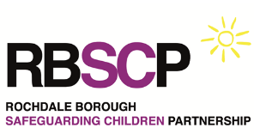
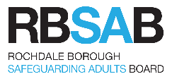
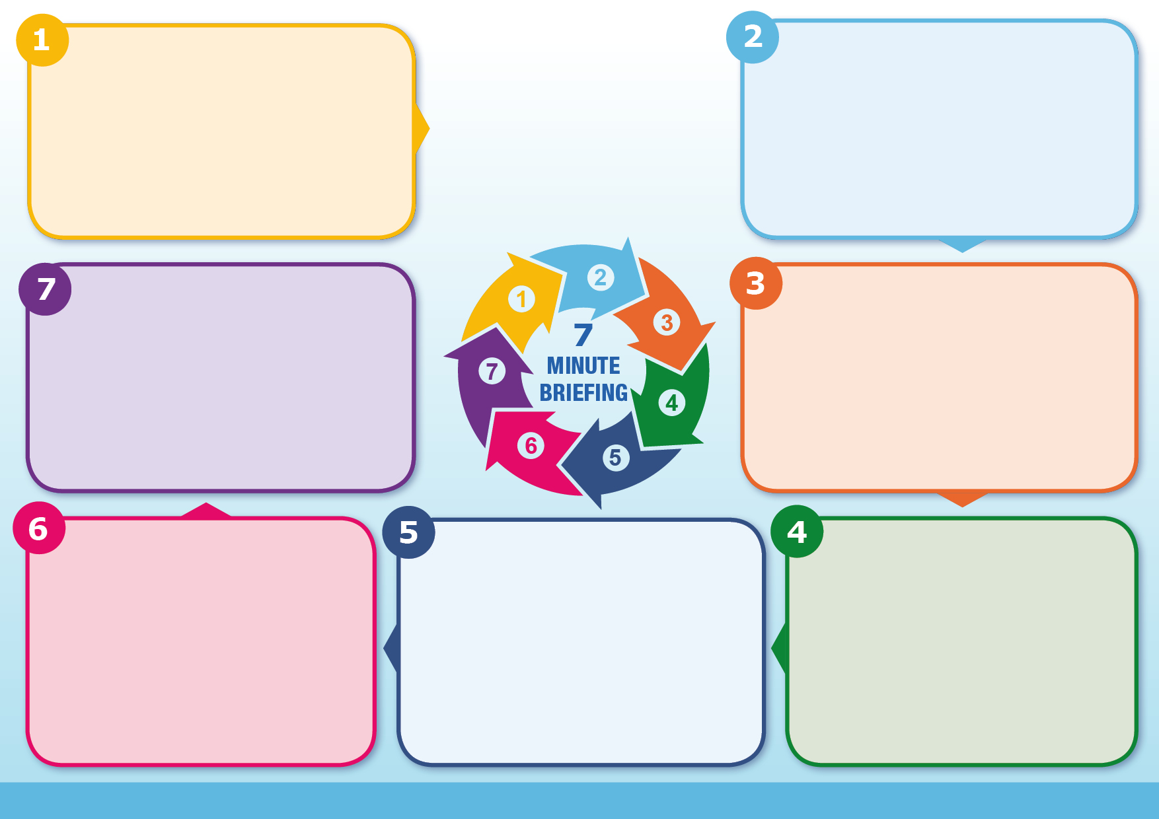
If there is any reasonable suspicion of exploitation, act early: refer, safeguard, and seek ICTG support.

The NRM provides the route to identification and support, while ICTGs ensure children receive advocacy, protection and a voice throughout safeguarding processes.
Could this be exploitation?
Is there any evidence or suspicion of criminal, sexual, or labour exploitation?
Has the child been moved or controlled?
Are they travelling, being directed, or influenced by others?
What vulnerabilities are present?
Are there factors such as missing episodes, care status, exclusion, or unmet needs increasing risk?
Are there clear warning signs?
Changes in behaviour, unexplained money/phones, injuries, fear, or secrecy?
Am I meeting the safeguarding threshold?
Do I suspect but cannot prove exploitation? This is enough for an NRM referral
What action is needed now?
Have I made a safeguarding referral, and should I refer to the NRM and ICTG service?
Questions
Children can be trafficked in, out and around the UK and can be citizens of the UK, or any other country. Children can also continue to be at risk of trafficking and exploitation once identified by, and in the care of, public authorities.
NRM identifies and safeguards victims of trafficking and modern slavery
Only First Responders (e.g. social workers, police, NHS, Border Force, Non-Governmental Organizations) can make NRM referrals
Children do not need consent for an NRM referral
Decision stages: Reasonable Grounds and Conclusive Grounds
NRM provides multi-agency support (housing, healthcare, legal advice)
The Home Office Single Competence Agency are responsible for assessing NRM referrals and eligibility for support
First Responders must complete and online ITCG referral form when completing an NRM referral
ICTGs provide advocacy, guidance and a consistent trusted adult
Child trafficking is child abuse and requires a safeguarding response
Information
The National Referral Mechanism (NRM) identifies and supports victims of modern slavery.
Independent Child Trafficking Guardians (ICTGs) are specialist professionals who support trafficked children under the Modern Slavery Act 2015.
The National Referral Mechanism and Independent Child Trafficking Guardians
Modern Slavery includes human trafficking, forced labour, criminal exploitation (including county lines), sexual exploitation and servitude.
Children under 18 are always considered victims if they are recruited, transported, transferred or harboured for exploitation regardless of consent, whether or not they have been coerced, deceived or paid to secure their compliance.
National Referral Mechanism (NRM) and Independent Child Trafficking Guardians (ICTG)

Make a Safeguarding Referral: 0300 303 0440 (Rochdale Children’s Social Care EHASH) / Contact Police on 101 / 999

Submit NRM referral via official guidance Link to Guidance & Referral Form

Refer to ICTG Service (24/7): 0800 043 4303 Link to Guidance & Referral Form
What to do
Key Message
Modern slavery is often hidden and complex, meaning victims can go unrecognised.

Children may experience significant trauma and ongoing risk, even after identification.

Early identification ensures safeguarding, protection, and recognition as victims rather than offenders.
Why it Matters
Background

