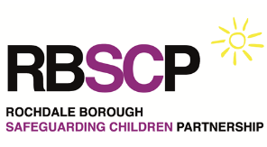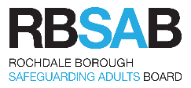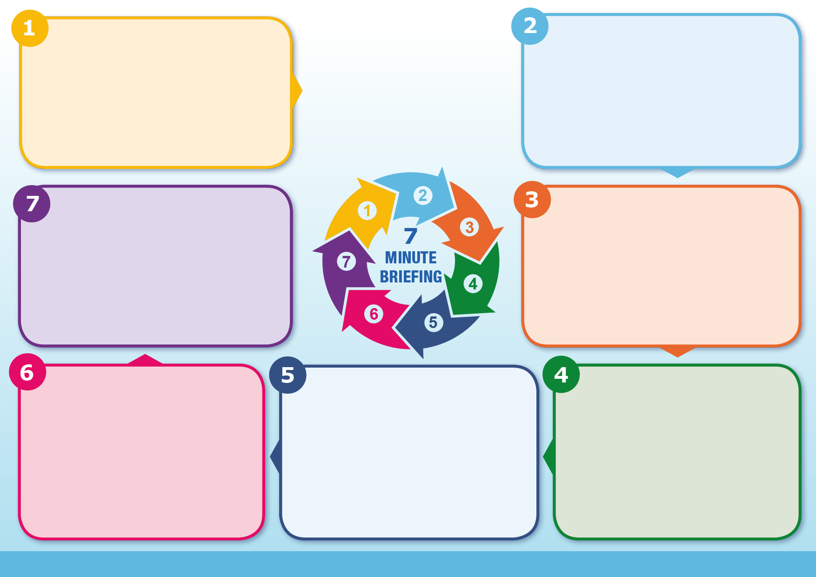

Helpful resources:

* [Crown Prosecution Service](https://www.cps.gov.uk/legal-guidance/non-fatal-strangulation-or-non-fatal-suffocation)
* [We can't consent to this](https://wecantconsenttothis.uk/)
* [Domestic Abuse resources on the RBSAB/CP website](https://www.rochdalesafeguarding.com/p/what-is-abuse-and-neglect/domestic-abuse)

If you suspect a person is at immediate risk of harm call 999 and speak to the Police.

More information is available on [www.rochdalesafeguarding.com](http://www.rochdalesafeguarding.com)

**Resources**

Seek urgent medical attention if the victim has any cardiac or breathing problems, signs of stroke or confusion.

Discuss the importance of reporting to the Police and seek advice from the Safeguarding Lead if victim declines.

Comprehensively record findings and actions.

Agencies need to follow safeguarding procedures to ensure children are protected and receive timely therapeutic interventions.

If you are impacted by a disclosure, seek support from your Safeguarding Team/Line Manager or colleague.

NFS & suffocation is a life-threatening experience which can cause brain damage, stroke, memory loss, miscarriage, hearing difficulties, physical trauma to the internal structures of the neck and devastating psychological effects.

Research shows that only 5% of victims seek medical attention.

During the assault the victim often fears they will die and may not disclose or will minimise their experience due to memory loss.

They could give a confusing / jumbled account due to lack of oxygen, the brains fear & flight response or fear of the consequences of disclosure

**Information**

NFS & suffocation result in decreased oxygen levels to the brain.

They are crimes and high-risk markers for potential serious harm and future homicide.

It is a gender-based crime against females and is the ultimate method of asserting power and control.

Loss of consciousness can occur within 6 to 8 seconds & death in less than 3 minutes.

Even a little amount of pressure on the neck can cause serious damage.

70% of victims experience this type of abuse more than once.

Victims may have no visible signs of injury, but it can pose risks to their health, both immediately and in the longer term.

**What is it?**

Non-fatal strangulation (NFS) and suffocation is a specific criminal offence under the Domestic Abuse Act 2021. This is a serious high risk assault that can lead to death. It must never be minimised.

Strangulation is the obstruction of blood vessels by external pressure to the neck impeding normal breathing or circulation of blood. Most common methods are hand(s) around a person's neck, head lock or chokehold, pressure to the neck from foot or knee, ligature and hanging.

Suffocation is depriving a person of air which affects their normal breathing. Most common methods are putting hands over mouth and nose, compressing chest or any other force or suppression applied to a person to restrict breath.

**What is it?**

**Non-Fatal Strangulation**

Using professional curiosity and a trauma informed approach is crucial to prevent further psychological damage and future risk.

Some victims do not have immediate visible injuries and it may take up to 48hrs for them to appear if at all.

NFS is often witnessed by children and can result in psychological trauma and is an adverse childhood experience.

**Information**

**What to do**

* Do you know how to instigate the MARAC referral procedures?
* Are you applying trauma informed principles?
* Be sensitive and validate the victim's experience.
* Use open questions, giving opportunity for the victim to speak about their experience in their own words.
* Consider referring to Domestic Abuse Services for safety planning and support?

**Questions to consider**