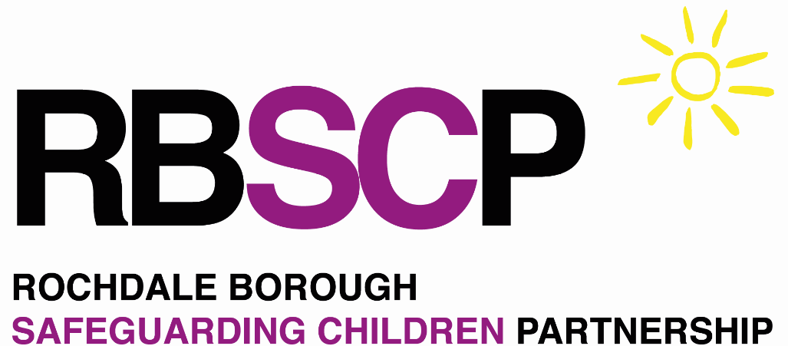

Neglect Toolkit

Who is completing this toolkit?
Name | Click or tap here to enter text.
Role | Click or tap here to enter text.
Date completed | Click or tap to enter a date.
Who is the toolkit completed for?
Child’s name | Click or tap here to enter text.
Date of birth | Click or tap to enter a date.

How to use this toolkit
The RBSCP Neglect Toolkit should be used to explore where you have identified safeguarding requirements when a child’s needs are not fully met by their parent or carer. Each of the sections contains guidance showing where a child’s needs are fully met, partially met or not met.

The sections are intended as a guide only, and should be interpreted alongside your own professional curiosity. The lists are not exhaustive and do not cover all possible interpretations or family situations.

For each section you are considering, please pay attention to the impact on the child, and their parent or carer’s ability to meet those needs. When considering the views of parents and carers, you should pay close attention to their responses to advice and support. How willing and open are they to accepting advice and support?

Not all of the child’s needs need to be either met or unmet. Remember the family’s individual circumstances and the impact these can have on the parent or carer’s ability to meet the child’s needs.

What to do if you have identified a safeguarding requirement |  | The 4 key considerations
Use this toolkit to guide you in any conversations with the family. The best agency to respond is not always Children’s Social Care. The Children’s Needs and Response Framework sets out the spectrum of support on offer. Please be mindful the support should be proportionate to the risks identified.  If you believe the child is at immediate risk of harm or danger, you should contact the Police on 999. Less immediate risks can be reported to EHASH where there is no other Early Help support that will meet the family’s needs. |  | During all conversations with families you should always consider the 4 key considerations:  - What has been identified?  - Which of the child’s needs are not being met?  - Why are some needs not being met?  - What could help ensure the child’s needs are met?  Being clear and specific regarding these 4 key questions will help when completing this toolkit.

The child’s development
Neglect can look different at different stages of the child’s life. Be mindful of the child’s age and stage of development, and how their needs change as they grow and develop. An adolescent will need different care, attention and support than a newborn child and we would expect parents and carers to respond differently to their developing needs. Guidance on age profiles can assist with identifying family and child strengths and vulnerabilities.

I have read instructions ☐
Physical care: What are your thoughts about the child’s physical development?

The following statements are examples to prompt discussion within Child Physical Development
For further information please visit Rochdale Safeguarding Partnership Board - What is Abuse and Neglect?
Needs fully met |  | Needs partially met | Needs not met
The child has appropriate food and drink for their age and stage of development. Any special dietary requirements are always met.  The child is dressed appropriately and has access to clean clothing.  The child is clean, and is able to demonstrate self-care appropriate to their age and stage of development. Any skin irritations are treated appropriately.  The child lives in an adequate home with all appropriate furniture, heating, and amenities. Any animals in the home are well cared for and do not present a danger. |  | The child receives low quality food and drink not appropriate for them. Parents / carers do not fully understand the importance of a balanced diet.  The child’s clothing does not always fit correctly.  The child is reasonably clean but this is not consistent, and they do not always brush their teeth. Skin conditions are not always treated (e.g. nappy rash)  The home has some essential amenities but is not always clean enough or is in need of improvement. Consider environmental factors such as mould. Are pro-active actions in place to address observations? | The child does not receive an appropriate diet, with a lot of sugar, crisps, chips, sweets etc. The child appears hungry.  The child’s clothing is dirty, does not fit and unsuitable for them, or the environment.  The child is dirty and is not encouraged to wash. Skin conditions are untreated and can become chronic.  The home is dirty and is in a state of disrepair. There are obvious hazards or opportunity for injury and is lacking in basic amenities. There are animal faeces, and the animals are uncared for and can appear anxious of their owners.
Record any observations, family strengths and risks you have regarding PHYSICAL | Click or tap here to enter text.
Health: How are parents and carers meeting the child’s health needs to promote their wellbeing?

The following statements are examples to prompt discussion within Child Health
For further information please visit Rochdale Safeguarding Partnership Board - What is Abuse and Neglect?
Needs fully met |  | Needs partially met | Needs not met
Parents / carers are aware of safe sleep advice.  Bedtime routines are encouraged and followed.  Appropriate health appointments are made and attended. Preventative care is followed and all immunisations are up to date or follow appropriate informed, consenting decision making.  Parents and carers are proactive in advocating for the child’s health needs, including any emotional, physical or disability needs. |  | Parents / carers do not consistently follow safe sleep advice.  Bedtime routines are infrequent and chaotic. The child can be late for school and appear tired.  Immunisations are delayed, but eventually completed. The child is not brought to all appointments. Dental and optical care are not routine. Consider disguised compliance.  Inconsistent approaches to managing any health and wellbeing or disability needs. | Parent / carer does not take account of safe sleep advice.  The child does not get enough sleep and experiences poor education and social development as a result.  Only severe / emergency health needs are addressed. Illness is allowed to deteriorate before being addressed.  Parents / carers to not participate in medical appointments such as ante-natal care.  Parent / carer does not support any of the child’s health, wellbeing or disability needs.
Record any observations, family strengths and risks you have regarding HEALTH | Click or tap here to enter text.

Safety and supervision: How are parents / carers promoting the child’s safety?

The following statements are examples to prompt discussion within Safety and supervision.
For further information please visit Rochdale Safeguarding Partnership Board - What is Abuse and Neglect?
Needs fully met |  | Needs partially met | Needs not met
Parents / carers have adequate and appropriate safety equipment in the home (e.g. stair gates)  Parents / carers are aware of the baby’s needs and pay careful attention when handling or laying the baby down.  The child is only left in the care of vetted or trusted adults over the age of 16. |  | Safety equipment and issues are understood and in place but inconsistently used.  Inconsistent supervision of the baby and can be distracted when interacting with the baby.  Parents / carers are sometimes unsure of their child’s whereabouts. | Parents / carers do not recognise danger or risk to the child.  Baby is left unattended, or is left strapped into car seats (or other seats) for long periods of time without adult attention.  Child is frequently missing from home or inappropriately home alone most of the time.
Record any observations, family strengths and risks you have regarding SAFETY AND SUPERVISION | Click or tap here to enter text.

Care and nurture: How well is the child cared for and nurtured by their parents / carers?

The following statements are examples to prompt discussion within Care and Nuture.
For further information please visit Rochdale Safeguarding Partnership Board - What is Abuse and Neglect?
Needs fully met |  | Needs partially met | Needs not met
Parents / carers value and promote the child’s identity, supporting them to develop a positive sense of self.  The child is happy to seek out physical or emotional care, and parents / carers respond appropriately.  Parents / carers do not argue or get aggressive in front of the child, and understand the impact of this on children.  Parents / carers are aware of the impact of substance misuse, risk taking and other negative behaviours on the child’s development. The child has a healthy mix of technology and human interactions. |  | Parents / carers can sometimes allow their personal values to impact on the child’s identity.  Parents / carers respond inconsistently to child’s request for care or support.  Parents / carers can sometimes disagree in front of the child, but there is no violence displayed.  The child is aware of some negative behaviours, although they do not always witness these. The child has not been encouraged to develop their own positive values. | Parents / carers do not show emotional warmth or promote the child’s individual identity.  Parents / carers respond negatively to the child.  Parents / carers frequently argue aggressively which can lead to physical violence, in front of the child.  The child regularly witnesses substance misuse and domestic violence. Parents / carers allow the child to watch inappropriate tv / films, and the child displays behaviours inappropriate for their age and stage of development.
Record any observations, family strengths and risks you have regarding CARE AND NURTURE | Click or tap here to enter text.

Child development: How do the above needs support the child’s overall development and emotional wellbeing?

The following statements are examples to prompt discussion within Child Development.
For further information please visit Rochdale Safeguarding Partnership Board - What is Abuse and Neglect?
Needs fully met |  | Needs partially met | Needs not met
Parents / carers have responded appropriately to developmental checks across health and education.  The child is encouraged to develop meaningful and positive friendships  Parents / carers encourage the child to take part in hobbies / sport / leisure activities  The child is encouraged and supported to eat a healthy balanced diet. |  | The child makes some progress in their health and educational development, although parent / carers’ behaviours can impact on this.  Parents / carers understand the importance of leisure activities to support development and friendships, but they are inconsistent in promoting these.  Parents / carers understand the importance of a balanced diet but do not always promote or provide this. | Parents / carers do not attend medical appointments or make arrangements for the child to attend school.  The child does not participate in any positive after school activities or sports clubs. Parents / carers do not understand the importance of the child developing positive friendships.  The child eats a very poor diet and parents / carers are unable or unwilling to address and improve this.
Record any observations, family strengths and risks you have regarding CHILD DEVELOPMENT | Click or tap here to enter text.

Summary – enter your reflections and assessment below. Once complete, review and take next steps

What have I identified?  What has specifically happened to identify this? | Physical | ☐ | Health | ☐ | Safety | ☐ | Emotional | ☐ | Developmental | ☐
 | Click or tap here to enter text.

What Strengths have you observed with the child and family? What is working well for the child and family? Have you communicated this to family? | What Vulnerabilities have you observed with the child and family? What are the short and long term impacts of vulnerability?
Click or tap here to enter text. | Click or tap here to enter text.
What Opportunities are present to support the family? Which services are there that would help the child / family to make positive changes? How will the child’s life improve as an outcome of result? What do the family think of this option? | What Risks are present to support the family? Consider, “What is the threat if I do nothing” to “What are my options to reduce risk and what do they offer the child and family”. How will we know it’s changed?
Click or tap here to enter text. | Click or tap here to enter text.

