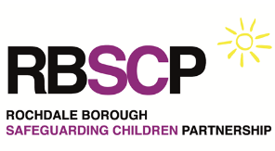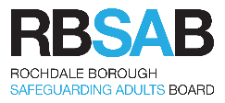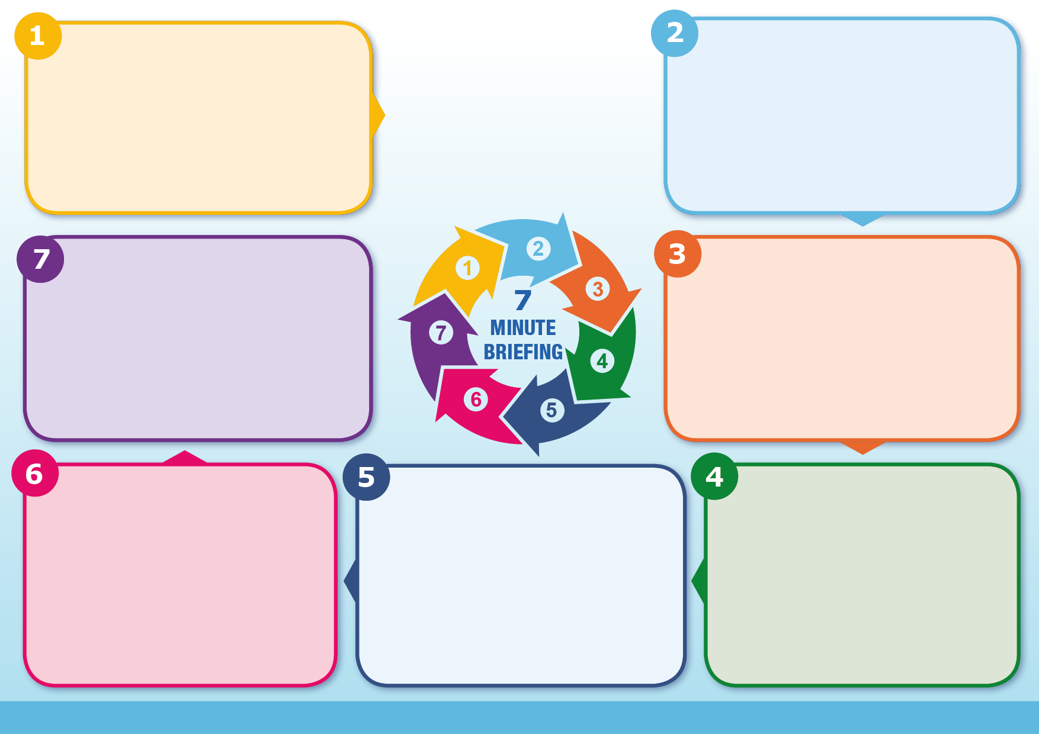

How might I recognise victims of trafficking and modern slavery?

Am I confident that I would know what to do if I suspected that someone was a victim?

Do I know where to get further help and advice?

**Questions to ask yourself**

The National Referral mechanism (NRM) is a victim identification and support process. It is designed to make it easier for all the different agencies that could be involved in a trafficking case to co-operate, share information about potential victims and facilitate their access to advice, accommodation and support.

There is a duty on first responders such as local authorities and police to complete the National Referral Mechanism (NRM) form in all cases of suspected trafficking

**Information**

**Barriers**

Victims may:

* be reluctant to come forward with information
* not recognise themselves as having been enslaved
* tell their stories with obvious errors (because these stories are often composed by others and learnt).

Indicators:

* Victims may appear malnourished or show signs of bruises, other injury, their appearance may be unkempt & they may be isolated from the local community
* people who are working &living at the same place
* tattoos indicating ownership

**Information**

Trafficking & modern slavery are serious and brutal crimes in which both adults & children are treated as commodities & exploited for criminal gain. People may be forced to work through mental or physical threat; bought & sold as ‘property’; physically restrained or have restrictions placed upon their freedom of movement.

The scale of modern slavery in the UK is significant & there have been year on year increases in the number of victims identified. In few other crimes are human beings used as commodities over and over again for the profit of others. In the UK the vast majority of known trafficking is for the purpose of sexual exploitation.

**Why it matters**

Trafficking involves transporting people away from their communities, by the threat or use of violence, deception, or coercion so they can be exploited. Once initial control is secured, victims are generally moved to a place where there is a market for their services, often where they lack the basic knowledge that would enable them to seek help. Trafficking can take place within a country’s borders or across borders.

Modern slavery includes trafficking, but also encompasses cases of sexual exploitation, forced manual labour, sham marriage, domestic servitude & organ harvesting. Some people may not be victims of human trafficking, but are still victims of modern slavery. Victims can come from all walks of life.

**Introduction**

**Modern Slavery and Trafficking**

Obstacles to coming forward may include fear of:

* punishment at the hands of their traffickers – including reprisals against their children and families
* punishment at the hands of the authorities
* deportation
* juju or witchcraft rituals
* discrimination from their community and families

**Further information**

Read the multi-agency procedure Safeguarding Children from Trafficking & Modern Slavery at [www.rochdalesafeguarding.com](http://www.rochdalesafeguarding.com)

Modern Day Slavery Helpline 0800 0121 700