Rochdale Borough Strategy for children who go missing
2021- 2024

Introduction
Partners in Rochdale Borough are committed to the safeguarding of all children resident in the borough and recognise that children who go missing schools are likely to be more at risk of exploitation and abuse.
Across the partnership, individual agencies have responsibility for particular cohorts of children at risk from missing episodes and adhere to individual policies and processes within their agency.
This strategy and associated action plan has been developed to ensure a consistent approach to missing children across the borough; to ensure information is shared so that services are cohesive and effective and that all partners clearly understand their responsibility for managing risks across the Children’s needs and Response Framework in relation to missing children. https://www.rbscp.org/professionals/children-s-needs-response-framework
Progress and outcomes arising from this strategy will be reported to the Rochdale
Borough Safeguarding Children Board/Partnership via the Complex Safeguarding subgroup.

Children who go missing
Research has shown that children are more likely than adults to go missing, placing them in risky situations and increasing their vulnerability to a whole range of issues. Whilst the majority of these children and young people are found quickly, all children and young people who go missing irrespective of the amount of time that they are
missing for, are at risk.
The reasons why children and young people go missing are varied and complex. These ‘push and pull’ factors, may include the child or young person running away because of problems at home or school, such as abuse, neglect, or bullying.
A child or young person may also go missing because they want to be somewhere other than their home, or because they want to be with someone they are unable to be with, unless they run away. Some children might be coerced to run away and go missing by someone who has power or control over them.

Children and young people whilst missing from home or care may experience physical and or emotional abuse, additionally they are more likely to engage in risk taking and self-harming behaviour, and they may find themselves sleeping rough, often
committing crime in order to survive, whilst also feeling fear and loneliness.
As a consequence of being missing, their education, family and social relationships and life chances often suffer. Moreover missing children and young people are particularly vulnerable to trafficking, violent crime, drug and alcohol misuse and exploitation, including sexual exploitation, as either a cause or consequence of going missing.
Significant evidence highlights that children and young people who go missing from home or care are at increased risk of being at risk of, or experiencing sexual exploitation. It is therefore essential that all partner agencies act rigorously to reduce incidents of children going missing.

Key Principles
- Any missing episode is potentially serious

- Individuals have a responsibility to report a child if they are missing.

- It is imperative that services working with children are able to and actively do identify those who are commencing a pattern of running behaviour and provide the appropriate interventions at the earliest opportunity to prevent future incidents which may place them, or others, at risk.

- Accurate and up-to-date information from the person's past and present is key to appropriate risk assessment and response to missing.

- Children and young people have a fundamental right to have their voices heard

Our strategic aims:

To reduce the number of children, who go missing whilst also ensuring that our children and young
Prevention
people understand the risks associated with going

Reduce the risk of harm to our children and young people who go missing
Protection

Provide our children and young people who go missing & their families and carers with high quality response, support and guidance.
Provision

1 | Prevention
 | What are we going to do? | How are we going to do it?
1.1 | Ensure that effective, multi-agency governance arrangements are in place to co-ordinate and oversee the services | Missing strategy and action plan in place and monitored by multi agency working group
1.2 | Ensure that all staff have access to resources that support robust, informed interventions and assessments that promote good outcomes | Regularly review missing policies, procedures and pathways to ensure that they continue to be fit for purpose and support early identification and appropriate action to address risk
1.3 | Ensure that children and young people are aware of the risks associated with going missing and of accessible sources of advice and support. | Information and advice provided to children by schools and other agencies across the borough
1.4 | Provide information for the general public that raises awareness of the indicators and risks associated with going missing and provides clear advice on what  they need to do if they are concerned about a child. | Support national and regional awareness  Campaign’s and develop local, targeted campaigns.

2 | Protection
2.1 | Promote a consistent understanding across the whole  Work force of the risk indicators in relation to children who go missing, and interventions are delivered in accordance with best practice. | The Children who go Missing training to be refreshed and included in the multi-agency safeguarding training programme for 2021/24
2.2  2.3 | Use RBSCP Quality Assurance Framework Tools to test Children who go Missing arrangements  Promote effective multi agency working to consider each child and agree multi agency approaches  to prevent further missing episodes. | Work with the Quality Assurance sub group to agree most effective approach to measuring the impact of Children who go Missing strategy/policy/guidance and  training on practice - including monitoring of return interviews/safe and well checks  The Children who go Missing panel meets monthly to review any child who has been missing and agree interventions and strategies to prevent further episodes.
3 | Provision
3.1 | Parents and carers are aware of the potential and actual risks associated with going missing and have access to sources of advice and support - including clear advice on what they need to do if their child goes missing. | Rochdale specific advice for parents/carers -'What to do if your child goes missing' developed and promoted.
3.2  3.3 | Children and young people who are missing/have gone missing can access appropriate support  The Strategic Children who go Missing Panel oversees the strategy and ensures appropriate provision and resources are available. | Engagement and consultation with children and young people to identify what works and areas for improvement.  Meeting on a quarterly basis to review the overall strategy and monitor impact on outcomes for our children.

Measuring impact—how will we know if the strategy is working?

We will measure the success and effectiveness of this Strategy by the impact on outcomes for children and young people.
A Performance Framework that provides information on key performance indicators.

We will review and monitor the activities detailed under the strategic objectives on an ongoing basis and report on them on an annual basis.

5. Local services, policies and procedures

Rochdale Borough Safeguarding Children Partnership
These procedures are the overarching, multi-agency procedures for the Rochdale Borough. They also link to Greater Manchester Missing Persons Procedures. They provide a definition of ‘missing’ and ‘absent’ children and a framework for protecting children who are missing.
The lead for consultation on these procedures is the Rochdale Borough Safeguarding Children Partnership (RBSCP), Business Manager. http://www.rbscp.org/

Complex Early Help and Safeguarding Hub
The Early Help and Safeguarding Hub is made up of a variety of services including the Police,
Children’s Social Care and Sunrise as well as Early Help and Health, all of whom contribute to the decision making regarding individual cases—this includes cases of missing children.
Where a referral is not seen as meeting Children’s Social care thresholds for a service the referral will be passed to the Early Help managers to consider whether alternative support can be offered and by whom. The lead for this service is Michelle Rhodes who can be contacted on Michelle.Rhodes@Rochdale.Gov.Uk
Telephone email: ehash@rochdale.gov.uk 0300 303 0440 (8.30am to 4.45pm)
0300 303 8875 (out of office hours)
Rochdale’s Children’s Needs and Response Framework helps practitioners to, share a common understanding of children’s needs so that timely and appropriate support is provided at the right level.
Rochdale Children’s Services procedures can be found at:
ADD HYPERLINK

Missing from Care procedures
These procedures agree the process between police, social care and relevant partners for managing children who are cared for by Rochdale Borough and who go missing from their
placement. They include details as to how that case is managed and recorded. The lead on these processes is Lee-Anne Agard the business manager in social care.

Missing from Education
The Children Missing Education guidance provides an outline of Rochdale Local Authority’s systems for identifying and maintaining contact with children missing education and of developments in identifying those at risk of going missing from education. Children Missing Education (rochdale.gov.uk)

5. Working Together
Whilst individual agencies follow relevant procedures in relation to children who are missing in specific circumstances this strategy and associated action plan identifies the need and agrees the premise for an integrated approach across the partnership and across the threshold of need, from children receiving services as part of the early help provision through to children receiving statutory intervention, to ensure
prevention and protection for all of our children who go missing.

Early Help
This includes prevention work through raising awareness for all children of high school age and also work with children who are deemed to be at greater risk of going missing. This includes the identification and support for children who are missing from education. Early help may include the identification of children at greater risk including risk of sexual exploitation and may result in referrals into statutory services.
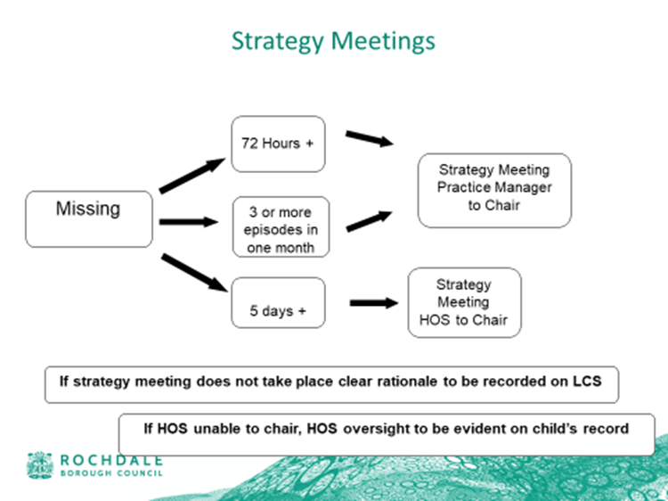

Statutory Services
This includes actions related to those children who are at risk and who maybe subject of child in need or child protection plan who go missing. It includes children at risk of child sexual exploitation where missing is a key feature.
This includes children who are cared for by Rochdale Borough who are known to have been missing from placement whether resident in Rochdale Borough or out of Borough.
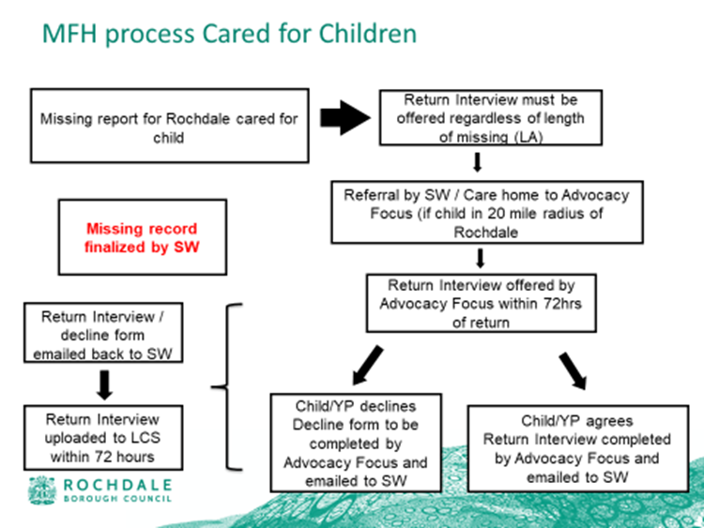
This may also include children missing from education

Children from Other Local Authorities - COLA
This includes children placed in Rochdale Borough from other local authorities who go missing. It ensures an appropriate response to children who go missing and the
escalation process to the responsible local authority and safeguarding children board where children are deemed to be at risk.

Appendix 1

Definitions:
Children who go Missing For the purpose of this strategy, children who go missing is used as a generic term but includes all children missing from home, children missing from care and also includes those children who are deemed absent, absconding or have runaway. It also includes children placed by another local authority, in Rochdale Borough

Child includes all children up to the age of 18

Missing from education refers to a compulsory school age child who is consistently missing from the education provision provided to them. Children and young people missing from education are at increased risk of poor education outcomes which in turn can limit life choices

Updated November 2021.

