Missing From Home or Care
Information and Practice Guidance
Updated May 2021 V1

Purpose

The purpose of this practice guidance is to assist practitioners across Children’s Services with the day-to-day management of children’s contacts, referrals and open cases where going missing is a factor.

This practice guidance should be read in conjunction with the Greater Manchester policies and procedures, which are available on Tri-X. However, it is important to note that a number of variations have been made within this guidance to reflect current practice expectations of Rochdale Council’s employees.

Reporting and recording

Once appropriate checks and attempts to locate the child or young person have been completed every child missing from home and care episode must be reported to Greater Manchester Police (GMP), who are the only agency who can formally categorise the child or young person as ‘missing’.

Missing children and young people remain the responsibility of the person/organisation who has Parental Responsibility for the child/young person, even after they have been reported missing. NB: the act of reporting a child/young person missing by staff at the care establishment or foster home placement does not absolve the carers from their ‘duty of care’.

Once a child/young person is reported missing, GMP are responsible for referring all missing children episodes to Children’s Services via the Early Help and Safeguarding Hub, EHASH. This notification is sent via email.

A Referral and Information Co-ordinator (RIC) based in EHASH is responsible for recording all notifications of missing children episodes on LCS and EHM. This generates a new missing episode on the child/young person’s record. An alert is sent to the allocated social worker, if the child is currently in receipt of ongoing services.

If an informed decision is made that a child/young person who is open to Children’s Social Care (CSC) is not officially missing this still needs to be recorded on LCS, both within a case note and the chronology. This will enable workers to identify/monitor patterns of behaviour and identify any increase in risk using a needs led approach, which is proportionate to the outcome of the risk assessment.

  - There is the option to record cared for children on LCS as ‘Away from placement without authorisation’ or ‘LAC away from placement without authorisation’.

  - Once a child/young person is located, the full details of this missing episode needs to be recorded on LCS. The missing episode can be completed after the return home interview has been completed and added to LCS within the MFH episode, it can then be finalised. Details of the missing episode must then be recorded within the child/young person’s chronology, including specific details regarding the duration of the episode, location where found and any associated risk factors.

  - The allocated social worker is responsible for finalising this missing episode. If the episode is not finalised the record is not counted in performance reporting. Practitioners must check cases and ensure that all missing (even historical incidences) are finalised.

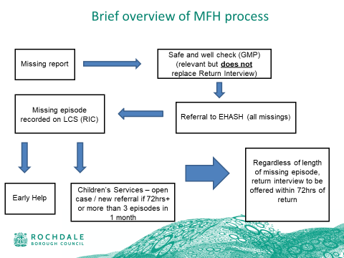
  - EHASH are responsible for finalising MFH episodes for any child not open to CSC. Close liaison is required with the Complex Safeguarding Team.

Specific Actions during the Course of the Missing Episode or Once the Child/Young Person Is Found

Strategy Meetings /Discussions

All missing episodes need to be reviewed and a decision made as to whether a strategy discussion is needed. In the following circumstances a strategy meeting must take place (regardless of the status of the child/young person):

If the child/young person is missing over 72 hours or a period of time deemed significant for that child.

If there has been three missing episodes recorded for the child/young person a strategy meeting is required.

If there is a significant missing episode that is out of character for the child/young person a strategy meeting is required.

If a management decision is made that a strategy discussion is not needed the rationale for this needs to be clearly recorded on LCS.

All relevant professionals need to be invited to the strategy meeting which needs to be planned and purposeful. Specific attention needs to be paid to the missing episode(s) and the risks associated with this. This meeting should inform planning and future interventions, which focus on reducing the identified risk and preventing further missing episodes occurring. All active plans need to be updated post strategy discussion to reflect the agreed actions.

The strategy meeting needs to be recorded on LCS and the minutes distributed to all key professionals in a timely manner, detailing the key responsibilities of all involved. It is important that partner agencies are invited to this meeting along with colleagues in the Complex Safeguarding Team, where appropriate.

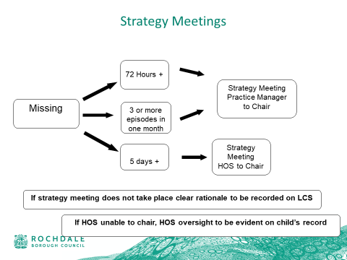
Any child that is missing for a period of 72 hours must be reported to the Assistant Director of Children’s Services. Any consideration for permission for social media involvement must be sought from the Assistant Director. Any child missing for more than five days must be reported to the AD and DCS , the child’s IRO should also be notified.

Safe and Well Check (SWC):

  - The statutory guidance states that safe and well checks should be carried out by the police as soon as possible after the child has been found or returned. Their purpose is to check for any indications that the child/young person has suffered harm, where and with whom they have been, and to give the opportunity to disclose any offending by them or against them.
  - Where a child/young person goes missing frequently, it may not be practicable for the police to see them every time they return. In these cases a decision should be taken in consultation with GMP and the child/young person’s parent or carer, or their social worker, with regard to the frequency of such checks bearing in mind the established link between frequent missing episodes and serious harm, which could include gang involvement, forced marriage, bullying or sexual exploitation. The reason for a decision not to conduct a SWC should be recorded on child/young person’s case file.
  - The RIC/Early Help Practitioner/social worker needs to consider the content of the safe and well check and liaise with other professionals i.e. Sunrise Team or Police Missing Coordinator regarding any significant concerns highlighted in respect of the child/young person and others that may be known to the department.

Return Interviews

This is an in-depth interview that is carried out by an independent person where possible. If this is not viable, it is best carried out by a chosen professional who the child/young person is comfortable speaking with and can follow up any actions that emerge. It is the responsibility of the Local Authority to ensure that return interviews take place and must be available for to children/young people who go missing from both home and care.

All efforts should be made to contact the child/young person within 72 hours of their return, to arrange an independent return interview.

In Rochdale all children/young people open to Children’s Social Care are offered a return interview regardless of how long they are missing for.

All children/young people will be offered a return interview, even if they do not choose to take part, with evidence of robust attempts to engage the young person in the return interview recorded. The missing from home episode must then be completed, indicating that a missing from home interview has been offered. If this is declined, this should be recorded on LCS as part of the missing episode and a decline form needs to be completed. The worker should still give consideration to the risks in the case and whether a referral to another service is required.

The return interview must have a clear analysis of risk, with consideration being given to previous missing episodes (do not consider it in isolation) and wider contextual information. Any significant information from the return interviews needs to be shared with the police, i.e. the names of other young people, information on locations, high-risk adults and criminal activity. The level of risk, ‘push ‘ and ‘pull’ factors and level of need and support, need to be carefully considered and addressed in the plan for the child/young person. Relevant referrals should be made to other support services if required. The practitioner responsible for undertaking the return interview must ensure that they consider the information contained in the SWC when analysing the return interview information.

Depending on the status of the child/young person at the point of them being reported missing there are different levels of response from Children’s Services.

Early Help Offer – if the child/young person reported missing is not an open case to Children’s Services a decision will be made in EHASH if the situation requires an early help response and should be managed at level 2 of the Children’s Needs and Response Framework or needs escalating to CSC.
At an early help level, depending on the nature of the concerns about the child and their case history, an appropriate professional will be identified to undertake the return interview. This may be a health practitioner, family worker, school practitioner, youth service or early help practitioner from the Early Help and Safeguarding Hub, if an independent person is required.
The interview must be completed within 72 hours of the child/young person being found, recorded on MFH return interview form within LCS as part of the missing episode. Any significant information needs to be shared with relevant services/agencies/professionals for information sharing/intelligence gathering purposes.
Once completed the return interview is returned to EHASH via email and where an early help practitioner will review the content in context of wider information including discussions with the EHASH manager, Complex Safeguarding Team or other professionals as required. The practitioner responsible for undertaking the interview should have further discussions with an early help/CSC practitioner at the Early Help and Safeguarding Hub should there be any emerging safeguarding concerns at the earliest opportunity.
The child’s case will escalate from early help level to CSC if required. Where it does not meet the threshold for CSC involvement, Early Help support and appropriate referrals will be made to other agencies/services as part of Rochdale’s Early Help offer at an early intervention and prevention level.
Child in Need or Child Protection – if the child/young person is already an open case at level 3 or 4 of the Children’s Needs and Response Framework (child in need or child protection) a return interview must be undertaken by the allocated social worker or another professional working with the child/young person. (As agreed as part of their individual plan i.e. family worker, ACT practitioner, Complex Safeguarding Team social worker).

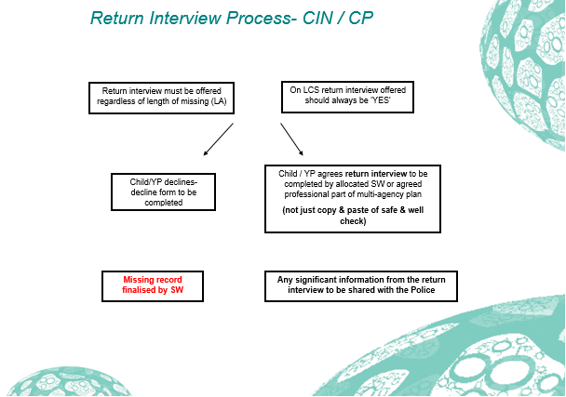
The interview must be completed within 72 hours of the child/young person being located and recorded or uploaded onto LCS as part of the missing episode. Any significant information needs to be shared with relevant services/agencies/professionals in order to safeguard the child. Appropriate referrals should be made to other agencies/services, the Complex Safeguarding Team if required and packages of support identified and implemented as deemed appropriate.

Cared for children – all cared for children/young people open to Children’s Services will be offered a return interview by Advocacy Focus who are commissioned by Rochdale CSC to undertake these interviews.
The interview must be completed within 72 hours of the child/young person being found and recorded or uploaded on to the child’s record on LCS as part of the missing episode. Any significant information needs to be shared with relevant services/agencies/professionals for information sharing/intelligence gathering purposes.
The police MFH notifications go directly to Advocacy Focus and the allocated (or substitute) social worker or residential worker if the child/young person is placed in a Rochdale Borough Council Children’s Home. These professionals are then responsible for ensuring that a return interview takes place. The record of the interview needs to be uploaded to the LCS system by the allocated social worker and the missing from home episode ended.
Where a child/young person is placed out of borough, discussions need to take place with Advocacy Focus regarding whether they are able to conduct this interview. If this is not viable, an alternative arrangement must be put in place. The allocated social worker and practice manager is responsible for ensuring this happens.
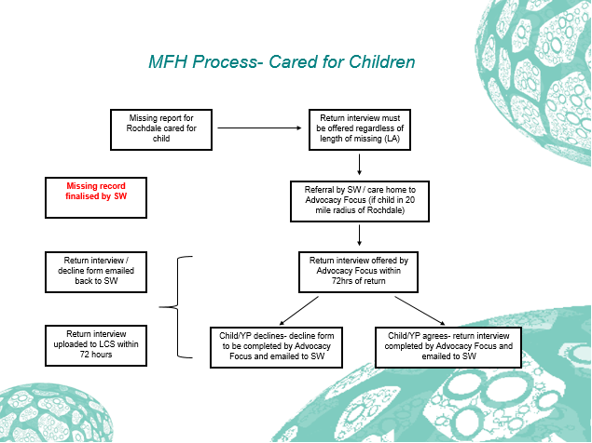

4. Provision of Specialist Intervention/Support Services

4.1 Within Rochdale the Missing from Care, Independent Visitors service and advocacy service is provided by a commissioned service Advocacy Focus

4.2 It has been agreed that missing notifications in respect of cared for children go directly from GMP to Advocacy Focus to aid in a swift response to the children. The referral form for Advocacy Focus is completed and emailed to admin@advocacyfocus.org.uk and the referral will then be triaged and allocated to the appropriate worker and service.

5. Assessment and Planning

Where missing episodes are a factor in a child’s case then a risk assessment should be completed and interventions to address the risks must be incorporated into the CIN/CP plan/Placement Plan/CLA care plan). This should include an overview of historical/background information as well as accurate and up to date information so a picture of a child / young person’s behaviour and experiences can be developed.

Where children and young people are an open case to Children’s Social Care or Early Help the missing episodes and associated risk needs to be built into the child/young person’s individual plan regardless of their status. There needs to be a plan outlining the tasks and responsibilities for each family member/professional involved i.e. their responsibilities in respect of reporting incidents. This would be part of the child or young person’s Early Help/CIN/CP or Care plan.

All plans need to be regularly reviewed by the multi-agency group responsible for working with the child/young person and their family/carers and amended to reflect any change in need and assessed level of risk.

Where the child/young person is cared for the risks associated with the child/young person’s missing episodes and how to manage this should to be fully detailed in their placement plan, or risk management plan if they reside in a residential unit. These plans should be working documents and should be regularly reviewed and amended as part of the care planning process. Placement planning meetings/multi-agency care planning meetings should be the forum for discussing such risks, family history as it will assist carers to understand and manage and risks to the child/young person. The responsible IRO must be notified of any missing episode.

Whilst considering placement options the social worker must consider the potential for the child/young person going missing, particularly when placing out of borough. This should include contact with the proposed host local authority to ensure that there are no contraindications to a child’s safety in that area.

6. Children who go Missing Panel

6.1 This operational multi-agency panel meets once a month. The purpose of the panel is to review children/young people missing from home or care in Rochdale. Children and young people at high-risk, as well as practice issues are considered and explored.

6.2 All children/young people who have been missing 3 or more times or 72hrs or over the previous month are discussed, with consideration being given to the quality of practice and management of the missing episodes. Panel members will be informed about the children’s cases to be considered and collate information to inform the Panel. If contacted by a panel member with a request for information regarding this cohort of children/young people this needs to be provided in advance of the meeting so appropriate multi-agency discussions can take place and action plans set as required.

6.3 Should any practitioner have any practice issues in respect of this area of practice they should share this with the representative from their service area/agency prior to the next missing panel.

6.4 The Strategic Group for children who go missing leads the approach to children missing from home and care in Rochdale and is responsible for the strategic action plan to improve and develop service delivery across the partnership.

Statutory guidance on children who run away or go missing from home or care, DfE (2014) London: HM Government.

