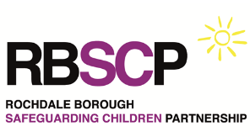

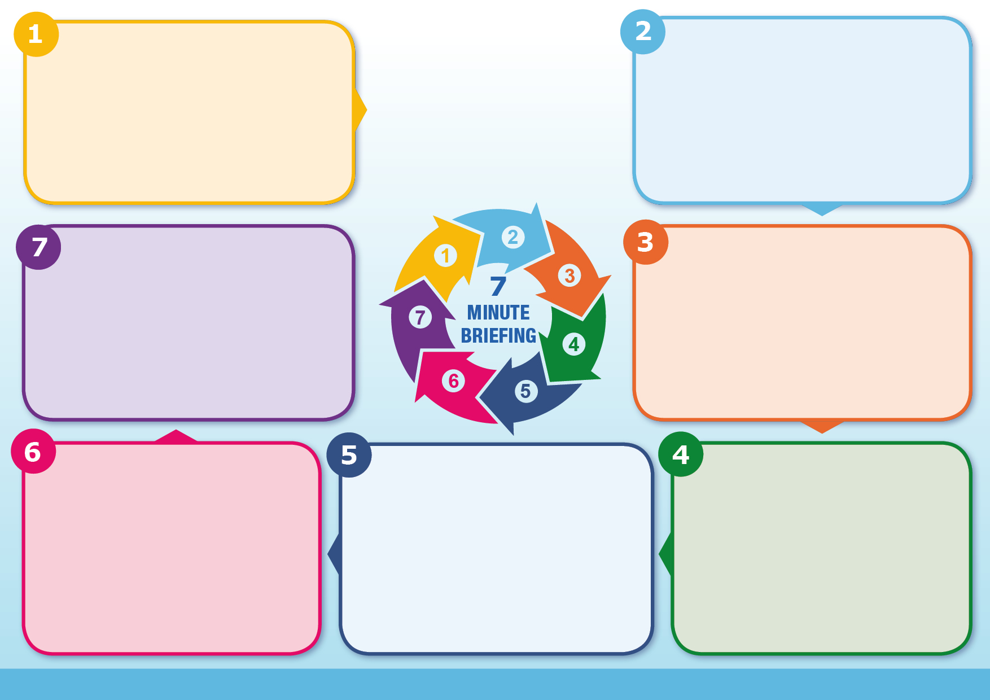
What To Do
If under 18 and known FGM identified or reported, complete mandatory police report Mandatory reporting of female genital mutilation: procedural information - GOV.UK
For concerns about Adults please ring Adult Care on 0300 303 8886
For concerns about Children ring Children’s Social Care on 0300 303 0440
In emergencies call 999 and report to the Police.
Work with families where safe to do so but prioritise child safety.
Complete the Home Office Female Genital Mutilation Awareness Training, available here.

Ask yourself…
- Do you know the name of your agency lead for FGM?
- Have you heard about The Guardian Project run by NESTAC and its free support services across GM?
- Do you know about the advice and resources on the rochdalesafeguarding.com website?
Current Context (2026 Update)
National safeguarding reviews continue to emphasise child visibility, professional curiosity, and information sharing. There is increased focus on early identification and multi-agency response at the ‘front door’ to prevent harm.

Often parents themselves can experience pressure to agree to FGM for their children. It is important to recognise that those seeking to arrange the cutting are unlikely to perceive it to be harmful. Whilst every attempt should be made to work with parents/carers on a voluntary basis to prevent FGM, the safety of the child must be paramount.
The procedure may be carried out shortly after birth, during childhood or adolescence, just before marriage or during a woman’s first pregnancy. The practice is not endorsed by any religion.

Information
Why it matters
FGM is illegal in England and Wales. As amended by the Serious Crime Act 2015, the Female Genital Mutilation Act 2003 now includes
- An offence of failing to protect a girl from the risk of FGM
- Extra-territorial jurisdiction over offences of FGM committed abroad by UK nationals and those habitually (as well as permanently) resident in the UK
- Lifelong anonymity for victims of FGM
- FGM Protection Orders which can be used to protect girls at risk
- Mandatory reporting duty which requires specified professionals to report known cases of FGM in under 18s to the police.
Information
- Family links to FGM practising communities
- Planned travel abroad (especially during school holidays)
- Disclosure of a ‘special procedure’ or ‘special occasion
- History of FGM in family, or isolation from wider society
- Parents have poor access to information on the harmful impact of FGM
Risk Factors
FGM & the Legal Framework
Female Genital Mutilation (FGM) includes all procedures involving partial or total removal of the external female genitalia or other injury for non-medical reasons. It is internationally recognised as a violation of human rights and a form of child abuse.
FGM is illegal in the UK under the Female Genital Mutilation Act 2003, strengthened by the Serious Crime Act 2015. Key provisions include: mandatory reporting duty for under 18s, FGM Protection Orders, lifelong anonymity for victims, and offence of failing to protect a child.

FGM is child abuse and a form of violence against women and girls which has immediate and long-term health consequences including severe pain and blood loss, shock, mental health problems, complications in childbirth, and/or death.
It is believed that FGM may happen to girls in the UK as well as overseas. Girls of school age subjected to FGM overseas are likely to be taken abroad (often to the family’s country of origin) at the start of the school holidays, particularly in the summer, in order for there to be sufficient time for them to recover before returning to school.
Female Genital Mutilation (FGM)

