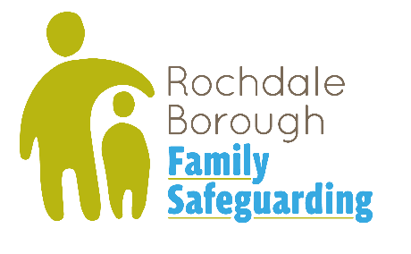
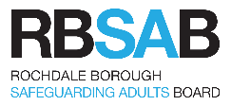
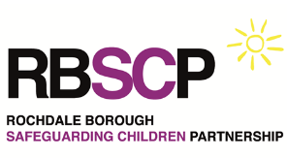
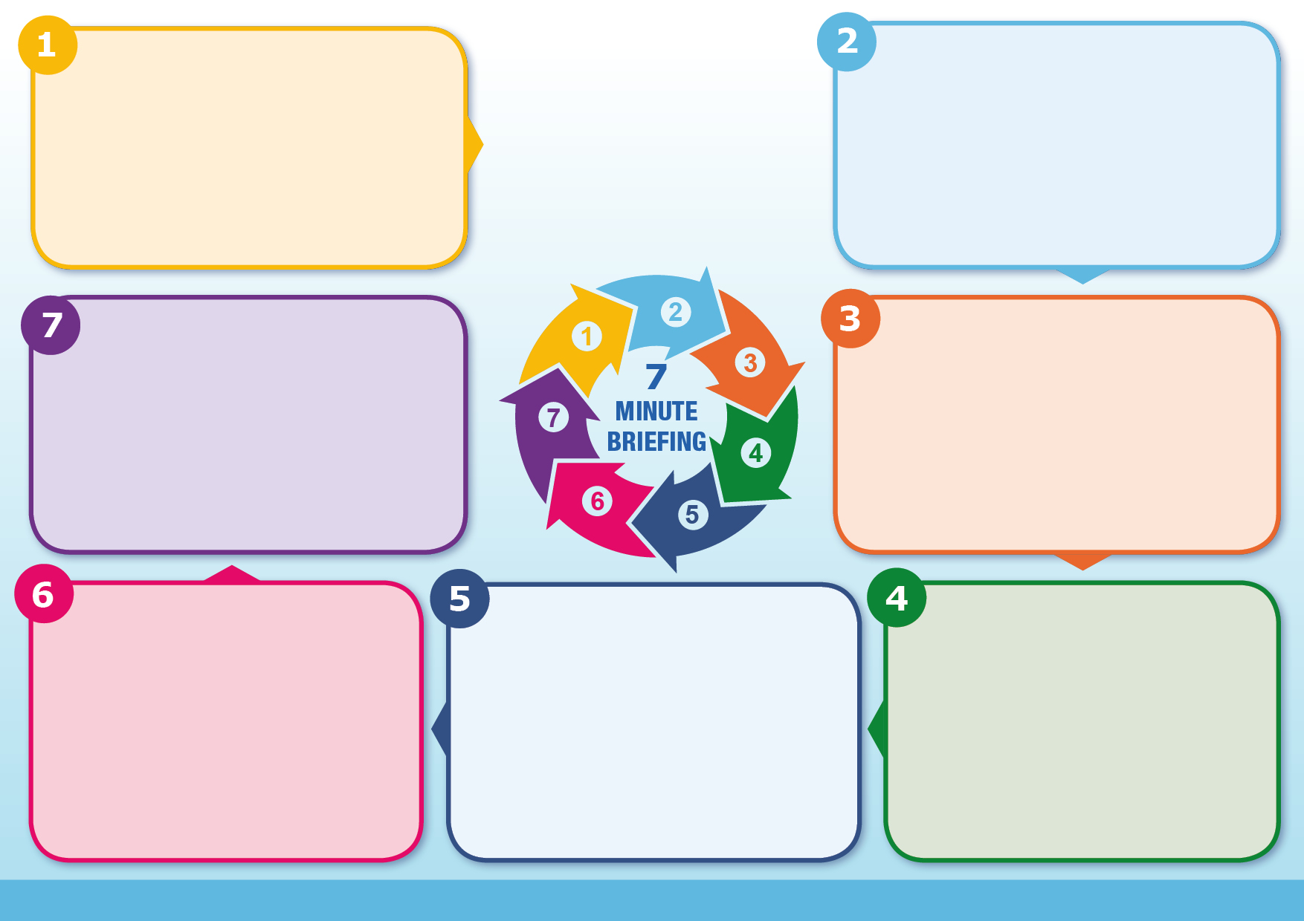
Children’s social care have adopted the Family Safeguarding Model, this 7 minute briefing explains how the model may change the way we work with our families and our partners.
The Family Safeguarding Model is a whole family approach to working with children and families that supports parents to create sustained change for themselves and for their family and improve outcomes for children. There is evidence that the model is successful in reducing the numbers of children subject to child protection plans and coming into care and in reducing re-referrals. Click here for an introductory video on the family safeguarding model
Family Safeguarding in Rochdale
Collaborative: Practitioners and families are partners -we do things with people, not to them​

Strengths based: All families have strengths, and we focus on using their strengths to support change

Purposeful: Our role is to meet child and family needs & give families the right support, first time
In Family Safeguarding we have a commitment to using language which is simple, non-blaming and non-judgemental. We try to avoid jargon and acronyms, but explain their meaning if they need to be used.
We remember we are talking and writing about someone’s life, they may return to access their records, we are therefore trauma informed, are empathetic and sensitive to how the person will react to the words and language we use. Click here for a 7 minute briefing on the use of language
A key learning point around changing practice for partners at the point of referral
Before a referral is made or a family steps in to child in need or child protection, there needs to be evidence shared that professionals have made efforts to work alongside the family and provide the right support the family need.
If intervention is not working there needs to be evidence that professionals have tried different approaches so families are fully supported to engage.

Link to frequently asked questions here
Multi-disciplinary Teams: Including social workers, family support workers and specialist domestic abuse and substance misuse workers all working alongside each other and the family. The team can address complex concerns and needs through joint home visits, reflective discussions and through peer and group supervision.

Motivational Interviewing: Is used by all professionals working with the family and is a collaborative conversation style designed for strengthening a person’s own motivation and commitment to make and sustain positive changes. Click here for an introductory video to MI
Values of the Family Safeguarding Model
Values of the Family Safeguarding Model ctd…

Language
Expectations from Other Agencies/Professionals
Thresholds
Core Components of Family Safeguarding
A key learning point for changing practice for partners at Child Protection Case Conferences
Although intervention thresholds remain unchanged, the Family Safeguarding Model focuses on working with families at the lowest level (where it is safe to do so) to reduce the trauma of intervention can cause. This may impact decision-making regarding levels of intervention in Child Protection Conferences and Child in Need meetings.

Rights Based: Remembering that families have rights and the autonomy to make choices. All professionals need to seek consent in almost all situations.
Empathetic: We listen carefully to families & offer a helping hand to create change & improve outcomes for children.

Aspirational: We want the best for families and provide support and help so they can make and sustain change.

