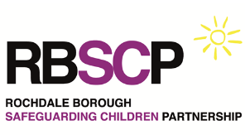
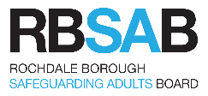
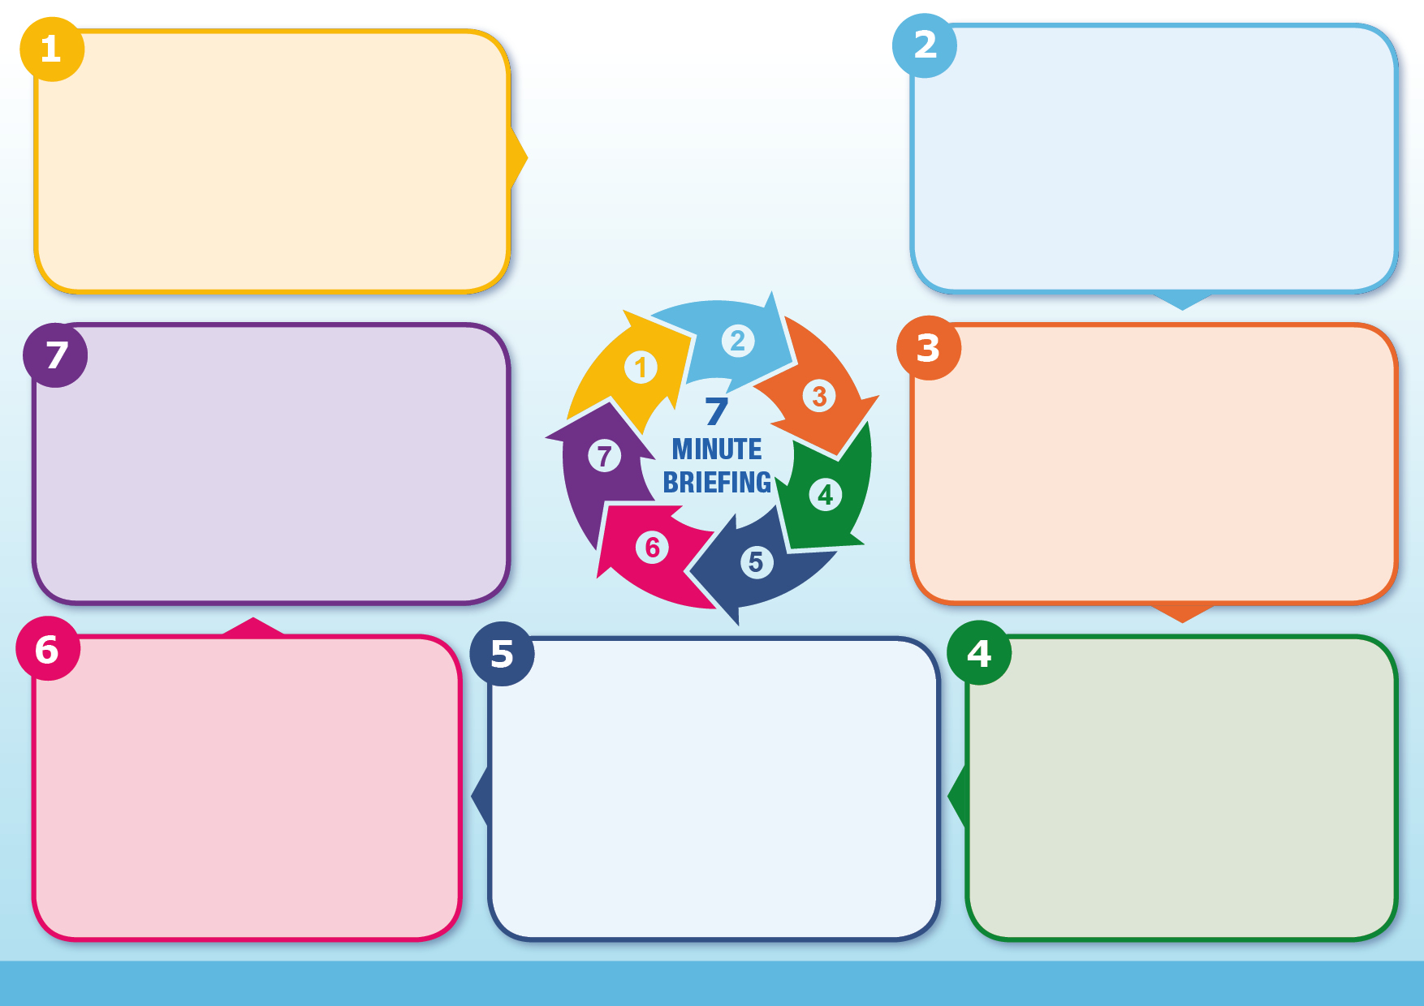
When communicating with a child who might have been sexually abused, it is essential that you put them at ease and respond effectively to anything they say or do. Children are likely to be encouraged by actions indicating that you have noticed them and have heard what they are telling you.

Communicate with the child in a way that is appropriate to their age, understanding and preference. This is especially important for children with disabilities or whose preferred language may not be English.

Communicating with Children – CSA Centre
Communication matters
A child may not disclose abuse and can feel shame and guilt, as it is common for children to feel that they are to blame for the abuse. It also needs to be considered that children who are pre- verbal, non- verbal, have learning disabilities and those who have different ways of communicating will not be able to make direct disclosures. Therefore, it is important to look out for the indicators of abuse.
•Becoming withdrawn, emotionally flat, disinterested and isolated
•Frightened when with someone they know
•Language or sexual behaviour you wouldn’t expect them to know
•Nightmares or bedwetting
•Sexually transmitted infections or pregnancy
•Becoming hyperactive or aggressive
•Alcohol or drug use
•Absence from school or disengagement in from school
•Assumptions – don’t assume that this disclosure is already known by other professionals. Treat it as a first disclosure and always refer to CSC
•Always consider the potential risk to other children
•Be professionally curious especially where children are displaying any behaviours that are indicative of child sexual abuse.
•Remember to utilise a trauma-informed approach and understand that the child may not fully disclose all the details to you. Never ask why the abuse happened and avoid victim blaming language.
•Identifying and responding to disclosures of child sexual abuse | CSA Centre
Signs and Indicators
Key Messages
Research tells us that 1 in 10 children experience CSA by the age of 16 years. When we put that into context of children across PCFT footprint, this equates to an estimated 24, 828 individuals.
Children who live in conditions of neglect, have disability, are Cared for or live in households where drugs and alcohol is feature are statistically more likely to at risk of sexual harm.
Experiencing child sexual abuse can have a long-lasting negative impact on a child’s wellbeing that can reach into adulthood. Effects can include: • mental health issues – such as post-traumatic stress disorder (PTSD), anxiety and low self esteem
Child sexual abuse (CSA) is when a child is forced or persuaded to take part in sexual activities. This may involve physical contact or non-contact activities and can happen online or offline.
Children and young people may not always understand that they are being sexually abused. Please view the NSPCC’s making noise: Children & young people’s voices after sexual abuse. Making Noise: children and young people's voices after sexual abuse
The devastation and harm caused by sexual abuse cannot be overstated. The impact of CSA, often lifelong, is such that everyone should do all they can to protect children (IICSA, 2022)”
• Show you care, help them open up
• Take your time, slow down
• Show you understand, reflect
Reassure the child that they have done the right thing in disclosing the abuse. Document what the child said, write down their exact words, and any information the child has given you about the alleged abuser. Absolute confidentiality can never be guaranteed when a child discloses sexual abuse. Always consider the risk to the child and others (Think Family). If you think a child is in immediate danger, contact the police on 999. If a child discloses child sexual abuse this must be referred to Children’s Social Care (CSC).
Respond
Around two-thirds of all CSA reported to the police is perpetrated by a family member or someone close to the child.
Child sexual abuse in the family is rarely an isolated occurrence and may go on for many years. Much abuse in the family remains undisclosed. Children may fear their abuser, not want their abuser to get into trouble, feel that the abuse was ‘their fault’, and feel responsible for what will happen to their family if they tell.
Abuse by a family member may be particularly traumatic because it involves high levels of betrayal, stigma and secrecy.
Intra-Familial CSA
Who is at risk?
What is Child Sexual Abuse?
Child Sexual Abuse (CSA)

