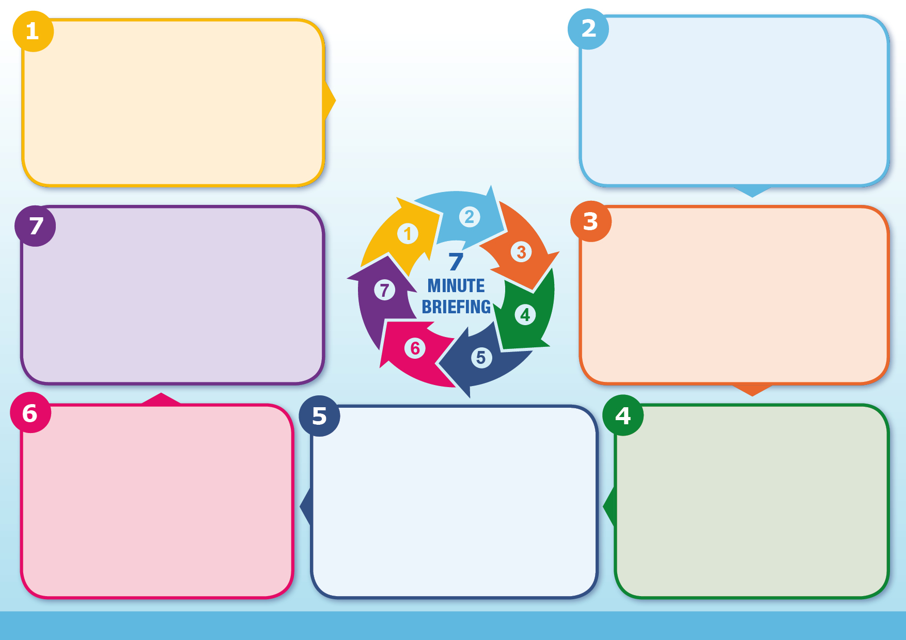

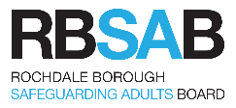
It is important that practitioners are willing and able to recognize that a previous decision may have been wrong – though reasonable at the time when the decision was made. These mistakes are an inevitable part of practice and recognising them is an essential element of good practice (Munro, 1996). Consensus isn't always safe. The fact that everyone agrees does not mean that they are right - and certainly does not keep a child safe. There is no safety in numbers - risk does not decrease because more people agree. Minority views are important and must be consider what it is about that workers experience that differs from others’

Obstacles to critical thinking:
Feeling under pressure to make quick decisions even when information is limited; people’s emotions interfering capacity to listen to others; feelings of ambivalence or even fear about seeing a particular family; or being overly optimistic about parental capacity for change
Critical Thinkers are:
- open to new information & will seek & consider alternative hypothesis
- aware that stress & the opinions of others can distort thinking
- able to consider information from multiple sources, even those that have opposing views
- self-aware, self-reflective, active listeners, and empathetic
- able to recognise faulty reasoning and logic
- able to conduct analysis, draw accurate conclusions, and articulate thoughts

Information:
Reviews in Rochdale, as in other areas across the country, have repeatedly highlighted messages about the necessity of critical thinking in practice. Problems in assessment seem to lie in the move from the collection of information to its analysis, evaluation and use in practice to support judgement or decision making. Core skills such as professional curiosity, professional judgement, and the ability to conduct rigorous assessments and draw conclusions are vital to safe planning. Practitioners must have an understanding of the blocks & challenges in safeguarding work and apply strategies to manage these, including situations of hostility & disguised compliance & to challenge their own and others’ practice both at individual and agency level.
Developing the habits required to support critical thinking takes conscious effort. Treat your first reaction to a situation, issue, or person as temporary. Resist the urge to pass judgement based only upon initial reactions. Have you observed carefully? Examine your reaction(s). Try to understand why you reacted the way you did. What assumptions were you making? What previous experiences may have contributed to your reaction? Think of alternative responses to situation, or issue at hand. Try to put yourself in someone else’s shoes (e.g. child/young person)

Click here for the RBSB training offer



What to do:
Information:
Why it matters:
Background:
‘Critical thinking is purposeful. It involves maintaining an open minded attitude & being able to think about different ways of understanding the information before you. Critical thinking also includes a process of evaluating claims & arguments in order to come to logical & consistent conclusions, assessing these conclusions against clear & relevant criteria or standards, & being able to spell out the reasons for the judgements you have made.’ (Turney 2014) The nature of work with children & families, with its fast pace & often limited information, makes critical thinking a challenging but essential process. (Munroe 1996) Complexity often lies in seeing what is always there, below the surface; recognising the wider implications of apparently ordinary actions; acknowledging the important part played by feelings, thoughts and values in people's lives.

Critical Thinking in Assessment

- What is the assessment for?
- What is the story?
- What does the story mean?
- What needs to happen?
- How do we know we are making progress?

Questions:

