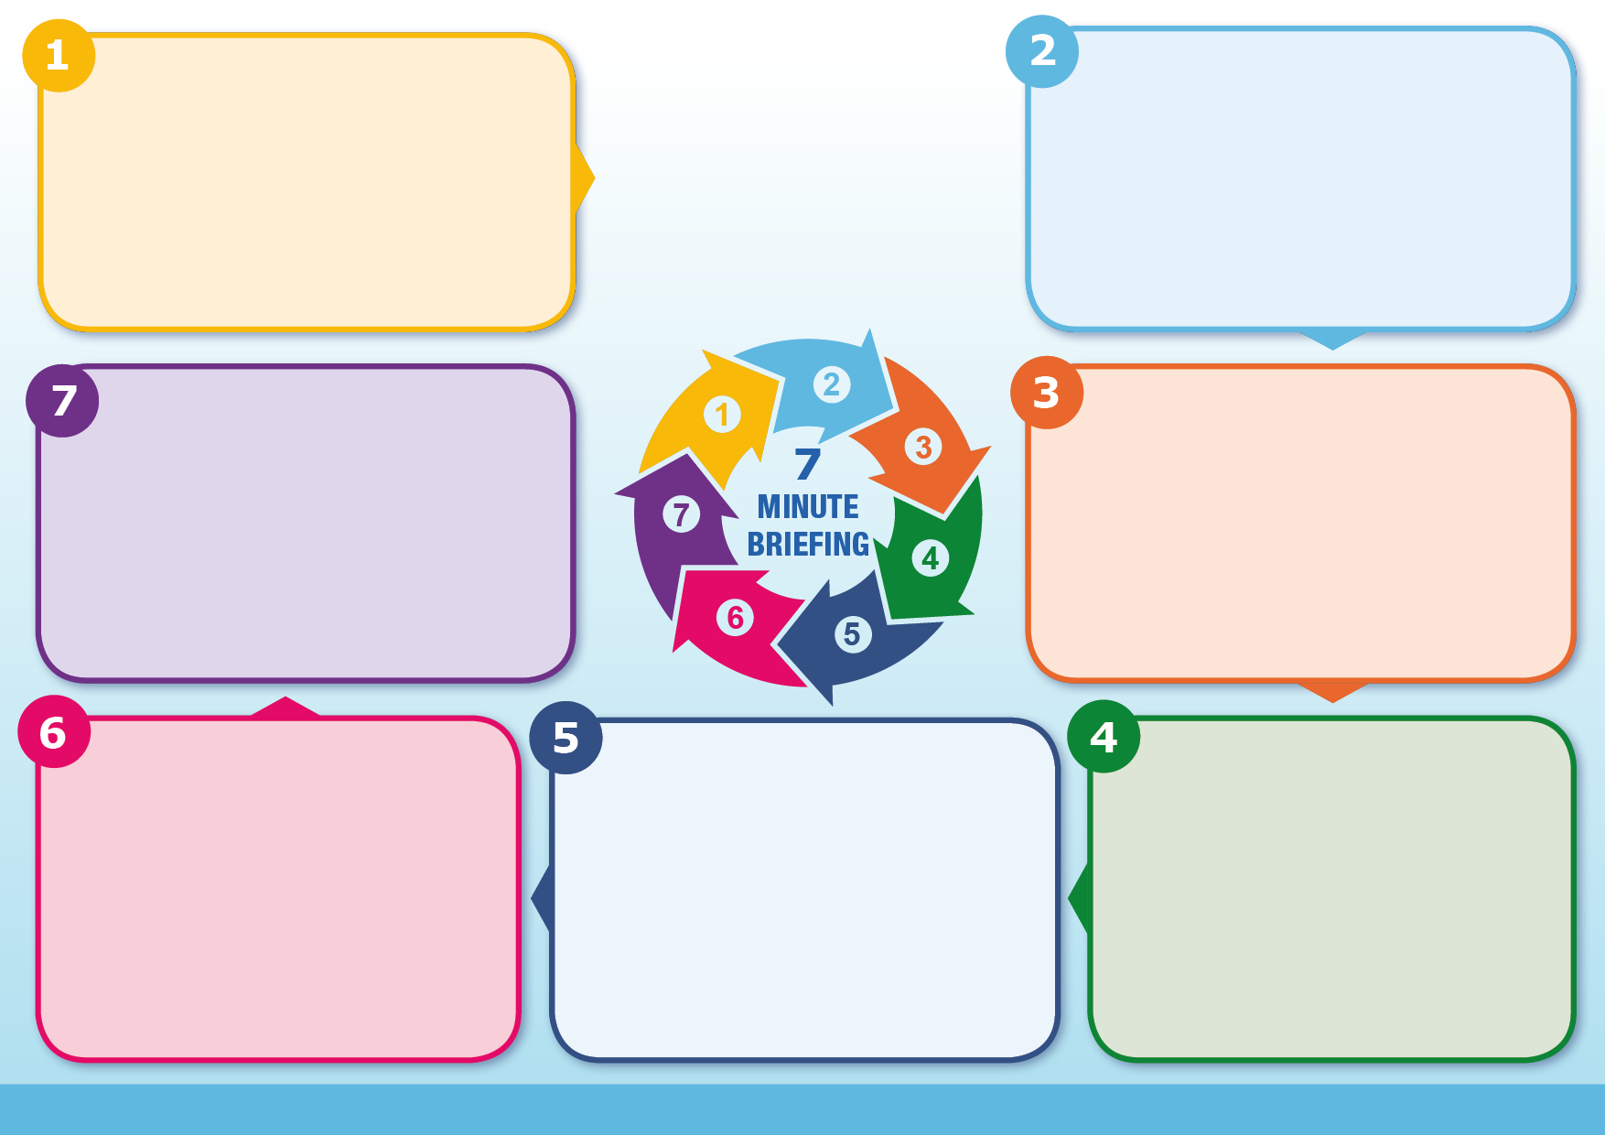

See [www.rochdalesafeguarding.com](http://www.rochdalesafeguarding.com)

For young people:

[Fearless](https://crimestoppers-uk.org/fearless) - access non-judgemental information and advice about crime and criminality.

[Children’s Society County Lines & CCE](https://www.childrenssociety.org.uk/what-we-do/our-work/child-criminal-exploitation-and-county-lines)

For professionals:

[Home Office Child Exploitation disruption toolkit](https://assets.publishing.service.gov.uk/government/uploads/system/uploads/attachment_data/file/1101687/Child_Exploitation_Disruption_Toolkit_082022.pdf)

[Home Office County Lines Guidance](https://assets.publishing.service.gov.uk/media/65322ad1e839fd001486720d/2023_FOR_PUBLICATION_-_Criminal_exploitation_of_children_young_people_and_vulnerable_adults_county_lines1.pdf)

[National Crime Agency County Lines website](https://www.nationalcrimeagency.gov.uk/what-we-do/crime-threats/drug-trafficking/county-lines)

**Further information**

* [Criminal exploitation of children and vulnerable adults: county lines](https://www.gov.uk/government/publications/criminal-exploitation-of-children-and-vulnerable-adults-county-lines)
* [Advice to schools and colleges on gangs and youth violence](https://www.gov.uk/government/publications/advice-to-schools-and-colleges-on-gangs-and-youth-violence)
* [Knives and offensive weapons information](https://www.gov.uk/government/publications/knives-and-offensive-weapons-information)
* [The Offensive Weapons Act 2019](https://www.gov.uk/government/publications/the-offensive-weapons-act-2019)
* [Knife Crime Prevention Orders (KCPOs)](https://www.gov.uk/government/publications/knife-crime-prevention-orders-kcpos)

All available [here](https://www.gov.uk/crime-justice-and-law/knife-gun-and-gang-crime)

**Guidance and Regulation**

♦ Parental concerns

♦ Significant decline in school performance

♦ Persistently going missing from school/ home or being found out of area

♦ Leaving home/care without explanation

♦ Excessive receipt of texts or phone calls

♦ Unexplained acquisition of money/ clothes/mobile phones ♦ Suspicion of self-harm or physical assault/unexplained injuries

♦ Significant changes in emotional wellbeing

♦ Relationships with older controlling individuals/ gang association

**Signs of Exploitation**

46,000 children in England are thought to be involved in gangs. There is likely many more. 90% of English police forces have seen county lines activity in their area and the violence is getting worse. Criminal exploitation has received considerable media coverage in the last year with a particular focus on the risks of county lines activity. It is a highly lucrative illegal business model and those who are running county lines can earn thousands of pounds per day. The adults running these networks are removed from the frontline activity of dealing – they exploit children who are at high risk transporting and selling drugs often many miles from home.

**Context**

Factors which increase vulnerability include:

♦ Neglected children and those left to their own devices

♦ Children in Care

♦ Substance misuse, Family alcohol use

♦ Poor school attendance, Peers being exploited, Homelessness, Poverty

♦ Domestic violence, Previous abuse, Dysfunctional family

♦ Learning disabilities, Learning difficulties

♦ Male domination, Gang association

**Additional Vulnerability**

Children who become exploited face huge risks to their physical, psychological and emotional health.

[Public Health England Mental health needs of gang affiliated young people Research paper](https://www.gov.uk/government/publications/mental-health-needs-of-gang-affiliated-young-people)

**Why it matters**

County lines is a term used to describe gangs and organised criminal networks involved in exporting illegal drugs into one or more importing areas using dedicated mobile phones. They are likely to exploit children and vulnerable adults to move and store the drugs and money and they will often use coercion, intimidation, violence and weapons. CCE occurs where an individual or group takes advantage of an imbalance of power to coerce, control, manipulate or deceive a person under the age of 18 into any criminal activity.

**Introduction**

**County Lines**