

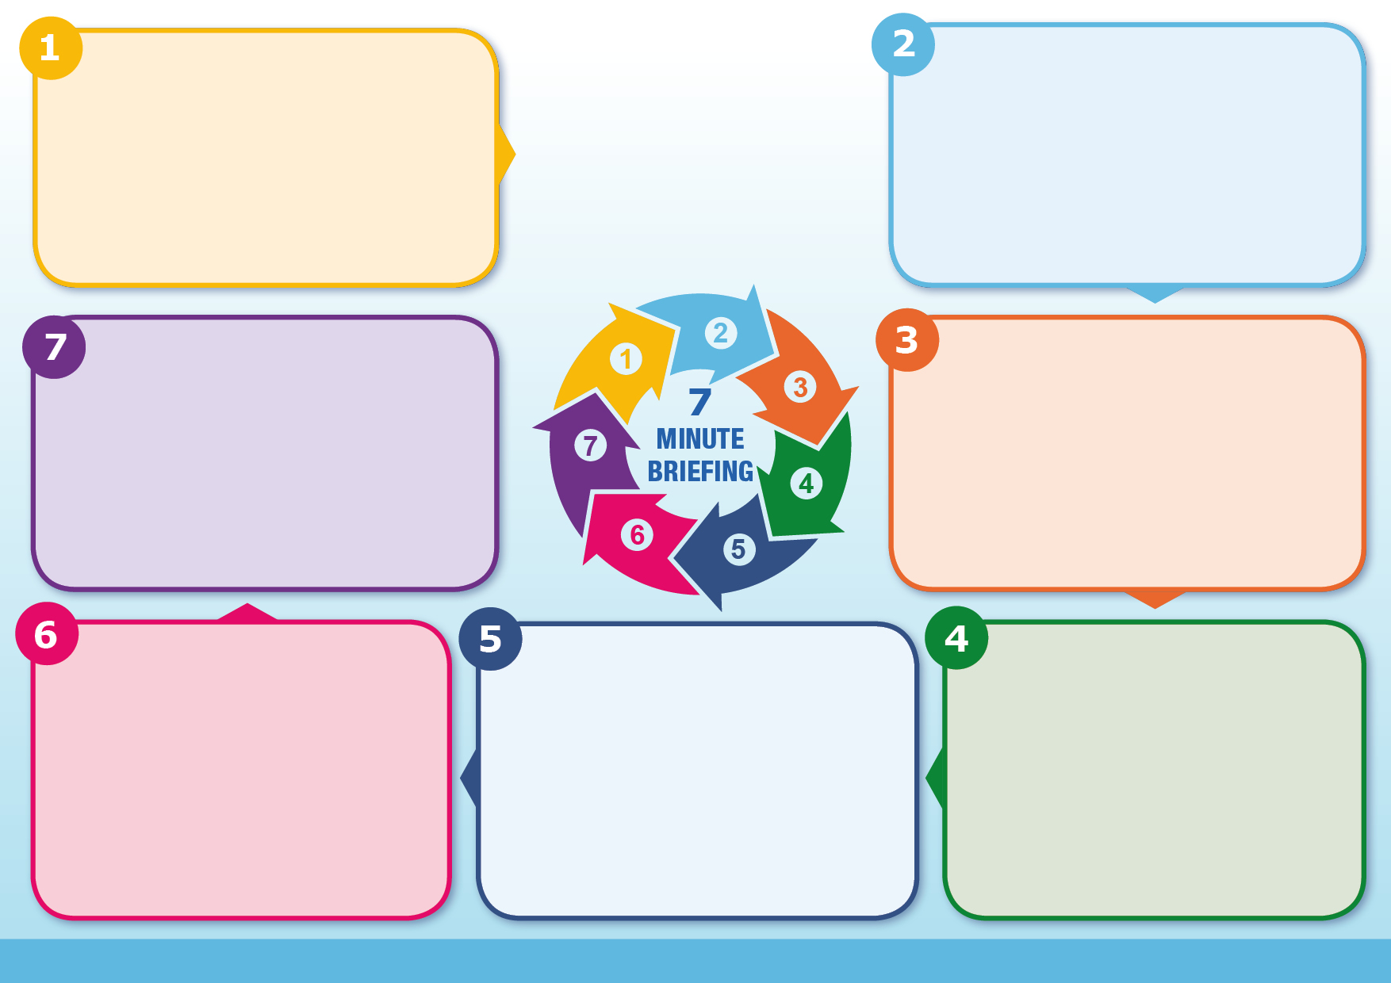
#
What are the risks?
Identify the ways in which young people can change the social conditions where abuse has occurred, and encourage self-responsibility for making these changes. Engage with individuals and sectors who have a bearing on social contexts, i.e. shopkeepers, local policing, community leaders, to make environments safer.
What should we do?
What should we do?
There are a wide range of potential risks where the prime cause of harm is outside of the family. This list isn’t exhaustive but includes: peer on peer abuse; exploitation and online abuse; missing episodes; gang involvement; radicalisation; trafficking and modern slavery.
Peer relationships
Why it matters
Why it matters
Contextual Safeguarding
Research tells us that peer relationships are increasingly influential during adolescence. If a young person forms friendships in contexts characterised by violence and/or harmful attitudes these relationships will be anti-social and unsafe.
A contextual safeguarding approach aims to disrupt harmful extra-familial contexts rather than move young people away from them. The approach seeks to identify the ways in which professionals, adults and young people can change the social conditions of environments in which abuse has occurred.
As children move from early childhood and into adolescence they spend increasing amounts of time socialising independently of their families. The nature of young people’s relationships that they form in these settings, inform the extent to which they encounter protection or abuse.
Traditional approaches to protecting children/young people from harm have focussed on the risk of violence and abuse from inside the home, and don’t always address the time that children/young people spend outside the home.
Contextual safeguarding seeks to identify and respond to harm and abuse posed to young people outside their home, either from adults or other young people.
What is it?

