
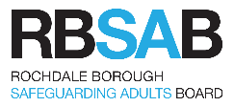
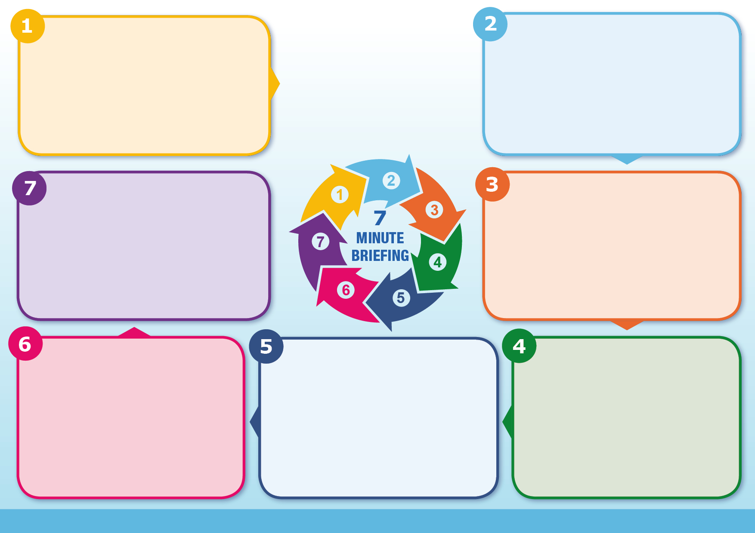
Information
The purpose of Channel duty is to safeguard individuals who may be vulnerable to radicalisation by providing early, voluntary, and supportive intervention through a multi-agency approach. Channel panels, led by local authorities and police, work collaboratively with education, health, and other partners to assess risk and develop tailored support plans that address the individual’s needs. This process is not about criminal enforcement but about protecting people from harm and promoting community safety in line with the Prevent strategy and existing safeguarding frameworks.
Purpose of the Channel Panel:
National Channel Duty Guidance is available here.

Channel Awareness training is available here.

Rochdale Borough Council has a Channel Panel policy and procedure which is based on the principles that a vulnerable individual is a unique person, vulnerable for unique reasons and needs an individualised safeguarding response. There is a duty to respond promptly and robustly to possible safeguarding concerns and there is a duty to share information with other agencies. It is a collaborative, integrated working process aimed at improving outcomes for individuals. The programme is a key element of the Prevent Strategy
Background:
Channel Panel
If you have a concern that a vulnerable adult is being radicalised, complete and submit a Channel referral form Channel@rochdale.gov.uk
You need to provide information on why you think they are being radicalised (what they have said or done) and why are think they are vulnerable (who or what is influencing them). The referral form and more information is available on the Council website.
Channel will process the referral and make a decision about what action is needed. If there are urgent safeguarding concerns speak to your Safeguarding Lead who will contact a member of the Channel panel for an urgent response
Questions:
Channel is a multi-agency safeguarding approach to identify and provide support to individuals who are at risk of being drawn into terrorism by identifying individuals at risk, assessing the nature and extent of that risk and developing the most appropriate support plan for the individual. The adult has to give consent.
Channel:
What to do?
Violent Extremism in the UK is a real and severe threat and can involve the exploitation of vulnerable adults and children to involve them in extremist activity. On 1 July 2015, a new Prevent Duty came into effect which has required local authorities to have in place a clear framework with which to respond to safeguarding concerns for those individuals who are vulnerable to radicalisation
Background:

