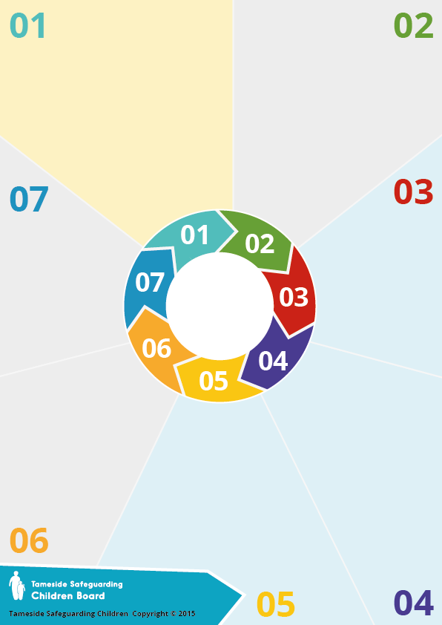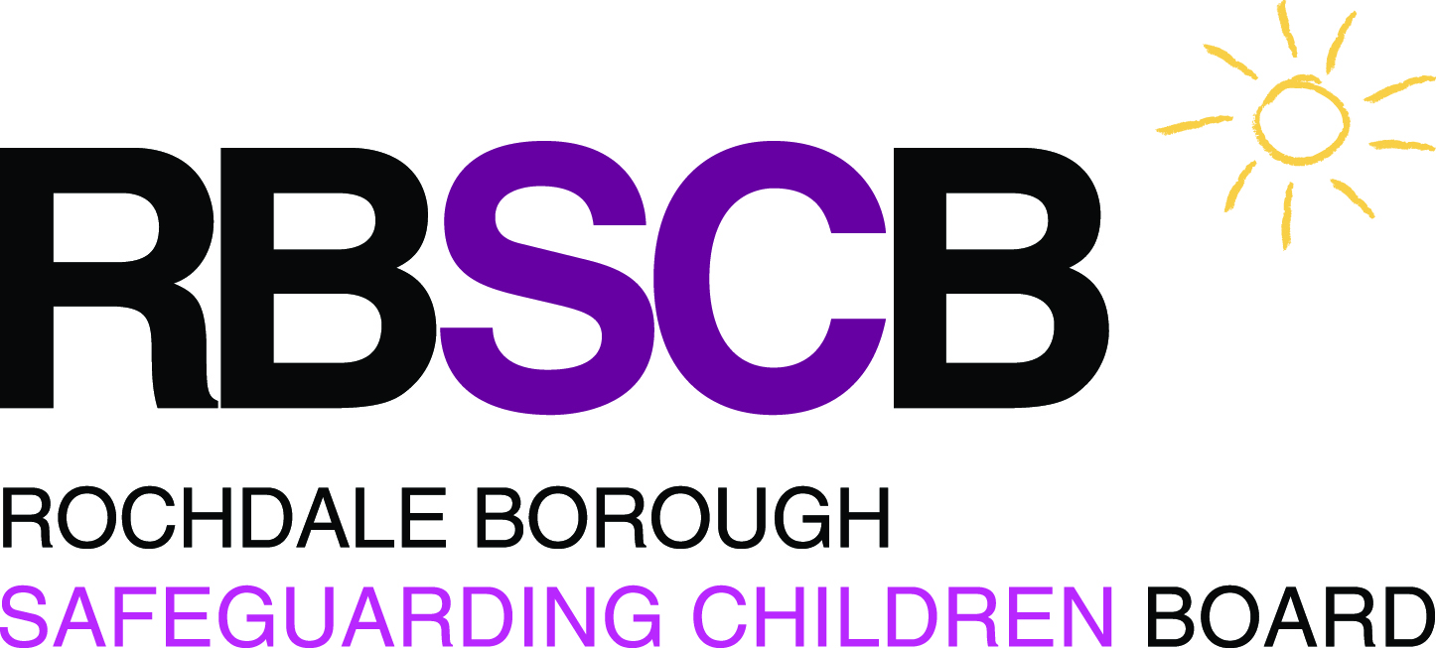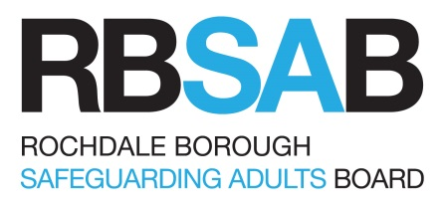

**5** That Rochdale Adult Care Services reports in writing to Rochdale Safeguarding Adult Boards the arrangements in place for recognising and responding to changing circumstances which impacts of risk assessments for people it is providing services to.

**2** That the commissioners

of care home places in

Rochdale provide assurance

to the Board that the care home

has taken action that enables staff

to identify and deal with developing

pressure ulcers.

**3** That Board is similarly assured that

record keeping in care homes is fit for

purpose in that a resident’s stay, including

their qualitative experience, is accurately and

fully recorded in the residents’ care plans.

**4** That the Board satisfies itself that there is an

effective process in place for identifying cases that have

potential to be SARs, including those where the coroner has

issued a Regulation 28 Notice, and for forwarding such

cases to the safeguarding adult review screening panel.

**Questions?**

How can I learn more about this SAR?

The full SAR report has been published on the RBSAB [website](http://www.rbsab.org) and will be available for 12 months.

Learning is also incorporated into the multi-agency safeguarding training programme.

**More information at**

**www.rbsab.org**

**Review:**

A Safeguarding Adult Review (SAR) was held in 2017, to identify how agencies worked together and to learn from any

lessons.

The report of the Review was

published on 29 September

2017 and will be available on

the [www.rbsab.org](http://www.rbsab.org) website

for 12 months.

**Adult C**

**(Mrs Hanson) Safeguarding Adult Review**

**Background:**

Paramedics attended and felt Mrs Hanson needed respite care and in due course this resulted in Mrs Hanson, accompanied by her son arriving at a care home about 1.00 am on

18th January 2015 for respite care. At that time Mrs Hanson was not known to have any pressure ulcers but the care home staff did note her bottom was bruised which they thought resulted from the falls. On 26 January 2015 a district nurse examined Mrs Hanson and discovered a grade 4 pressure ulcer. An ambulance was called and Mrs Hanson was admitted to Hospital where she died in the

early hours of the following morning.

**Background:**

This Safeguarding Adult Review is about Mrs Hanson who until 17 January 2015 was living with her husband in unsupported accommodation owned by a housing association. It was reported she had not left the flat for about two years because of mobility problems.

They were being supported by their son Tony. Additionally, Rochdale Council Adult Care Services commissioned a service to provide four daily visits to Mrs Hanson to assist her with personal care, the preparation of meals and to monitor her medication. Mrs Hanson was being treated for a urinary tract infection and on 17 January 2015 she fell

three times in the flat. Tony called North West

Ambulance Service because he suspected his

mother had a serious water infection.

**Recommendations:**

There are five recommendations in the Review, relating to the Safeguarding Adult Board, the Clinical Commissioning

Group, Rochdale Adult Care and the

named Care Home. The

recommendations are:

**1** That Rochdale Adult Social Care

provides written assurances to

Rochdale Safeguarding Adult

Board that the commissioners

are only commissioning

care homes where the

residents receive a safe

level of care that is

relevant to their

needs.