

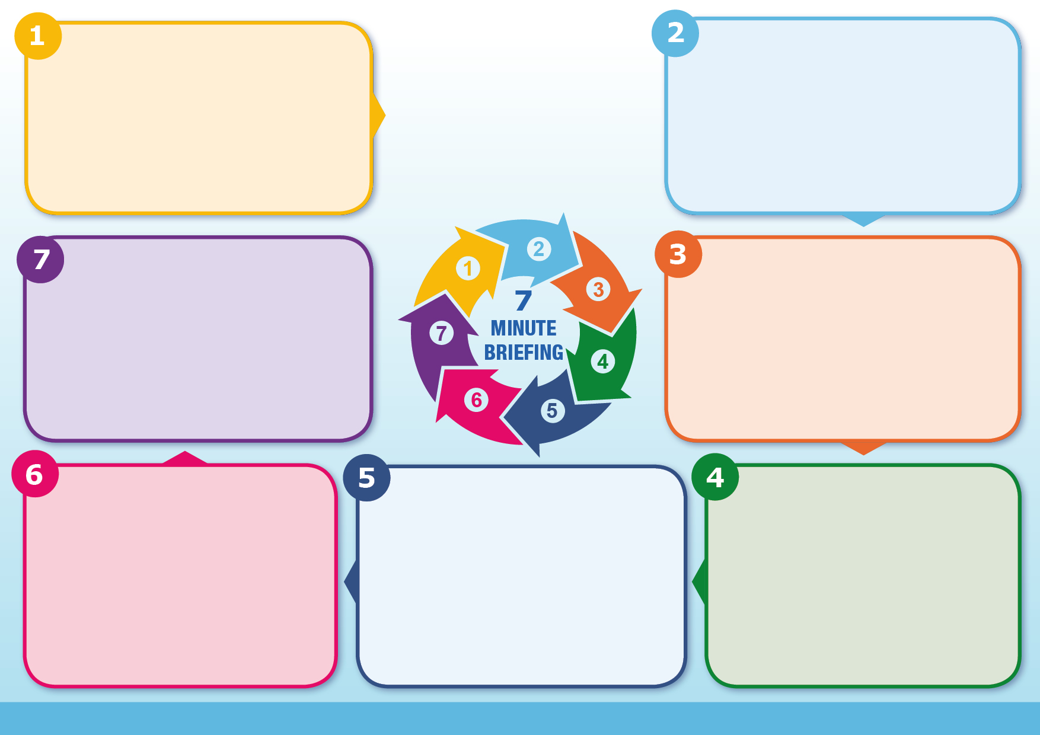
- Protective factors can be identified through consistent clear plans and professional involvements.
- Calm communication can reduce distress
- Boundaries held respectfully to protect both children and parents.
- Multi agency working is essential and working in a trauma informed way.

Self Harm and Symptoms of EUPD
- Self-harm is often used to regulate overwhelming emotional distress rather than to seek attention.
- Whilst self-harm can often offer an immediate reduction in stress, for most people this only works in the short term, and many find themselves feeling guilty and ashamed, creating additional negative feelings.
- Self-harming behaviour can also lead to severe injuries resulting in admissions to general hospital or psychiatric wards.

- Not all parents with EUPD experience difficulties, however, some may struggle with positive attachments, boundary – setting and separating their own emotional needs from the child’s.
- Parents may experience heightened distress when babies cry or when children begin to develop independence.
- They may experience difficulties separating their own needs that that from the child

Current research indicates that EUPD develops due to an interaction between biological (genetic/hormonal) and environmental factors (historic abuse/early attachments). Predisposing factors include:- experiencing abuse or neglect; living with someone with a substance misuse disorder or severe mental illness; exposure to domestic violence and parental death or loss. Perpetuating factors include adverse community environments such as poverty, discrimination, lack of opportunities and poor housing. In later life symptoms can be exacerbated by physical illness, relationship breakdowns and/or experiencing conflict. People with EUPD are 14 times more likely to report trauma and adverse childhood experiences than those without this diagnosis.
Causes of EUPD

Emotionally Unstable Personality Disorder (EUPD) is sometimes referred to as Borderline Personality Disorder. As with Complex PTSD it is strongly linked to complex trauma and is caused by genetic (nature) and environmental (nurture) factors. Presenting symptoms include:- intense and labile mood; anger, depression and anxiety lasting hours/days; fear of rejection/abandonment, heightened sensitivity to perceived criticism; unstable self-image and low self-confidence, Impulsivity and self destructive behaviours such as deliberate self harm; chronic feelings of emptiness, isolation and problems with interpersonal relationships.
What helps reduce the risk of symptoms
- Some people may end their own lives. There is an increase in suicide for people who struggle with this diagnosis.
- During pregnancy mothers maybe become more depressed and anxious.
- During the perinatal period, mothers are more likely to find parenting more emotionally demanding, they may experience attachment difficulties with their child and have an increased propensity towards ending their own lives.
- Parents may continue to experience distress due their own adverse childhood experiences.

Impact of symptoms
Children…continued

Impact of symptoms
Impact of symptoms of EUPD :-
- Difficulties developing mature and lasting relationships.
- Difficulties developing attachments with their own family and others around them.
- They may struggle functioning effectively in the home, education and work.
- Life may become dysfunctional due to emotional dysregulation.
- They feel enormous emotional pain and evoke high levels of anxiety in those around them.
What is EUPD and what are the symptoms?
Suicide and EUPD
Emotionally Unstable Personality Disorder

