2.

1.
What is private fostering?
Private Fostering is when a child is cared for by someone who is NOT a close relative, for 28 days or more, and the arrangement is made privately between the parent and the carer. 'Close relatives' are defined as grandparents, brothers, sisters, uncles or aunts (whether of full blood, half blood or by marriage) step-parents by marriage only. This definition applies to arrangements for children under 16, or 18 if disabled, living with family friends, neighbours, parents of a child’s friend, or distant relatives.
Since the Children Act 2004 it has been a legal responsibility for Local Authorities to recognise, monitor and support any child in their area who is being ‘privately fostered.’
7 Minute Briefing:

Why are children privately fostered?
A private fostering arrangement may arise for several reasons:
Children and young people living apart from their family; Children whose parents are overseas; Children who are living with a host family for a variety of reasons; Children on holiday exchanges; Children on educational exchanges; Family breakdown; Parents feeling unable to cope; Children who may have been trafficked.

3.
Signs that a Child may be privately fostered:
- An adult mentions that they are caring for a child who is not their immediate relative.
- An adult is seen by the practice with a child who has not been seen before.
- An adult attends the surgery regularly with different children referred to as their ‘niece’ or ‘nephew’.
- A child mentions that the person they are with is not their parent.
- A child says there is another child staying at home with them.

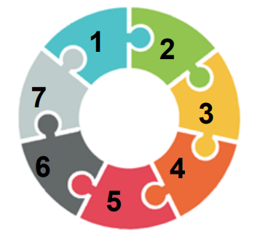
Difference Between Private Fostering and Cared for Children:
Children cared for in private fostering arrangements do not have the same legal status as Cared for Children and do not have any legal orders in place. Children’s services have not been involved in the making of the arrangement.
The parents have full parental responsibility and can remove the child from the placement if they want.
Cared for Children receive regular health assessments, whereas privately fostered children do not.

5.
What to do if you Identify a Child is Privately Fostered?
There is a statutory duty on professionals to notify Children’s services if they become aware of a private fostering arrangement; this is not a breach of confidentiality, and failure to do so may put the child/young person at risk.
Professionals should not make any assumptions; they should always find out & document the name and relationship of any adults accompanying children or young people during visits/appointments.

How to make a referral to Children’s Services:
If you recognise that a child you are working with may be in this situation, or about to be, contact:
Rochdale’s Early Help and Safeguarding Hub on 0300 303 0440 or refer via the online portal.
Give as much information about the child and the circumstances as possible.
What happens once a referral has been made to Children’s services?
Once notified of a private fostering arrangement, a social worker will visit the premises where the child is being cared for. The social worker will complete a Private Fostering Assessment of suitability, along with completing checks on the adults in the household, including DBS checks.
An Independent Reviewing Officer will undertake regular reviews of the arrangement.
Each privately fostered child will have a private fostering placement agreement and care plan.
The social worker will undertake regular visits to ensure the child’s needs are being safely met.
Involvement will be ongoing for the duration of the arrangement.

4.

6.

7.

