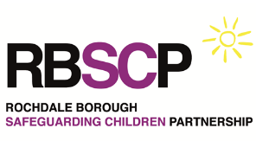

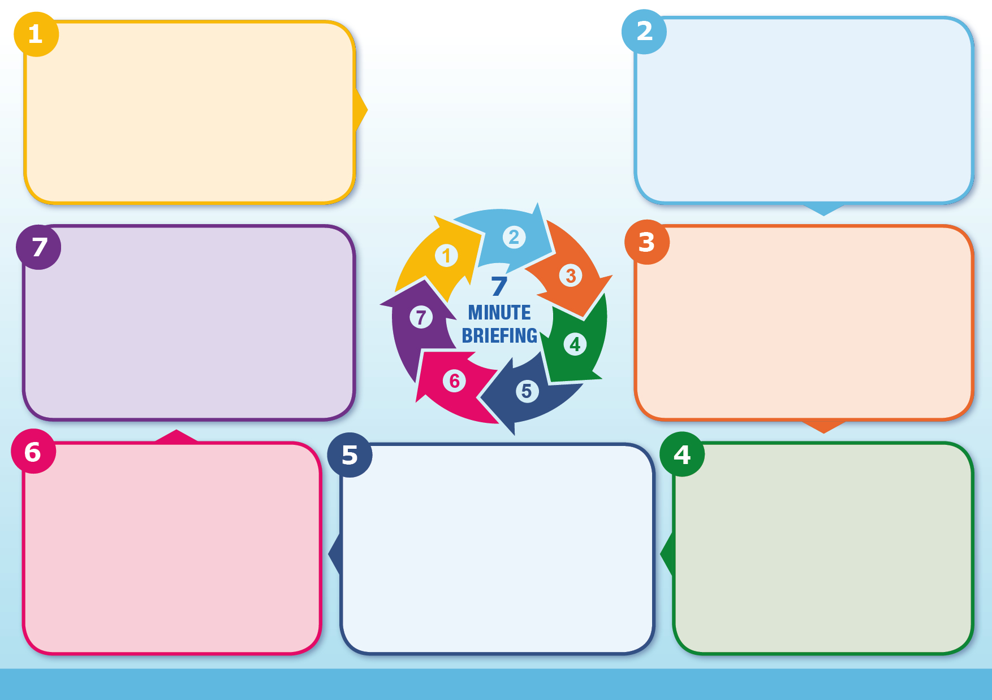
Consequences

Girls married young are far less likely to stay in school, with lifelong economic impacts. They are often isolated, with their freedom curtailed. They are at higher risk of physical and sexual violence. Child brides are also at greater risk of experiencing dangerous complications in pregnancy and childbirth, contracting HIV/AIDS and suffering domestic violence. (Source: Save the Children). Payzee Mahmod, married at 16 to a man nearly twice her age, has campaigned against child marriage in the UK and spoken out about its very dire consequences.

The legislation provides that a person commits an offence under the law of England and Wales if he or she carries out any conduct for the purpose of causing a child to enter into a marriage before the child’s 18th birthday (whether or not the conduct amounts to violence, threats, any other form of coercion or deception and whether or not it is carried out in England and Wales).
A marriage is defined as any religious or civil ceremony of marriage, whether or not it is legally binding.

Underage, unrecorded marriages can occur in any community but are frequent in ultraconservative Asian and Middle Eastern populations, as well as among certain Orthodox Jewish and Roma traveller communities.
Child marriage refers to any formal marriage or informal union between a child under the age of 18 and an adult or another child.
Deep-rooted patriarchal beliefs, the low value placed on girls, and the desire to control women, especially girls' sexuality, underlie child marriage.
Child marriage is a hidden form of child abuse. In the UK, the Forced Marriage Unit provided advice or support to 229 victims and had 572 enquiries in 2024.

Early marriage has devastating consequences for a girl’s life. Effectively, child marriage ends her childhood. Girls are forced into adulthood before they are physically and mentally ready. Child brides are frequently deprived of their rights to health, education, safety and active participation in daily lives. They frequently experience abuse, rape, and forced pregnancy. A forced marriage often means a girl is forced to wed an, at times significantly, older man.

Forced Marriage Unit - e-learning for professionals
GM Safeguarding Children procedures - Also provide guidance on Forced Marriage
Girls not Brides - Global Partnership to End Child Marriage
Karma Nirvana - Run the national Honour Based Abuse Helpline and campaign for change
Action Aid - Child Marriage
The Marriage & Civil Partnership Act raised the age of marriage and civil partnership to 18 in England and Wales to protect children from forced marriage, making it illegal to marry or enter a civil partnership under this age in any circumstances, even with parental consent. The Act has expanded to make it a criminal offence in all circumstances to do anything intended to cause a child to marry before the age of 18.

Ending Child Marriage in the UK
Marriage and Civil Partnership Act 2022

Further Information for Practitioners
Further Information for Practitioners

Consequences
Child Marriage and Gender Inequality
Marriage and Civil Partnership Act 2022

Legislation

