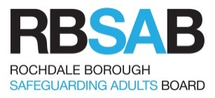
11. Reporting a Concern
To make a safeguarding referral

A referral may be made by phone to Adult Care or the Emergency Duty Team (0300 303 8886 Monday to Friday from 8.30am to 4.45pm, or 0300 303 8875 at all other times), email adult.care@rochdale.gov.uk or the referrer may use their own agency’s referral form or the Multi-agency Referral form (Appendix A).

If an adult is in immediate danger ring 999.

This chapter should be read with reference to the Quick guide to understanding what constitutes a safeguarding concern, published by the Local Government Association.

11.1 Responsibilities of the person reporting a concern

Anyone who first becomes aware of someone with care and support needs (whether those needs are met or not) and has concerns that they are experiencing or at risk of abuse or neglect must report those concerns as soon as possible and in any case within the same working day to the relevant manager (or responsible person) identified in their internal agency procedures.

As a general rule, concerns should be raised as soon as abuse or neglect is witnessed or suspected. This should always be the case if the adult remains in or is about to return to the place where the suspected/alleged abuse occurred, particularly if the person alleged to have caused harm is likely to have access to the adult or others who might be at risk.

Anyone can report a concern:
- if discussion with the manager would involve delay in a high-risk situation
- if the person has raised concerns with their manager and they have not taken action.

A concern may be prompted by:
- a direct disclosure by the adult
- a concern raised by staff or volunteers, others using the service, a carer or a member of the public
- an observation of the behaviour of the adult, of the behaviour of another person(s) towards the adult or of one service user towards another.

11.2 Responding to an adult who is making a disclosure

- Whether an incident is low risk and no harm occurs, or high risk, it is important to consider the views of the adult or the adult's advocate and record them. When considering the consequence/impact, always identify the individual’s account of the depth and conviction of their feelings. What effect did it have on the individual? Making Safeguarding Personal (MSP) means the actions of all staff working with the adult at risk should be person led and outcome focused.
- Assist the adult to feel safe and comfortable, both physically and emotionally.
- Assure them that you are taking them seriously.
- Listen carefully to what they are telling you, stay calm, get as clear a picture as you can, but avoid asking too many questions at this stage.
- If you do need to clarify the concern, ask non-leading questions for example: “can you tell/explain/describe what happened”, “when did it happen”, “where did it happen”
- Do not give promises of complete confidentiality.
- Explain that you have a duty to tell your manager or other designated person, and that their concerns may be shared with others who could have a part to play in protecting them.
- Reassure them that they will be involved in decisions about what will happen.
- Explain that you will try to take steps to protect them from further abuse or neglect.
- If they have specific communication needs, provide support and information in a way that is most appropriate to them.
- Do not be judgemental or jump to conclusions.

11.3 Taking immediate action

- The person who is made aware of the concern must make an immediate evaluation of the risk and take steps to ensure that the adult is in no immediate danger.
- if there is immediate danger or someone needs urgent medical attention: call the police (999) or an ambulance and then inform Adult Care – details are at the beginning of this chapter.
- if you think a criminal offence has been committed inform the police
- if you think a child may also be affected or also at risk contact Children's Services (0300 303 0440 Monday to Friday from 8.30am to 4.45pm, or 0300 303 8875 at all other times)
- If possible, take action to make sure that other individuals (adults or children) are not at risk.
- Inform a manager or supervisor immediately.
- If your manager is not available you MUST report the concern yourself.
- If you are concerned that a member of staff has abused an adult, you have a duty to report these concerns. You must inform your line manager or supervisor.
- If you are concerned that your line manager has abused an adult, you must inform a senior manager in your organisation, or another designated manager for Safeguarding Adults.
- If you are a practitioner, report the matter internally through your internal agency reporting procedures (e.g. NHS practitioners may also need to report under clinical governance or serious incident processes)
- The Police should be contacted immediately so they can gather and preserve any evidence.

11.4 Gathering and preserving evidence

The police may need to speak to vulnerable witnesses. This means that their evidence has to be obtained in accordance with the Youth Justice and Criminal Evidence Act 1999. This is designed to help vulnerable witnesses to give evidence and provides a number of ‘special measures’ to enable them to do this.

The police will attend the scene but agencies and individuals can play an important part in ensuring that evidence is not contaminated or lost.
- Try not to disturb the scene, clothing or victim if at all possible.
- Secure the scene, for example, lock the door.
- Preserve all containers, documents, locations, etc.
- Evidence may be present even if you cannot actually see anything.
- If in doubt whether the police should be involved, contact them to seek advice.

11.5 Role of the Safeguarding Lead within your organisation.

It is the duty of the Safeguarding Lead to act promptly when safeguarding adults and decide without delay on the most appropriate course of action, which will include:
- It is the role of the safeguarding lead ensure discussion of the allegation has taken place with the adult.
- Make an immediate evaluation of the risk to the adult and take reasonable and practical steps to safeguard them.
- Refer to the police if the abuse suspected is a crime and seek advice regarding preserving evidence and other guidance.
- Arrange any necessary emergency medical treatment. Offences of a sexual nature will require expert advice from the police.
- If there is a need for protection contact Adult Care or the Emergency Duty Team – details are at the beginning of this chapter.
- If the person causing the harm is also an adult with care and support needs, arrange for a member of staff to attend to their needs.
- Ensure appropriate action has been taken so that others are not at risk
- Follow your organisation’s disciplinary procedures and consider appropriate actions including suspension.

It is the responsibility of the Safeguarding Lead within the organisation to decide what discussion takes place with the person who is alleged to have caused harm. If the person who is alleged to have caused harm is a member of staff or volunteer, consideration should be given to referring the case to the Allegations Management process.

If appropriate the Safeguarding Lead should speak to the adult about the concern and:
- speaking to them in a private and safe place and informing them of any concerns
- obtaining their views and wishes on what has happened and the next steps with the adult.
- establish what outcomes they want to achieve in relation to the issue
- giving them information about the Safeguarding Adults process and how that could help to make them safer
- Supporting them to ask questions about issues of confidentiality
- Explaining how they will be kept informed and supported
- Discussing what could be done to ensure their safety.
- Provide any appropriate advice, information or signposting.

The Safeguarding Lead is responsible for:
- supporting any member of staff or volunteer who raised the concern
- enabling and supporting relevant staff to play an active part in the Safeguarding Adults process
- ensuring that any staff delivering a service to the adult are kept up to date on a need-to-know basis and do not take actions that may prejudice the safeguarding enquiry.
- Skilled and knowledgeable supervision focused on outcomes for adults is critical in safeguarding work. Managers have a central role in ensuring high standards of practice and that practitioners are properly equipped and supported. It is important to recognise that dealing with situations involving abuse and neglect can be stressful and distressing for staff and workplace support should be available. Managers are responsible for providing supervision and to ensure the wellbeing of staff in what will be a distressing situation.

11.6 Deciding whether or not to report a concern

In order to raise a concern the referrer needs to consider the criteria for safeguarding. Section 42 (1) of the Care Act 2014 specifies that the safeguarding duties apply to an adult who:
- Has needs for care and support (whether or not the local authority is meeting any of those needs)
and
- Is experiencing, or at risk of, abuse or neglect
and
- As a result of those needs is unable to protect him/herself against the abuse or neglect or the risk of it.

If you do have reasonable cause to suspect that the adult meets the criteria above, have you discussed with the adult about raising a safeguarding concern? Does the adult wish to raise their own concerns? Do they need support to do this?

If you are unsure whether the criteria is met, who else can you talk to within your organisation? Can you seek advice from others outside of your organisation or consider seeking advice from the local authority? If the outcomes of these discussions give you reasonable cause to suspect Section 42 (1) (a) & (b) safeguarding criteria is met then raise a safeguarding concern to the local authority.

If your concerns do not meet the safeguarding criteria above, what further support, advice, information or signposting can you offer the adult?

A concern should be reported when:
- the person is an adult with care and support needs and there is a concern that they are being or at risk of being abused or neglected
- the adult has capacity to make decisions about their own safety and wants this to happen, or, the adult has been assessed as not having capacity to make a decision about their own safety, but a decision has been made in their best interests to report a concern
- a crime has been or may have been committed
- the abuse or neglect has been caused by a member of staff or a volunteer
- other people or children and young people under 18 years of age are at risk from the person causing the harm
- the concern is about organisational or systemic abuse
- the person causing the harm is also an adult with care and support needs.

11.7 Mental Capacity

Where it is felt that the adult has substantial difficulty or does not have the capacity to understand the relevant issues in order to make a decision regarding the safeguarding concern, it should be explained to them as far as possible, given the person’s communication needs. They should also be given the opportunity to express their wishes and feelings. If an adult lacks capacity or appears to have substantial difficulty, a concern should be raised and support given.

The mental capacity of the adult and their ability to give their informed consent to a concern being raised and action being taken under these procedures is a significant but not the only factor in deciding what action to take.

The test of capacity in this case is to find out if the adult has the mental capacity to make informed decisions:
- about the safeguarding concern being reported
- about actions which may be taken under multi-agency policy and procedures
- about their own safety, including an understanding of longer-term harm as well as immediate effects and
- an ability to take action to protect themselves from future harm.

If there is an overriding public interest or vital interest, or if gaining consent would put the adult at further risk, a concern must be raised. This includes situations where:
- Other people or children and young people under 18 years of age could be at risk from the person causing harm
- It is necessary to prevent crime
- Where there is a high risk to the health and safety of the adult
- The person lacks capacity to consent.
- Harm was alleged to have been done by a worker or volunteer

The adult would normally be informed of the decision to report a concern and the reasons, unless telling them would jeopardise their safety or the safety of others.

If the adult lacks capacity to make informed decisions about maintaining their safety and they do not want any action to be taken, professionals have a duty to act in their best interests under the Mental Capacity Act 2005 therefore the manager with safeguarding responsibilities must make a decision in their best interests.

If the adult has capacity and does not consent to a concern being reported and there are no public or vital interest considerations, they should be given information about where to get help if they change their mind or if the abuse or neglect continues and they subsequently want support to promote their safety. The person raising the concern must assure themselves that the decision to withhold consent is not made under undue influence, coercion or intimidation.

The key issue in deciding whether to raise a concern is the harm or risk of harm to the adult and any other adults who may have contact with the person causing harm or contact with the same organisation, service or care setting.

If the manager with safeguarding responsibilities is unsure whether to report a concern, they should contact Adult Care or the Emergency Duty Team (0300 303 8886 Monday to Friday from 8.30am to 4.45pm, or 0300 303 8875 at all other times) or email adult.care@rochdale.gov.uk for advice.

11.8 Making a record

It is vital that a written record of any incident or allegation of crime is made as soon as possible after the information is obtained, and kept by the person raising the concern. Written records must reflect as accurately as possible what was said and done by the people initially involved in the incident, including the adult, person alleged to have caused harm or potential witness.

The notes must be kept safe as it may be necessary to make records available as evidence and to disclose them to a court.

You must make an accurate record at the time, including:
- Date and time of the incident
- Exactly what the adult said, using their own words (their account) about the abuse and how it occurred or exactly what has been reported to you.
- Appearance and behaviour of the adult
- Any injuries observed
- Detail what types of abuse or neglect you are concerned about.
- The views and wishes of the adult, what was discussed and agreed as the next steps with the adult.
- Detail any advice, information or signposting you gave the adult
- Any actions or decisions taken at this point, including decisions made by the adult themselves
- Any information given to the adult.
- Opinion should not be recorded.
- Sign and date your record.

The record must be factual, however if it does contain your opinion or an assessment this should be stated clearly and information from another person should be clearly attributed to them.

It is recommended that organisations have a separate part of the adult’s file/record that is clearly labelled “Safeguarding”.

  - Where to refer to and how to make a referral

- Referrals will be taken from anyone who has a concern that an adult (who appears to have care and support needs) is at risk of, or experiencing, abuse or neglect. Details of how to make a referral are at the beginning of this chapter.
- Some referrers in a professional capacity may be asked by Adult Care to complete a RBSAB Information Gathering Form and send it to Rochdale Adult Care.
- The matter can additionally be reported to the police where a crime is committed or suspected.

11.10 Information to include in a referral

Where possible, include as much information under the following headings.

Details of the referrer
- Name, address and telephone number
- Relationship to the adult
- Name of the person raising the alert if different
- Name of organisation, if referral made from a care setting
- Anonymous referrals will be accepted and acted on. However, the referrer should be encouraged to give contact details

Details of the adult
- Name(s), address and telephone number
- Date of birth, or age
- Details of any other members of the household including children
- Information about the primary care needs of the adult, that is, disability or illness
- Funding authority, if relevant
- Ethnic origin and religion
- Gender
- Sexual orientation
- Communication needs of the adult due to sensory or other impairments (including dementia), including any interpreter or communication requirements
- Whether the adult knows about the referral
- Whether the adult has consented to the referral and, if not, on what grounds the decision was made to refer
- What is known of the person’s mental capacity and their views about the abuse or neglect and what they want done about it (if that is known at this stage)
- Details of how to gain access to the person and who can be contacted if there are difficulties

Information about the abuse, neglect or physical harm
- How and when did the concern come to light?
- When did the alleged abuse occur?
- Where did the alleged abuse take place?
- What are the details of the alleged abuse?
- What impact is this having on the adult?
- What is the adult saying about the abuse?
- Are there details of any witnesses?
- Is there any potential risk to anyone visiting the adult to find out what is happening?
- Is a child (under 18 years) at risk?

Details of the person causing the harm (if known)
- Name, age and gender
- What is their relationship to the adult?
- Are they the adult’s main carer?
- Are they living with the adult?
- Are they a member of staff, paid carer or volunteer?
- What is their role?
- Are they employed through a personal budget?
- Which organisation are they employed by?
- Are there other people at risk from the person causing the harm?

Any immediate actions that have been taken
- Were emergency services contacted? If so, which?
- What action was taken?
- What is the crime number if a report has been made to the police?
- Details of any immediate plan that has been put in place to protect the adult from further harm
- Have children’s services been informed if a child (under 18 years) is a risk?
- Ensure you record who information has been shared with

The record must be signed and dated bearing in mind that it may be required later as part of evidence in legal proceedings.

11.11 Factors to consider when raising a concern

- How vulnerable is the adult? What personal, environmental and social factors contribute to this?
- What is the abuse and neglect you are concerned about? What is the nature and extent of the abuse?
- Is the abuse a real or potential crime?
- How long has it been happening? Is it a one-off incident or a pattern of repeated actions?
- What impact is this having on the individual? What physical and/or psychological harm is being caused? What are the immediate and likely longer-term effects of the abuse on their independence and well-being?
- What impact is the abuse having on others?
- What is the risk of repeated or increasingly serious acts involving the person causing the harm?
- Is a child (under 18 years) at risk?

11.12 Person alleged to have caused harm

The person who is alleged to have caused harm to an adult has the right to be treated fairly and their confidentiality respected throughout the safeguarding adults procedures. However if the person who is alleged to have caused harm is a person in a position of trust the Safeguarding Lead must consider the use of the Allegations Management procedures. The Safeguarding Lead has the responsibility to ensure that a person or organisation alleged to have caused harm:
- knows that they are the subject of an allegation (irrespective of any other investigation, such as disciplinary investigation or criminal proceedings)
- are informed in a timely manner
- are informed of the nature and content of the allegation
- knows that a referral has been made to the Allegations Management Lead and an enquiry is being undertaken under the Allegations Management procedures
- If the person causing harm is another adult with care and support needs, arrangements could include removing them from contact with the adult. In this situation, arrangements must be put in place to ensure that the needs of the person alleged to have caused harm are also met and their risks managed

11.13 Who should be informed that a concern has been reported?

It is important that all partners are clear where responsibility lies where abuse or neglect is carried out by employees or in a regulated setting, such as a care home, hospital, or college. The first responsibility to act must be with the employing organisation as provider of the service.
Where relevant the manager with safeguarding responsibilities should consider informing:
- the unit or service manager responsible for the management of the service
- the Safeguarding Adults lead in their organisation or service
- the police, if a crime has been or may be committed
- the relevant children’s and families team if children and young people under the age of 18 are also at risk from harm.
- NHS staff may still need to report under clinical governance or serious incident processes, as well as reporting a concern to Rochdale Adult Care.

11.14 Notification of a Care Quality Commission (CQC) regulated service to the CQC and commissioning bodies

When an employer is aware of abuse or neglect in their organisation, then they are under a duty to correct this and protect the adult from harm as soon as possible and inform the local authority and the Care Quality Commission. They should also inform the agency commissioning their services, whether this is Rochdale Integrated Commissioning Directorate or the Greater Manchester Integrated Care Service. Where it is indicated that a member of staff may have caused harm the organisation’s allegation management procedure and disciplinary procedures should also be considered.

11.15 Referrals to the Disclosure and Barring Service

If someone is removed by being either dismissed or redeployed to a non-regulated activity, from their role providing regulated activity following a safeguarding incident, or a person leaves their role (resignation, retirement) to avoid a disciplinary hearing following a safeguarding incident and the employer/volunteer organisation feels they would have dismissed the person based on the information they hold, the regulated activity provider has a legal duty to refer to the Disclosure and Barring Service .If an agency or personnel supplier has provided the person, then the legal duty sits with that agency. In circumstances where these actions are not undertaken then Rochdale BC can make such a referral. Referral should also be made to the Allegations management process if this has not already been done.

11.16 Referrals to the police

- Staff must make it clear whether they are reporting a crime or suspected crime, or seeking advice.
- Referral must also be made to the relevant local authority.
- In an emergency call the police on 999.
- If a crime has been or may have been committed, report immediately to the police unless the adult has mental capacity, does not want a report made and there are no overriding public or vital interest issues.
- The police may also be contacted later, if more information becomes available and it becomes apparent that a crime has been committed.

11.17 Feedback to the referrer

There is an expectation that all referrers will receive feedback on referrals they have made. If this is not received they have a right to request it.

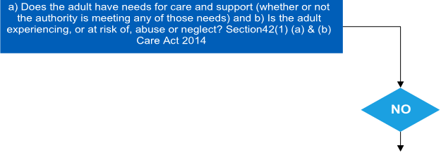
Are you concerned that an adult is at risk of or is experiencing abuse or neglect?
What types of abuse or neglect are you concerned about?
Have you had a conversation with the adult about the concerns?
Have you sought the views and wishes of the adult?*
Are there any immediate risks to the adult or to others including children?
Have you discussed and agreed next steps with the adult?*
Have you provided advice, information or signposted the adult?

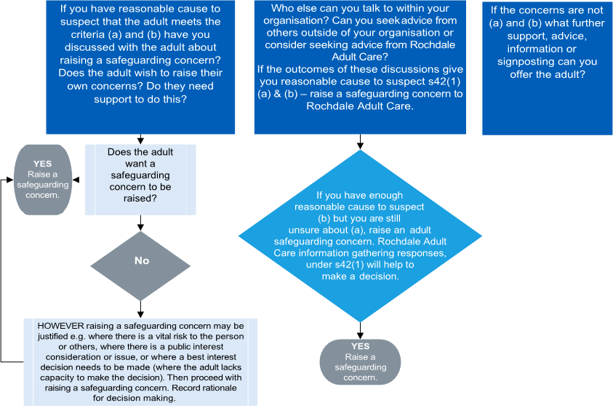

*There may be circumstances where the safety of the adult or yourself prevent this from happening.
If you still have concerns about abuse or neglect and it is not possible or within the scope of your role to have a conversation with the adult, then if in doubt continue with the process and raise a safeguarding concern.

