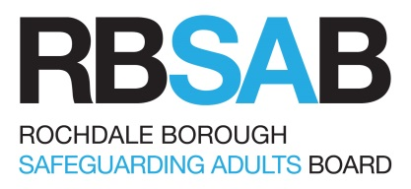
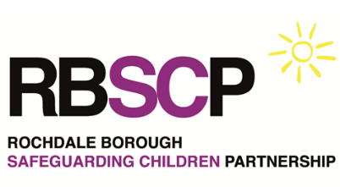

Training level guidance

How do you identify the Safeguarding training that is relevant to your role?

Different staff groups will require different levels of training depending on their role and degree of contact with children, adults and families, the nature of their work, and their level of responsibility. As a minimum all staff must know what to do if there is a safeguarding concern, including knowing who to contact within their organisation to communicate their concerns.

In order to meet the differing levels of training needs across the range of agencies and staff roles, RBSCP/AB courses are targeted according to the level of contact with children, adults and families, and their level of responsibility.

Depending on the level of interaction of staff (paid or unpaid) have with children young people & their families or wider partners.

In order to decide which level of training you require we have split the workforce into 4 levels of staff.

- Essential: Those courses which are crucial to the role
- Recommended: Those courses which are important for the role
- Optional: Those which would be useful to the role
- Not recommended: Those which are not particularly recommended for the role

Staff working with Children
 | Single Agency  Training  (coordinated by single agency safeguarding  Children representatives) | Multi Agency Training  (coordinated by the Rochdale Borough Safeguarding Children Partnership – can be accessed on www.rbscp.org)
Practitioner levels | Basic Introduction to Safeguarding Children | Working Together to safeguard Children | Specialist courses and seminars
Those staff with minimal face to face contact with children, young people & parents & carers. Including all staff involved with information concerning children, young people & families (e.g. admin staff) | Essential | Not recommended | Not recommended
All those in regular contact with children, young people and adults who are parents/carers in their day to day work | Essential | Optional | Optional
Those who work regularly with children, young people and adults who are parents/carers. Including those with particular responsibility for safeguarding children including designated child protection officers & managers who supervise practitioners and volunteers & those who attend Case Conferences & Core Groups regularly. | Essential | Essential | Recommended
Those with a particular responsibility for safeguarding children in their job roles & those who have strategic responsibility for commissioning and providing services to children, young people and adults who are parents/carers including members of the Local Safeguarding Children Partnership. | Essential | Recommended | Optional
Staff working with Adults
 | Single Agency  Training  (coordinated by single agency safeguarding adults  representatives) | Multi Agency Training  (coordinated by the Rochdale Borough Safeguarding Boards  – can be accessed on www.rbscp.org)
Practitioner levels | Basic Adult Safeguarding Awareness | Specialist courses and seminars
Professionals or volunteers who have a responsibility to contribute to Safeguarding adults, but do not have specific organisational responsibility or statutory authority to intervene. This includes drivers or other transport staff, day service staff, support staff in health and social care settings, Elected Members, Volunteer Befrienders and Charity trustees | Essential | Not Recommended
Staff who have considerable professional and organisational responsibility for Safeguarding adults. They have to be able to act on concerns and contribute appropriately to local and national policies, legislation and procedures. This group needs to work within an inter or multi-agency context. This includes social workers, nurses and frontline managers. | Essential | Optional
Professionals who are responsible for ensuring the management and delivery of safeguarding services is effective and efficient. In addition they will have oversight of the development of systems, policies and procedures within their organisation to facilitate good working partnerships with allied agencies to ensure consistency in approach and quality of service, such as Operational Managers, Heads of Assessment, Care Managers and Service Managers | Essential | Recommended
Staff who are responsible for their Organisations Safeguarding systems and resources, including Heads of Support Services, Heads of Directly Provided Services and Heads of Assessment and Care Management Services | Essential | Optional

Refresher training
Speak to your agency safeguarding children training lead about your service requirements for refreshing.
However, as a general guide:
- Basic introduction to Safeguarding Children training (in house or single agency) should be refreshed once every three years.
- The “Working Together” course does not need t be repeated but practitioners can update every year by attending another multi agency course

