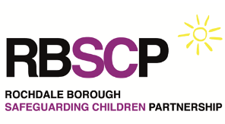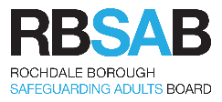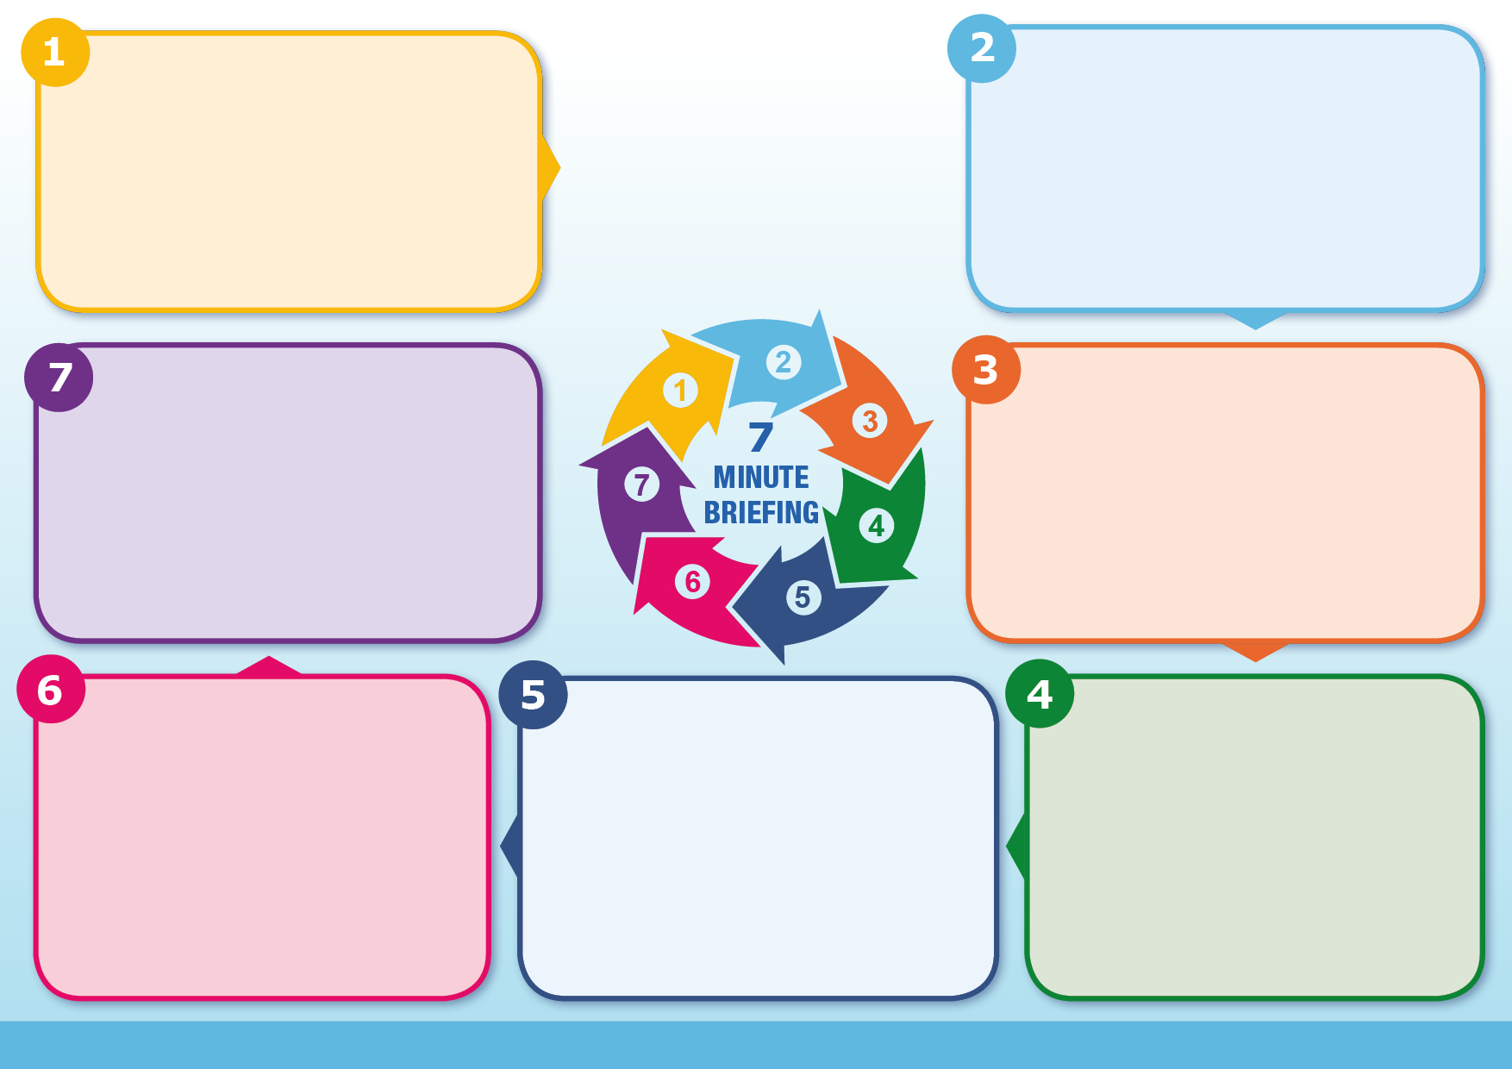

Send completed MARF by email to: [ehash@rochdale.gov.uk](mailto:ehash@rochdale.gov.uk)

Telephone: 0300 303 0440 (8.30 am – 4.45 pm)

0300 303 8875 (out of hours)

**Rochdale Multi Agency Referral Form (MARF)**

**Why it matters:**

**Background:**

Information already compiled in an Early Help Assessment, Graded Care Profile or other assessment can be attached to the MARF and does not need to be transferred to the form itself.

**Information:**

Professionals should always try to discuss concerns with the family and seek their agreement to a referral unless this may place the child at increased risk of Significant Harm.

**Information:**

You can find copies of the new MARF at: [assessment tools forms templates other resources](https://rochdalesafeguarding.com/p/resources-and-tools/assessment-tools-forms-templates-other-resources)

**Questions:**

The new MARF is a 4 page form and is more concise than the earlier version.

**Information:**

**What to do:**

Good quality referrals ensure that any advice or activity to protect or intervene on a child’s behalf is appropriate, timely and proportionate.

The Complex Early Help and Safeguarding Hub (CEHASH) assesses the needs of children as soon as a concern is raised about their welfare. Professionals can contact CEHASH for advice and guidance or make a referral using the new Multi-Agency Referral Form.