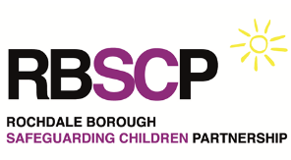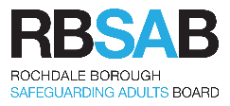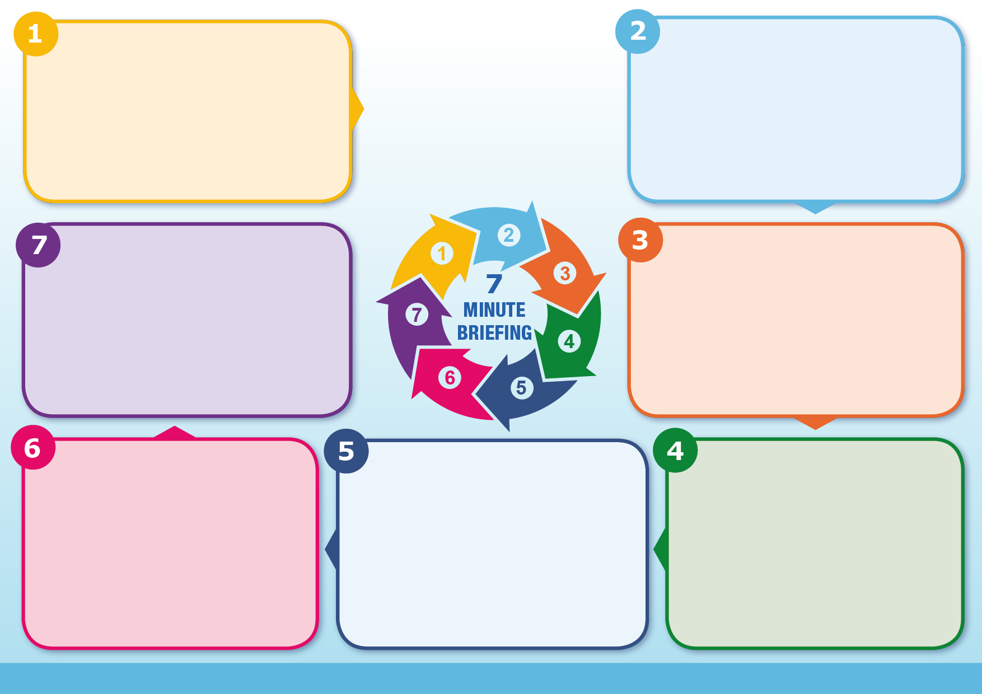

**How is this different to**

**a professionals meeting?**

• Be open and honest with the Adult and seek their consent to share information with others.

• You may still share information without consent if, in your judgement, the need to secure consent can be overridden in the public interest.

• Seek advice if you are in doubt.

• Keep a record of your decision and the reasons for it.

Familiarise yourself with the procedures, protocols and guidance documents to be found on the RBSAB website, especially the escalation procedure, the Multi-Disciplinary Team (MDT) protocol, the Tiered Risk Assessment and Management (TRAM) protocol and the Multi-Agency Risk Management (MRM) procedure.

All can be found on [www.rochdalesafeguarding.com](http://www.rochdalesafeguarding.com)

Escalation is an essential part of good safeguarding practice for adults and families. As practitioners we can have different views on the best way to provide support and we should expect to be challenged because working together effectively depends on an open and honest relationships between agencies.

At times we may disagree about threshold judgements and the appropriate course of safeguarding action. If we do, it is our individual responsibility as practitioners to follow the “Resolving Professional Disagreements” section in the [RBSAB Policy and Procedures.](https://www.rochdalesafeguarding.com/p/resources-and-tools/multi-agency-policy-procedures-protocols-and-guidance)

A professionals meeting is one that only professionals/ practitioners are invited to, and the person concerned does not usually know the meeting is taking place.

A professionals meeting is the exception rather than the rule and is held for different reasons, such as agencies needing to address difficulties in working with a family or an agency or group of professionals feeling that agencies are working in conflicting ways or have serious safeguarding concerns that for the resident’s safety need to be initially shared without them.

**What does this mean for me?**

**Escalation**

**Consent and Information Sharing**

The practitioners closest to the Adult should attend. If lots of agencies are involved, it should be agreed who is best placed to attend and bring feedback from others. The meeting should be a conversation, not a conference and be kept to a reasonable size so that everyone is able to contribute easily, especially the Adult.

The key person will be agreed at the first meeting. They will coordinate the plan of support and care for the Adult and be the point of contact for everyone involved, including the Adult.

**Who should attend a TAA meeting?**

* Identifies needs, risks and the desired outcomes of the Adult

• Agrees an action plan with clear roles, responsibilities, actions and timescales, including next steps if risks increase

• Works in partnership with the Adult and promotes a culture of trying to prevent premature case closure.

• Uses a persistent and proactive approach, to positive risk taking

• Avoids the ‘revolving door’ (keep being referred to the same agency) and agency ‘ping pong’ (keeps being passed to different agencies).

**What does a Team around the Adult meeting do?**

Team around the Adult is a multi-agency way of working to create beneficial outcomes for people with care and support needs. This process can be used in care management and for people with emerging needs around promoting independence.

Team Around the Adult brings together the individual Adult and the different people that are providing or could provide support.

It is a process that happens in partnership with the Adult concerned and their family, with the Adult and their wishes and feelings kept at the heart of the discussion.

**What is Team around the Adult?**

**Team around the Adult**